# Acknowledgement

# Abstract

FPS games are easy to play and are great source of fun; this project is about creating a FPS game for Windows platform. The game to be developed is equipped with multiplayer features and the players can interact with each other via a server. The system uses a popular game engine known as “Unity 3D”, which make this project more easy to make. This project explains a game development trend through game engine and provides an overview of game development cycle that can be followed if any person gets inspired to create a game on his own. As the game is multiplayer, it will be broadly scripted with code, use network protocols for multiplayer interaction and multimedia techniques for creating game assets.

While we look in the game developed by big companies then we find that the games require high hardware resources and cannot be played neither in low bandwidth network nor in low hardware configuration computers. The game developed from this product will be able to be operate on low hardware resourced computers and low bandwidth networks.

We all are aware of the game development trend in Nepal, it is almost null. The games are very simple and there is not account of 3d games developed, let alone the 3d multiplayer games. This game will innovate the game development and people will know that indie games can be developed via a single developer.

# Chapter 1: Introduction

## 1.1 Introduction

In this chapter, the system to be developed is briefed with the current scenario of the world and in relation with under developed country like Nepal. The problem that is prevailing currently that will eventually be solved from this system are discussed. The approach with which the system is to be developed is also illustrated here.

## 1.2 Motivation

Playing video games was my childhood hobby, I have played various games of various genre on various consoles. The world of video games had rooted an inspiration in my brains which was giving me the feel of developing some game for my amusement. Living in an underdeveloped country like Nepal where the game development trend is almost null; by creating a game, I can make by FYP project distinct as I have never seen any game developed yet from game engine in Nepal. As game development in Unity 3D requires creating scripts from javascript and C# in OOP approach, I was greatly encouraged in writing code for gameObjects which will make them interactive. Through this project I will not only develop my code writing skill but I will also learn networking and multimedia techniques.

## 1.3 Current Senario

The world of game development and its design recently has been widely appreciated by the world of entertainment. This gives us the idea that the gamers have increased in large number rather than the developers; this has led to a large demand of gaming products that should be fulfilled by a small number of development teams.

The game development trend is new for human society as it was yet to be discovered for about 3 decades ago. The early games were very simple looking yet required lots and lots of coding, games such as Super Mario Bros, Dave were popular back then; which were based on low quality 8 bit technology. Nowadays, the gaming environment has been made very easy by the use of different game engines; Unity 3d is also a game engine that utilizes the concept of importing various multimedia aspects into it and be processed to give the desired output as the development team wants. The trend of game engine is so much popular that each company has its own proprietary game engine to develop their own games. This makes the physics, character animation, terrain creation to be very much easier than the primitive pure coding trend. The game engines are responsible for pushing the software and hardware resources to their edge, therefore demanding new resources in the market.

The game development industry in Nepal is crucial and only a small number of pure code based games have been deployed in the market without any economic concerns. There has been no idea generated concerning the game development via game engine.So, by introducing Unity 3D to Nepal's IT environment and exposing its capability many focus will be drawn towards this project and this will be very inspiring to various game designers and developers.As geographically, Nepal lies between two massive countries; that dominate the entire world in the field of IT, taking a leap in the game development world would be a great approach for advancement for technology as well as economic aspect for our country. In respect to the Windows Store (Apps for Windows 8, 2013), there has been no 3D game deployed for Microsoft Windows from the developers of Nepal, let alone the advanced 3D mulitiplayer FPS games. By launching this FPS game for Windows platform, a new commercial view of game development in Nepali market will be vivid. Our country cannot fall behind as the other countries root their dominance in the game development industry, as this is one of the rapidly flourishing sector. There are many free game engines in the international market, which makes game development possible for any small low budget teams or companies in Nepal.

This project is all about trying a new approach of game development which has been considered the most effective and convenient. This project will produce a FPS game in which the players can play in an interactive environment in the same way compete with each other. The final product should be rendered and manipulated in the Windows platform. The game should be able to perform all the vital aspects and functionality that will consider it to be a FPS game.

For achieving this project I plan to use Unity 3D game engine and other software such as Maya, Adobe Illustrator to create the environment and its objects. The physics and terrains will be manipulated by the game engine whereas characters/props will be imported from Maya. I plan to finalize the characters first and then the environment for the game.

The game development interest was a hobby of mine since my childhood. Slowly I found that, this hobby was not easy as I reckoned. It required extensive knowledge of various aspect of computer science, such as computing, networking and multimedia. The game objects solely depends on the code or scripts to give them identity, various games need to be simultaneously interactive to more than a user at a time which demands networking knowledge and lastly the objects are created with the various ideas regarding multimedia. As, it was mine childhood dream to create interactive games, I plan to make this project a grand success. Eventually, this project will teach me the ways to write codes that will control the objects and environment. I will learn to create connection between the users to make it multiplayer; I will also gain some ideas regarding the multimedia field. Nevertheless, I will also learn about the Windows platform and the project planning-manipulating techniques.

This project answers various questions such as; Why use game engine approach rather than the pure code based approach for game development? How to develop an app (game) for MS Windows devices? How to build FPS game and manipulate the environment? Finally, a full playable game will be developed which will eventually promote the game development era of Nepal.

## Problem Background

The current game development trend in international scenario is at the peak level but there are some factor that have shown their dark side to the general gamers.

- Most of the FPS games are of huge size (typically 1-2 GB), making them require lots of hard disk space.

- Most of the FPS games require high-end hardware resources (minimum of 2 GB RAM, minimum of Dual Core Processors, at least 515 MB of RAM).

- They can be played on LAN but they require high bandwidth network.

The problem domain for Nepal is huge:

- There have been some commercial games developed but only in pure code environment making them hard to develop.

- There have been no complete 3d games developed via game engine. (There was a game being in progress via EsenthelEngineSDK for outsourcing but I was cancelled because of technical difficulties).

- No multiplayer games yet developed in Nepal.

## 1.5 Aims and Objectives

The main aim of this project is to deploy a FPS game from Unity 3D to Windows platform. As this type of game has not been deployed in Nepal’s market, this will be a different approach for Nepali market. The FPS game will be wireless multiplayer game where more than one player will be playing simultaneously with each other.

### 1.1.1 Objectives

* Research on other similar projects from which the positive aspects can be followed and negative aspects can be avoided.
* To carry the fact findings of the problem domain.
* Make the requirement engineering for this system
* To select the design, development, implementation methods.
* Design the system with UML components.
* Learn to operate Unity 3D and its components.
* Import and work with character controllers in Unity 3D.
* Build the terrains in Unity 3D.
* Embed the scripts to the components.
* Make multiplayer components.
* Port the system in Windows platform.
* To test the system for its functionalities.
* Implement and Install the system.

## Document Overview

This section provides brief information about the structure with which this report has been prepared. It has been organized with the help of different chapters; each chapter covers different aspects of the system.

***Chapter 1: Introduction***

Here the aims and objective of this project is comprehended and then a detailed scenario of the game development trend in the whole world is illustrated.

***Chapter 2: Literature Review***

In this section, the similar game developed which can be referenced to my current project is described then are compared with each other with different technical aspects.

***Chapter 3: Methodology***

In this section of the document, the approach and model of the system development cycle for this project is illustrated.

***Chapter 4: Requirement Analysis***

This chapter talks about the ways in which the requirement for this project was compiled.

***Chapter 5: System Design Specification***

In this chapter, the design of the system is illustrated with class diagram, state transition diagram and many more.

***Chapter 6: Development***

This chapter shows the main codes which were written to make the system functioning.

***Chapter 7: System Testing and Implementation***

Here the build system is tested with test cases and the deployment of the system is discussed.

***Chapter 8: Critical Evaluation***

Here the evaluation of the system and the methods are made, along with the challenges that were faced are briefed.

***Chapter 9: Issues***

The social, legal, ethical economical and technological issue that should be considered by this project is stated here.

***Chapter 10: Conclusion***

The entire project is concluded here.

# Chapter 2. Literature Review

This project is totally based on Unity 3D game engine which will beported to the Windows platform. I have planned various policies that will give this game some specific ideas for creation and development.

FPS games are the trendiest games in present era as per their multiplayer online games capabilities. The gamers love it so my users range increases with its popularity. In other hand many games have been developed via Unity 3D, so there are various assets for FPS game in Unity 3D library than any other genre of game.

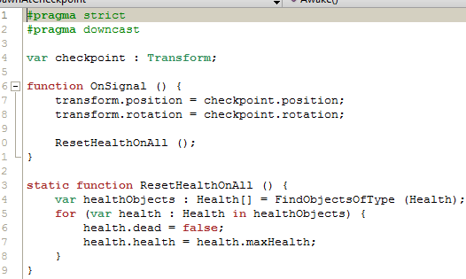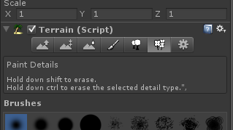The game will consist a single game terrain (level) developed in unity 3D’s scene mode. The terrain will be small, so there will be the need of closing the terrain with peak slopes at the edges. The terrain will be filled with tress and messes to make the environment more realistic, with the wind component smoothly moving the objects. For the soils and rocks the textures from terrain assets will be imported. (Unity Technologies, 2011)

Figure 2: Spawn Script on MonoDevelop

Figure 1: Terrain Editor on Unity 3D

The game will be code in Javascript and C# scripts that will define the components of the game. The reason why I choose these scripting language is because unlike “Boo Script”, javascript is easier for creating prefabs and setting physics in the environment and C# is convenient for replicating the components and their behavior in OOP approach.

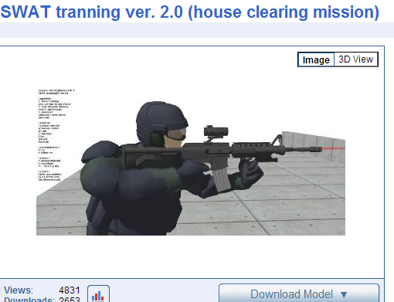

Figure 3: FPS army model on google 3D warehouse

There will be two sets of gaming groups; army and terrorist who will be fighting with each other for their survival and tending to complete their respective objectives. The game objects might be imported from “google 3d warehouse” and be exported from SketchUp to Maya to process the characters, (some props will be created in Autodesk Maya) in the manner that this project demands but this project will not be focusing on the art aspect rather the technical aspects of game development. Finally, the weapon and character will be processed and be exported to unity 3D objects. There will be only one weapon that will be reducing the health points of the opponent team members.

This game will be multiplayer 1st person shooter where users possibly can interact with each other via a chat room box. There will be water bodies via water assets and fire/smokes via particles component. (IGN, nd)

One of the game instances will act as a server in a specific IP with a certain port use, than the players can connect to the game world by being a client of that server via that port number. This will make the game flow and interaction between the game instances constant in the same way interactive.

The characters will be controlled by the mouse and keyboard I/O, the keyboard buttons “A”, ”S”, ”D”, ”W” are “Left”, “Down”, “Right” and “Up” controls for the charter in the game respectively. The “Space” button will make the player jump whereas Right Mouse Button will fire the weapon. The movement of the mouse is responsible for changing the view angle for the player.

For destroying the opponent team member the team is awarded with a +1 point in the scoreboard, the first team to acquire 20 points will win the game.

The players will have health points that will be decreased as that player is hit with the collider of the weapon but that health point also increases steady over the time period.

There 10 specific spawn points in the game world, 5 for the terrorist team and 5 for the army team. If a player of certain team is killed then he gets randomly spawned in the game from those selected spawn positions.

## 2.1 Similar FPS games at present

The game development industry has become so much popular that I can review various games and try to learn positive aspects of them and try to avoid negative aspects of them.

### 2.1.1 Counter-Strike: Global Offensive

This game is the most popular online multiplayer FPS game, which is developed by Valve Software. It can be played in Microsoft Windows, Xbox, Mac OS X and Linux platform.

It comes with lots of gameplay options as well as various maps. Game play is relatively same as of other FPS games. (Lahti E., 2012) The graphics in the game are crystal clear. Any user familiar with the computer system can operate this game without hassle. Players don’t win the game just by pressing the buttons; they need to develop a strategic approach to win the game. It is considered very secure as there has been no reports of its servers been hacked.

The gamers need to buy this game, but many FPS games in market are free. This game has relatively less physics and less weapons selection. I disliked the fact that barely anything moves in the map. It needs a decent machine to play; it cannot be ported to handheld devices.

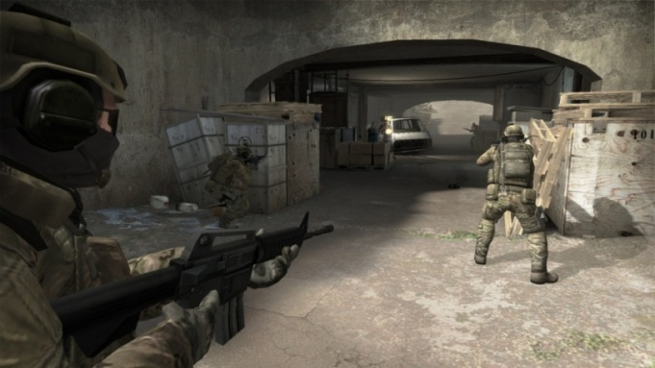

Figure 5: Counter Strike: Global Offensive gameplay

### offensivecombatlogo_stroke.png (1280×640)2.1.2 Offensive Combat

Offensive Combat is a free to play 3D browser-based first person shooter (FPS) by U4iA Games. With a variety of crude internet jokes, silly kill streak prompts and humorous melee weapons, Offensive Combat aims to appeal to players who enjoy internet humor. (mmobomb, 2012)

It was developed with Unity 3D engine, which is based on browser platform. This clearly gives us the clear concept and ideology on creating games based on low hardware resource platforms. This game has lots of action, if the player stops his motion he will probably die. The player needs to put his all concentration on the game if he wants to stay alive in the game, quick reflexes is the most valuable assets when facing the online opponent. On top of that, we don’t need to pay any money to enjoy this entertaining game. (U4iA, 2012) In the game, the player can choose from variety of avatar and weapons. It has addictive game policies; the players gain coins and experience level as they win the game which can be invested for weapons and superiority over other opponents. The player can battle other players in four different game modes; Free for all, Team Deathmatch, Capture the Flag and Capture Point.

Trying to get Offensive Combat to run smoothly can be bit of a pain. It is never unplayable, but the framerate slowsand game play lags. The win and get coins policy, can be great trouble for inexperienced players as the weapons, avatar all depends on coins. The game development team has not put extensive effort on making this game great on graphics.

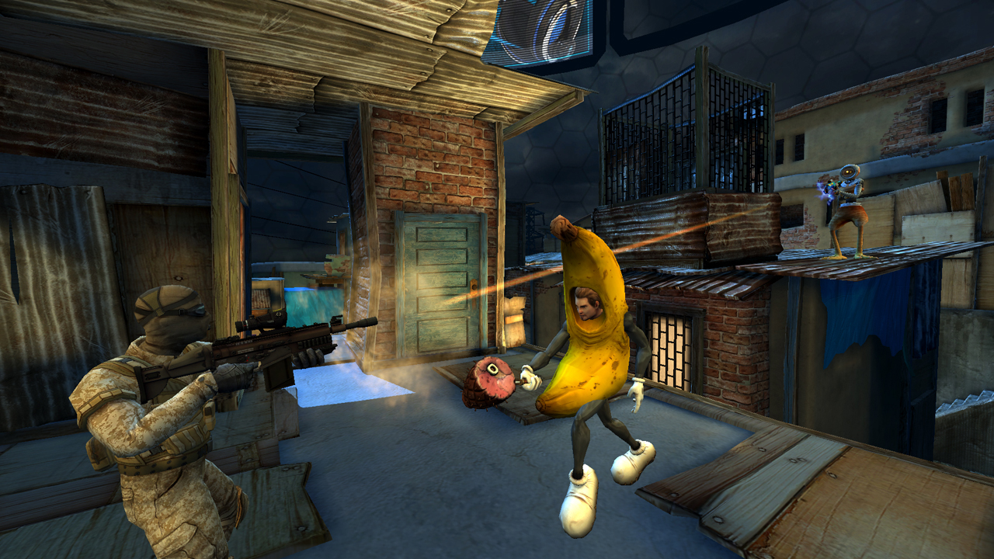

Figure 6: Offensive Combat gameplay

### http://appaddict.net/wordpress/wp-content/uploads/2012/09/20120827_ModernCombat4_logo_05-copy-e1348655888337.jpg2.1.3 Modern Combat 4: Zero Hour

Modern Combat has been a FPS game series developed by Gameloft and Zero Hour is the recent deployment for this series for iOS, Android, Windows Phone 8, BlackBerry 10 and BlackBerry Playbook. This game can be played either in campaign mode or online multiplayer mode, both of the mode are fair easy to play.

The story of campaign mode is great, the environment are more compact and less repetitive. There are some ground and airborne vehicles and player gets to play the game as both the liberators and terrorists. (App Store, 2013) This game seems to lag on iphone 3gs and lower devices but works fine on its successors.

Talking about multiplayer mode, players can play 12-player deathmathches or alternative team up with others in the objective-based modes. There are many environment and objects in the game that the player can interact with. (Mac|Life, 2013) The maps are not repetitive and wide range of weapons can be used.

Gameloft has obviously made some compromises on the resolution to keep the frame rate running at relatively heavy environment. The game cannot be played in retina level on iPad 3. The controls are bit of an issue. As the controls are virtually to be pressed on the screen, this makes the game unrealistic and inconvenient.

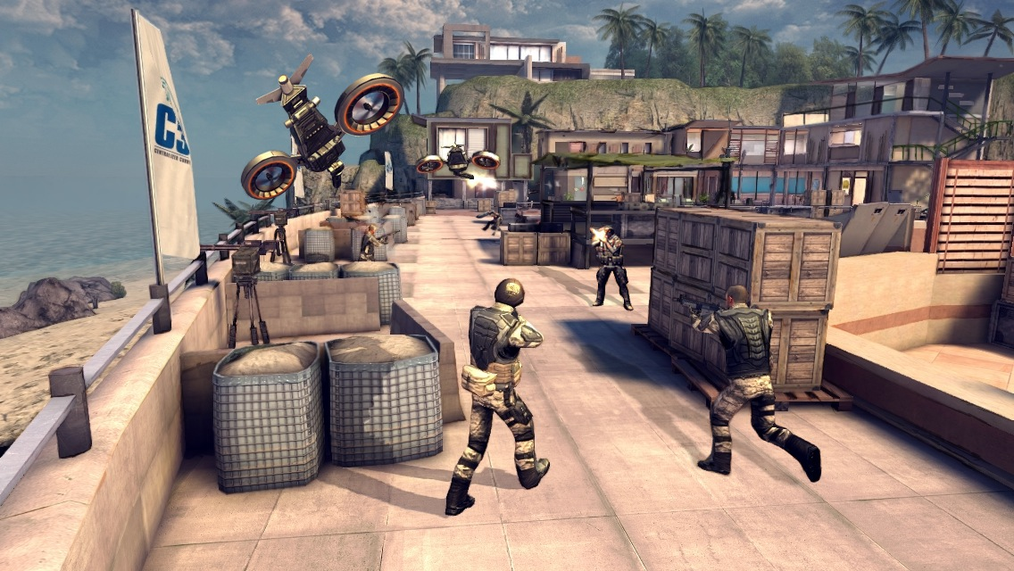

Figure 7: Modern Combat Zero Hour gameplay

## 2.2 Comparison between similar existing games

|  |  |  |  |
| --- | --- | --- | --- |
|  | ***Counter Strike : Global Offensive*** | ***Offensive Combat*** | ***Modern Combat : Zero Hour*** |
| ***Online-Mulitiplayer*** | Yes | Yes | Yes |
| ***Game Playmodes*** | 5 | 7 | 2 |
| ***Graphics*** | Above average | Below average | Average |
| ***Hardware Required*** | Heavy | Lite | Lite |
| ***Strategic*** | Yes | Yes | No |
| ***Online Security*** | Good | Average | Bad |
| ***Need to Buy*** | $14.99 | Free | $6.99 |
| ***Physics*** | Bad | Good | Good |
| ***Weapons*** | Limited | Extensive | Extensive |
| ***For Portable Devices*** | No | Yes | Yes |
| ***Avatars*** | Limited | Extensive | Limited |
| ***Addictive Policies*** | Yes | Yes | Yes |
| ***Smooth Gameplay*** | Yes | No | Yes |
| ***Campaign Mode*** | No | No | Yes |
| ***Easy to novice*** | No | Yes | Yes |
| ***Easy Controls*** | Yes | Yes | No |
| ***Terrains*** | Above Average | Below Average | Above Average |
| ***Skyboxes*** | Above Average | Below Average | Above Average |
| ***Audio Assets*** | Good | Excellent | Good |

# Chapter 3. Methodology

This project demands lots of work to be completed and therefore the methods, tools and techniques are the backbones to complete it without error and convenience.

## 3.1 System Development Methodologies

The system Development Methodologies are responsible for tracking the development of project in the right track. It defines the phases and there making the milestones and objectives more vivid; by implementing methodologies the system produced will have more quality, build with lesser cost and will be developed in right time. The system development methodologies have been applied in every successful project and will continue to be applied. This project also needs a backbone of phases which I intend so following.

3.1.1 Waterfall Model (not Chosen)  
As the name of this model suggests, this model goes in the linear phases fashion. It has its draw backs, which made it not applicable in my system development trend.

- It required the early detection of requirement which was not defined in my case it was flexible.

- Errors needed to be detected in early phase, as I was doing a out of box project error detecting in first phase was impossible.

### 3.1.2 Agile Scrum Model (not Chosen)

This model is very new and effective in terms of the recent software development needs. It focuses on the requirement fulfillment of the client rather the other factors, so adapting this model will make the system easier to cope with the changes. This was not implemented because:

* This methodology requires well experienced team members on the technology used, which is not in my case.
* As this model has very flexible time parameter, this will do no good for my project as I have to follow strict deadline meeting trend.

### 3.1.3 Incremental Methodology

This project has many components that go top on each other as they are gradually developed individually. The terrain needs to be built first, and then the characters need to be imported from SkecthUp to Maya for manipulation. The prefabs need to be processed, and then the physics need to be implemented. Skyboxes, water bodies and audio bodies are individually put under consideration. Scripts for each component needs to be embed for further development. Hence, each module needs to complete a whole development cycle and put on top of the other module to make a complete system.

From this development method, I can pay special attention to each and every component individually. I will be testing and changing my ideology as my system gradually gets developed. I will also be getting useful feedback from my peers and teachers as this system will be functional while in development phase.

Unlike incremental methodology, the other methodologies like Waterfall, Prototyping, DSDM, etc cannot fulfill the requirement of this project. In waterfall, the requirement, design and development go in linear fashion which is inappropriate for developing a game which demands its components to be built in parallel fashion. DSDM also is not appropriate as time is not flexible in this methodology which is crucial for this project.

## 3.2 Tools and Techniques Used

### 3.2.1 Development Tools

|  |  |
| --- | --- |
| ***Tool Used*** | ***Description*** |
| Unity 3D | The base engine through which the whole game development process takes place. |
| MonoSQLite/MySQL | The database engine made for Unity 3D, for keeping track for stats and highscores of users. |
| SketchUp | For importing the game objects form google 3D warehouse. |
| Maya | It will be used for importing the objects from SketchUp and manipulating the character in the way the project demands. |
| Mozilla Firefox | For early simulation of environment, Unity 3D will be using firefox. |

#### 3.2.1.1 Unity 3D

Unity 3d has been the most inspiring game development engine recognized this decade as for its simple yet powerful game development tricks. It has successfully deployed various games of different genres and has won many internationally recognized awards. It deploys games for different platforms such as MS Windows, Mac OS X, Linux, Web Player, iOS, Andriod, BlackBerry, FlashPlayer, Google Native Client, XBOX 360, PS3, Wii, Windows Store Apps and Windows Phone 8.

I will be using its free version, as the free version provides me with all the necessary tools needed for me. There are many game engines in the market yet I plan to use this particular engine, as it can handle most of the game objects from other software such as; Autodesk Maya, Autodesk 3D Max, etc. It also is the most popular free game engine with many assets and libraries. (Toogle, 2011) It is convenient tool for an individual developer to develop his own full playable game. Many FPS games have been deployed through its platform, so there are many components focused just for FPS.

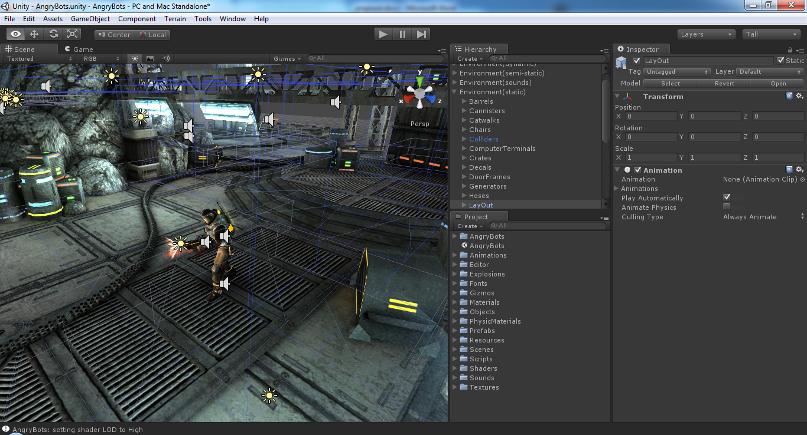

Figure 4: Angry Bots on Unity 3D engine

#### 3.2.1.2 Game Development Platform

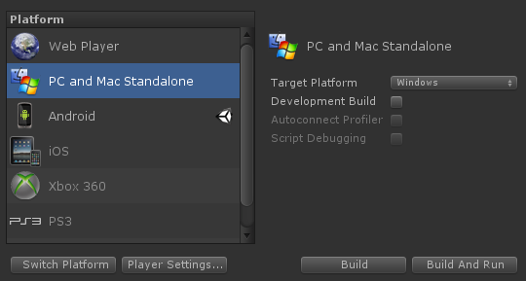The latest update, Unity 4.2, was released July 2013. It currently supports development for iOS, Andriod, Windows, BlackBerry 10, OS X, Linux, Web Browsers, Flash, PS3, Xbox 360, Windows Phone 8, and Wii U.

Figure Unity 3D Game Build Settings

I will be centered for developing this FPS game for Windows Platform, but the best feature of Unity 3D is that, “The project file of unity 3d is cross-platform” i.e. if I developed this FPS game development project for Windows then with some I/O integration I can export the same project files for different execution platforms. The game in the Windows platform solely depend on the D-pad of keyboard but iOS devices need virtual keys, therefore some I/O porting and scripting is to be done at the ending. This means I will generate a FPS multiplayer game for Windows platform but the game will possibly be cross platform.

Windows and its app store are the buzz words these days, commercially app deployed in Windows's app store are very attention grabbing and successful. Games on Windows have superiority over big game consoles these days, so by developing a FPS game for Windows devices I will be provided with wide range of users.

Figure Image source (http://www.windowsstore.com/)

I did a research on the apps developed in Windows App Store (<http://windows.microsoft.com/en-us/windows-8/apps>, 2013), where I filtered the apps according to the geo-location and it was not a surprise for me to find out that the store had the absence of 3D games by the developers of Nepal. In the store there were some minor hardcoded 2D games which were not impressive on playing. Some of the games are listed below:

* Casion (<http://apps.microsoft.com/windows/en-us/app/95f49b14-6b90-4bb5-8a26-552fd5e193c3>)
* Water World (<http://apps.microsoft.com/windows/en-us/app/c44475e3-8d4f-4029-8571-572e530ef881>)
* Dog vs Cat (<http://apps.microsoft.com/windows/en-us/app/80eb22ef-e2f8-470e-ad15-3b092cc45048>)
* Killing the Fly (<http://apps.microsoft.com/windows/en-us/app/d840315c-3113-4cfb-af57-06b00ccaa78a>)
* FreeBoard Bagh-Chal (<http://apps.microsoft.com/windows/en-us/app/91073310-8a47-4f97-9fa8-1e23be90d64e>)

I found that Windows App Store is filled with immature games, so I focused on producing a mature 3D FPS game for Windows platform.

### 3.2.2 Modeling Tools

***UML (Unified Modeling Language)***

For manipulating the game objects such as First Person Controller, Camera, Lights and Skyboxes, I will be using OOP in C# script. For making that approach clearer I will be following the UML method. The UML provides several types of diagrams that, increases the ease of understanding this system under development. I will be using UML diagrams such as; use case diagram, class diagram, sequence diagram, activity diagram.

From the use-case diagram, I will be able to visualize the functional requirements of this system, including the relationship of actors to essential processes, as well as the relationships among different use cases.

The class diagram will be showing the different classes (army, crates, and bullets) relate to each other; in other words, it will show the static structures of the system.

### 3.2.3 Programming Tools

|  |  |
| --- | --- |
| ***Tool Used*** | ***Description*** |
| Javascript | It makes scripting easier for creating prefabs and setting physics in the environment. |
| C# | The C# scripting is convenient for replicating the components and their behavior is OOP approach. |
| MonoDevelop | The proprietary IDE for Windows platform, which helps to code the scripts in Javascript and C#. |
| Unitron | The proprietary IDE for Mac OSX, from which can only the Mac Os X platform gamesare able to be deployed. |

### 3.2.4 Assets and Libraries

|  |  |
| --- | --- |
| ***Assets/Libraries*** | ***Description*** |
| Skyboxes | It helps to generate the sky and then the components of sky operate automatically. |
| Terrains | The height of the terrain and the textures of the terrain can be set through it. |
| 1st Person Controller | This asset makes the character move as per the controller is pressed |
| Water Bodies | From this asset realistic view of water bodies can be seen. |
| Trees and Plants | The trees and messes can be imported that will operate according to the wind direction. |

# Chapter 4. Requirement analysis

Before the system is started to be designed and developed the requirement should be known so that the system is directed towards the proper system which meets the quality and scope. There are various fact finding techniques that can be followed to define the requirements in proper manner. I have followed these techniques to justify the system with usably and user’s demands

## 4.1 Fact Finding Techniques

### 4.1.1 Interview

This is the copy of interview of a game designer working at Olive Media Pvt. Ltd. Located at Mitra Park, Kathmandu, Nepal. He has suggested me the work flow of the game before I could design or develop it.******

******

### 4.1.2 Document Sampling

As there are various open source games developed via Unity 3D, I can get the documents from those projects. In other hand, Unity 3D has a documentation “<http://unity3d.com/learn/documentation>” for learning about its components and its own forum “[http://forum.unity3d.com](http://forum.unity3d.com/)” from which I can reference on.

In official website of unity itself there are lots of pre build games with source codes, I can reference them. In those specific game the compete cycle of game development are shown via videos. From those tutorials I relate their functionality into my game. They have not only the script references but the whole game assets package there.

***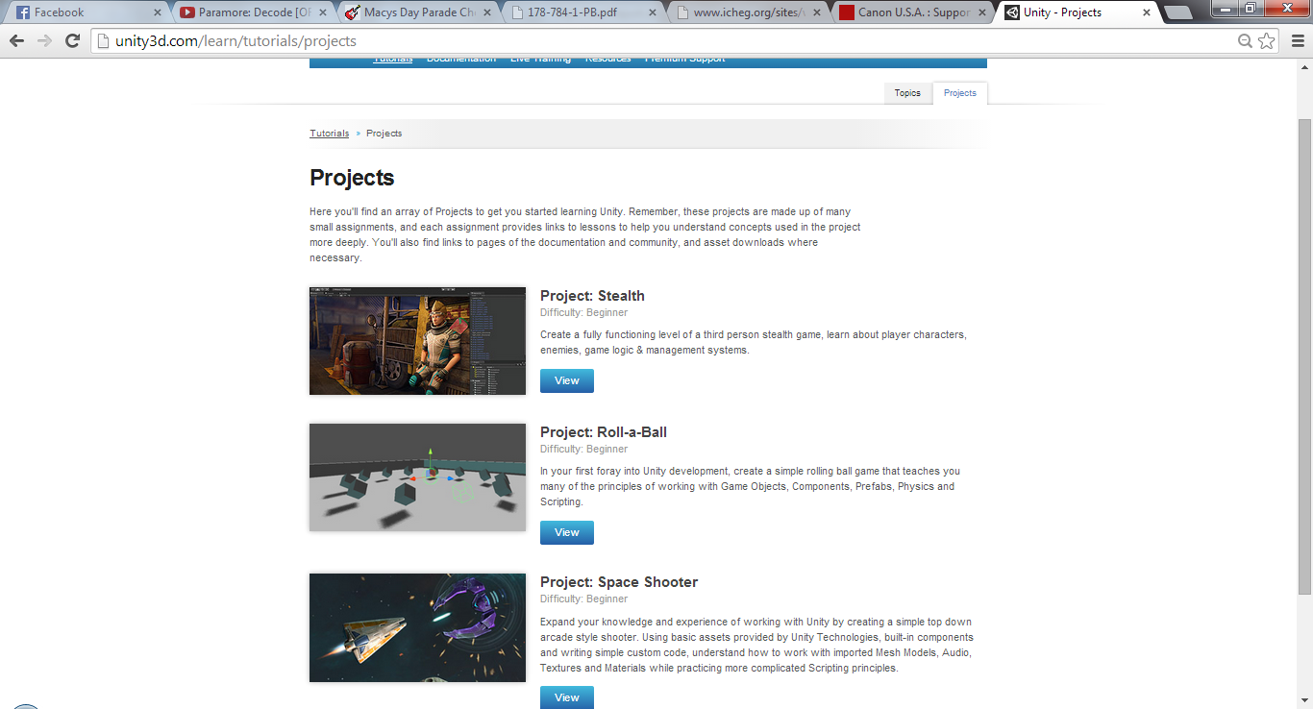***

### 4.1.3 Questionnaire

I will be using the form distributing feature of google docs, to distribute a questionnaire to all those who know the field of game development or game environments. From those feedbacks I will try to incline my project towards the major suggestions.

# Chapter 5. System Design Specification

## 5.1 System Architecture

The system created will have a router from which the LAN will be created. First of all the server computer connects to the network and starts a game server on his IP on his specific Port number. Then other computer connect as the client for the game by giving the IP and Port of the server, then they select a team from which they can compete with other team.

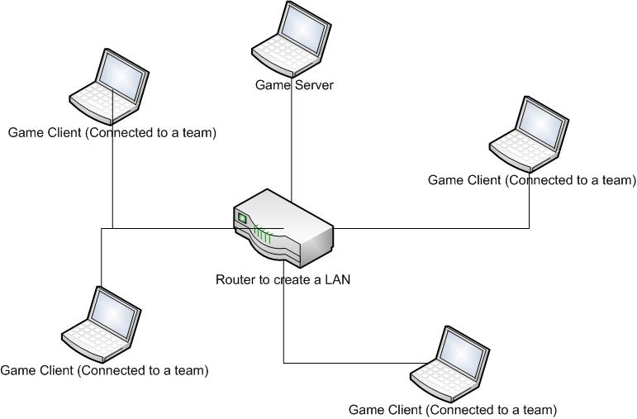

## 5.2 Class Diagram

The class diagram was produced according to the need to the system; the system had many requirements, so the classes were also in huge quantity. All the classes were integrated within the gameObjects of the Unity3d environment. First the gameObjects were classified and then according to the needs of the gameObjects the classes were formed. Here are the List of gameObjects within which the classes were contructed.

|  |
| --- |
| ***Player (Prefab) – gameObject*** |
| CameraMovementScript.cs |
| FireBullet.cs |
| MovementUpdate.cs |
| CursorControl.cs |
| PlayerName.cs |
| Target.cs |
| StatDisplay.cs |
| PlayerLabel.cs |
| PlayerScore.cs |

|  |
| --- |
| ***Bullet (Prefab) - gameObject*** |
| BulletScript.cs |

|  |
| --- |
| ***SapwnManager - gameObject*** |
| SpawnScript.cs |

|  |
| --- |
| ***MultiplayerManager - gameObject*** |
| Communication.cs |

|  |
| --- |
| ***GameManager - gameObject*** |
| PlayerDatabase.cs |
| ScoreTable.cs |

|  |
| --- |
| ***Trigger - gameObject*** |
| Health.cs |

From these gameObject the classes could communicate with each other.

***Class Diagram***

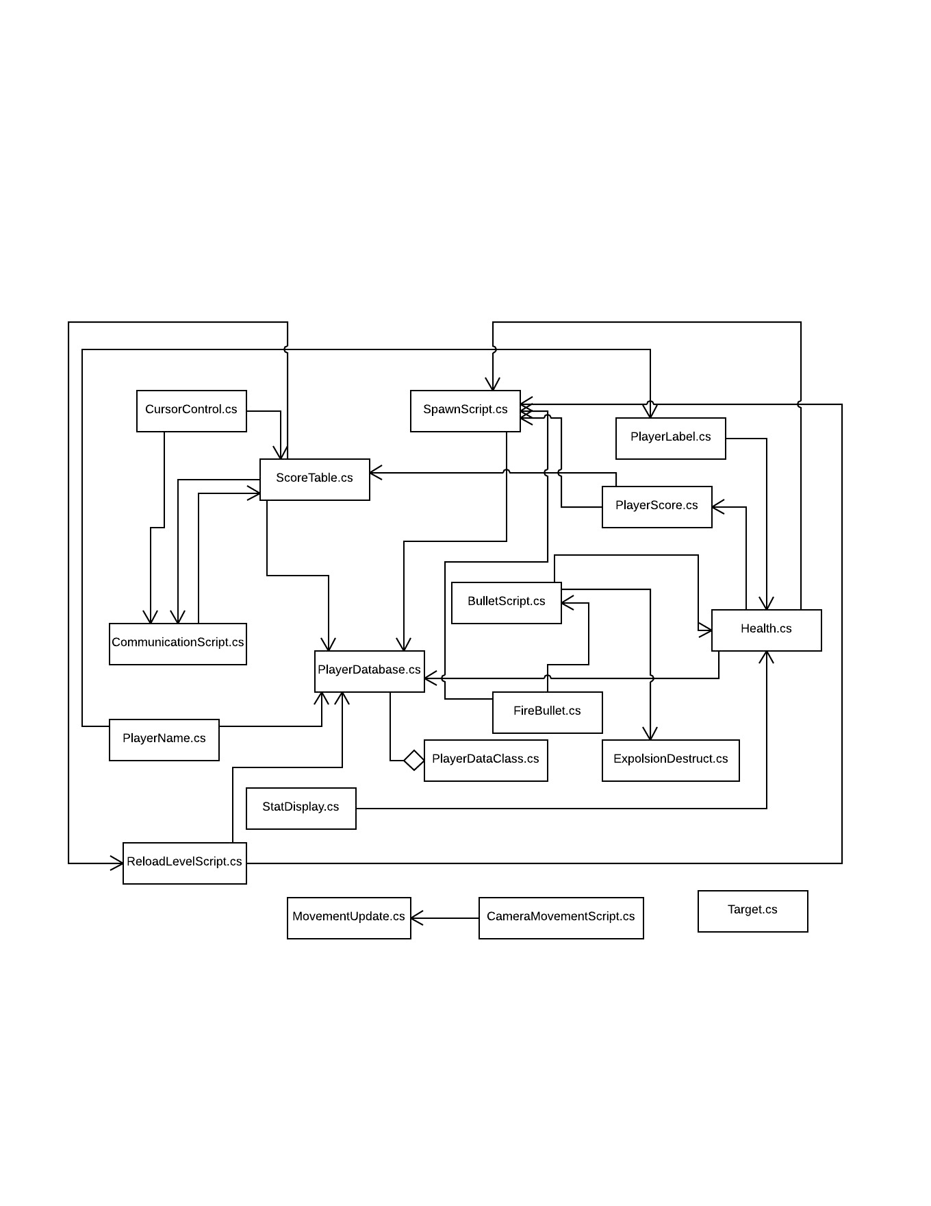

5.3 Use Case Diagrams and Descriptions

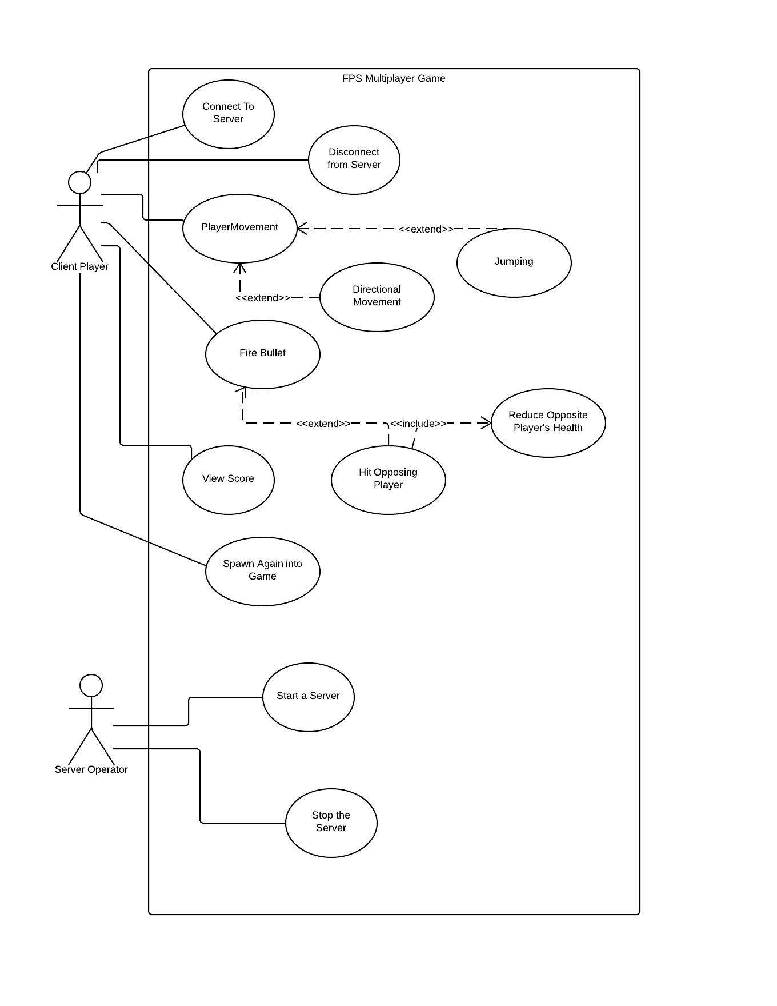

### 5.3.1. Module – 1: Server Connect and disconnect (Client Player)

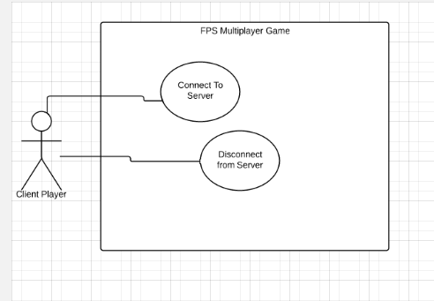

**Use Case Name:** Server Connect

**Actor:** Client Player (Initiator)

**Purpose:** To make connection to the server of the LAN

**Overview:** The client player joins the server by providing their server IP and Port number.

**Type:** Primary, Real

**Dialogue:**

|  |  |
| --- | --- |
| ***Actor*** | ***System*** |
| 1. The player starts the game.  2. He clicks the “Connect to server” button  4. Player inputs the IP and Port number of the server.  5. Clicks the “Connect” button. | 3. System provides the connection window GUI    6. System connects the player with the server. |

*Alternative Course of Action*

**Line 6:** If the IP or the Port number of the server is not correct then the system does not proceed onto the connection.

**Use Case Name:** Server Disconnect

**Actor:** Client Player (Initiator)

**Purpose:** To make the player disconnect from the server of the LAN

**Overview:** The client player disconnects from server by Pressing the Disconnect button.

**Type:** Primary, Real

**Dialogue:**

|  |  |
| --- | --- |
| ***Actor*** | ***System*** |
| 1. The player presses the Pause button.  3. Player Presses the “Disconnect” button. | 2. System provides the player with the Pause state window.  4. System disconnects the player from the server. |

### 5.3.2. Module – 2: Player Movement (Client Player)

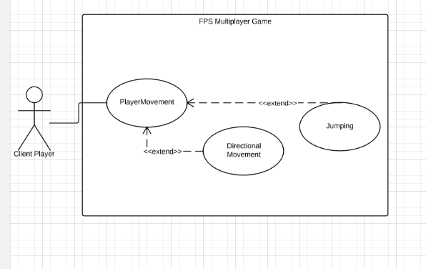

**Use Case Name:** Player Movement

**Actor:** Client Player (Initiator)

**Purpose:** To make connection to the server of the LAN

**Overview:** The client player makes movement of his player on his machine this gets updated across the network in each player’s instances.

**Type:** Primary, Real

**Dialogue:**

|  |  |
| --- | --- |
| ***Actor*** | ***System*** |
| 1. The player presses the directional button or space bar on the game play. | 2. System calculates if the movement is noticeable to be updated across the network.  3. Updates the player movement across the network via RPC. |

*Alternative Course of Action*

**Line 6:** If the Movement of the player is not noticeable then the RPC is not send across the network.

### 5.3.3. Module – 3: Fire Bullet (Client Player)

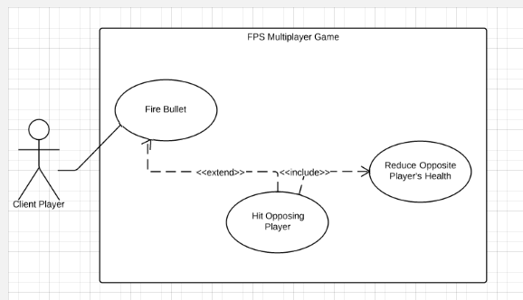

**Use Case Name:** Fire Bullet

**Actor:** Client Player (Initiator)

**Purpose:** To instantiate the bullet prefab onto the world and hit opponent player to reduce their health.

**Overview:** The client player presses the mouse0 button and instantiate the bullet, the bullet gets transform property and hits the opponent team member causing his health to reduce.

**Type:** Primary, Real

**Dialogue:**

|  |  |
| --- | --- |
| ***Actor*** | ***System*** |
| 1. The player presses the mouse0 button. | 2. The system instantiates the bullet prefab onto the world.  3. The bullet gets its transform property.  4. Bullet hits opponent team member.  5. Bullet instantiates the explosion effect.  6. The health of the player gets reduced. |

*Alternative Course of Action*

**Line 4:** The bullet will not always hit some gameObject.

**Line 6:** If the hit player is of same team, the health does not get reduced.

### 5.3.4. Module – 4: View Score (Client Player)

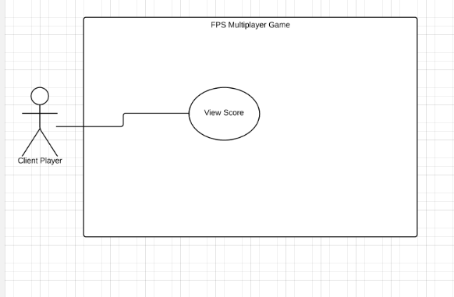

**Use Case Name:** View Score

**Actor:** Client Player (Initiator)

**Purpose:** To view the current score of each team.

**Overview:** The client player presses the View Score button, the game accesses the gameManger gameObject and updates its parameters and shows the score on the screen.

**Type:** Primary, Real

**Dialogue:**

|  |  |
| --- | --- |
| ***Actor*** | ***System*** |
| 1. The player presses the view score button. | 2. The system accesses the gameManager gameObject.  3. The system updates its scores parameters.  4. Displays the score in the screen. |

### 5.3.5. Module – 5: Spawn into game again (Client Player)

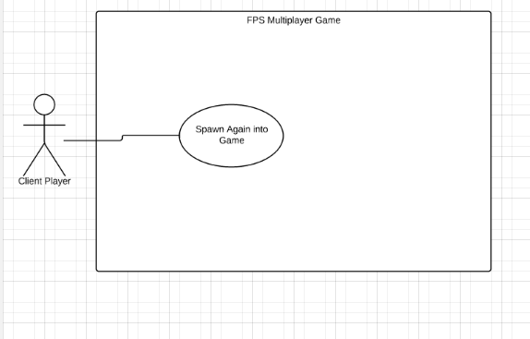

**Use Case Name:** Spawn Again into Game

**Actor:** Client Player (Initiator)

**Purpose:** To reappear in the game after being destroyed by opponent team player.

**Overview:** The client presses the “Respawn” button and he again gets respawn into the game.

**Type:** Primary, Real

**Dialogue:**

|  |  |
| --- | --- |
| ***Actor*** | ***System*** |
| 1. The player presses the “Respawn” button. | 2. The system makes call to the spawnManager.  3. The player gets respawn again into the game.  . |

### 5.3.6. Module – 6: Start or Stop a server (Server Operator)

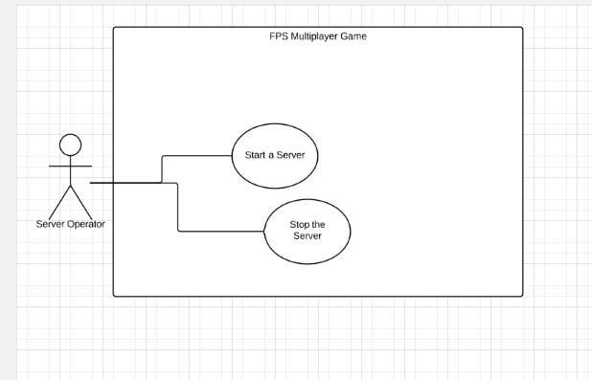

**Use Case Name:** Start a server

**Actor:** Server Operator (Initiator)

**Purpose:** To start a server in the network.

**Overview:** The server operator starts the server with his PC IP and inputs a Port number and starts up a new server.

**Type:** Primary, Real

**Dialogue:**

|  |  |
| --- | --- |
| ***Actor*** | ***System*** |
| 1. The server operator clicks the “start a server” button.  3. The server operator inputs the server name and the connection Port number.  4. Clicks the “Connect” button. | 2. System provides the connection startup window GUI.    5. System starts up a new server. |

*Alternative Course of Action*

**Line 5:** If the Port number of the PC is busy then the connection will not start.

**Use Case Name:** Stop the server

**Actor:** Server Operator (Initiator)

**Purpose:** To stop the server in the network from operating.

**Overview:** When the server operator clicks the button to stop the server the server will stop operating in the LAN.

**Type:** Primary, Real

**Dialogue:**

|  |  |
| --- | --- |
| ***Actor*** | ***System*** |
| 1. The server operator clicks the “Disconnect” button. | 2. System stops the server of the LAN.  3. The system displays the connection window. |

## 5.4. Sequence Diagram

### 5.4.1 Module 1: Server Connect and Disconnect

When the client wants to connect to the server, he presses the connect button. The GameConnectUI forwards the info to the CommunicationScript object and the data is manipulated in MuliplayerManager. The player inputs the IP and Port number of the server to connect, if it is valid the connect is established.

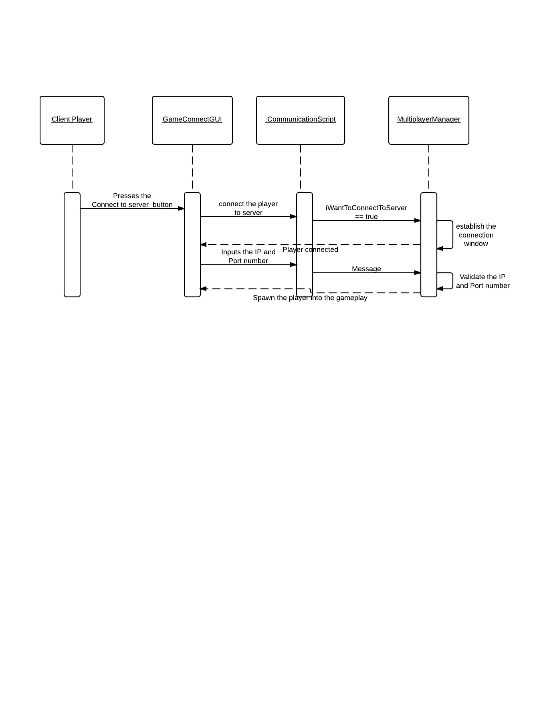

When the player presses the pause button, the game is paused with a disconnect window. If the player presses the Disconnect button, then he gets disconnected from the server.

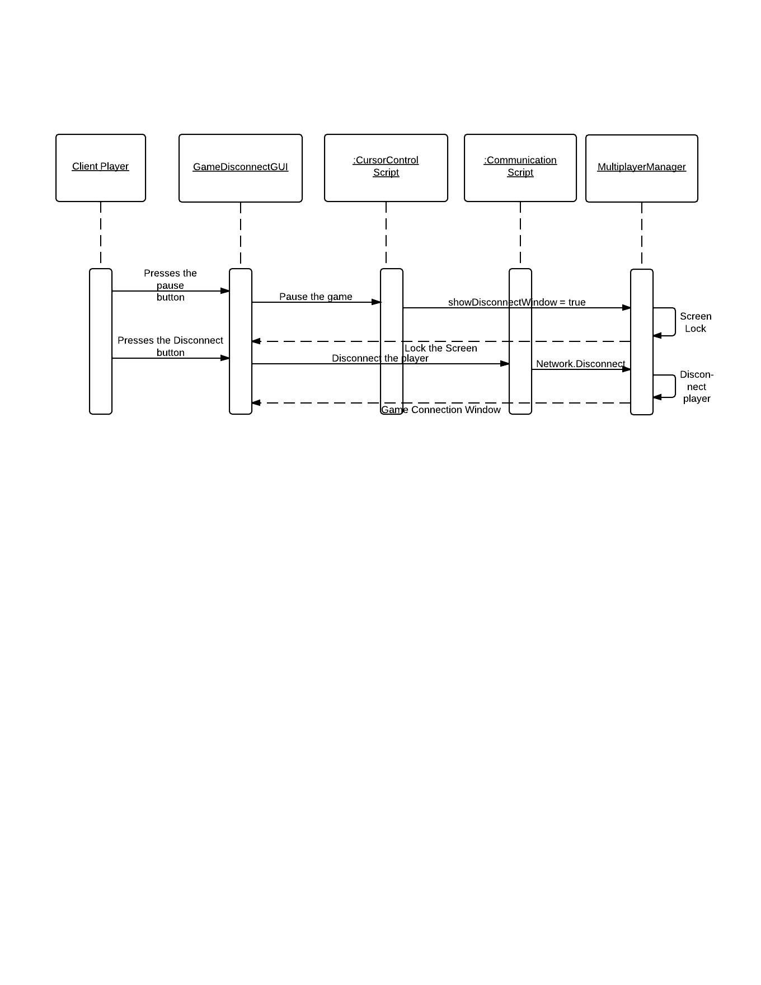

### 5.4.2 Module 2: Player Movement

If the client player presses the direction keys for movement or space bar for jumping, his transform gets altered. If the transform value is noticeable the object of MovementUpdate sends out a RPC to all the client player to update the new location of the current player.

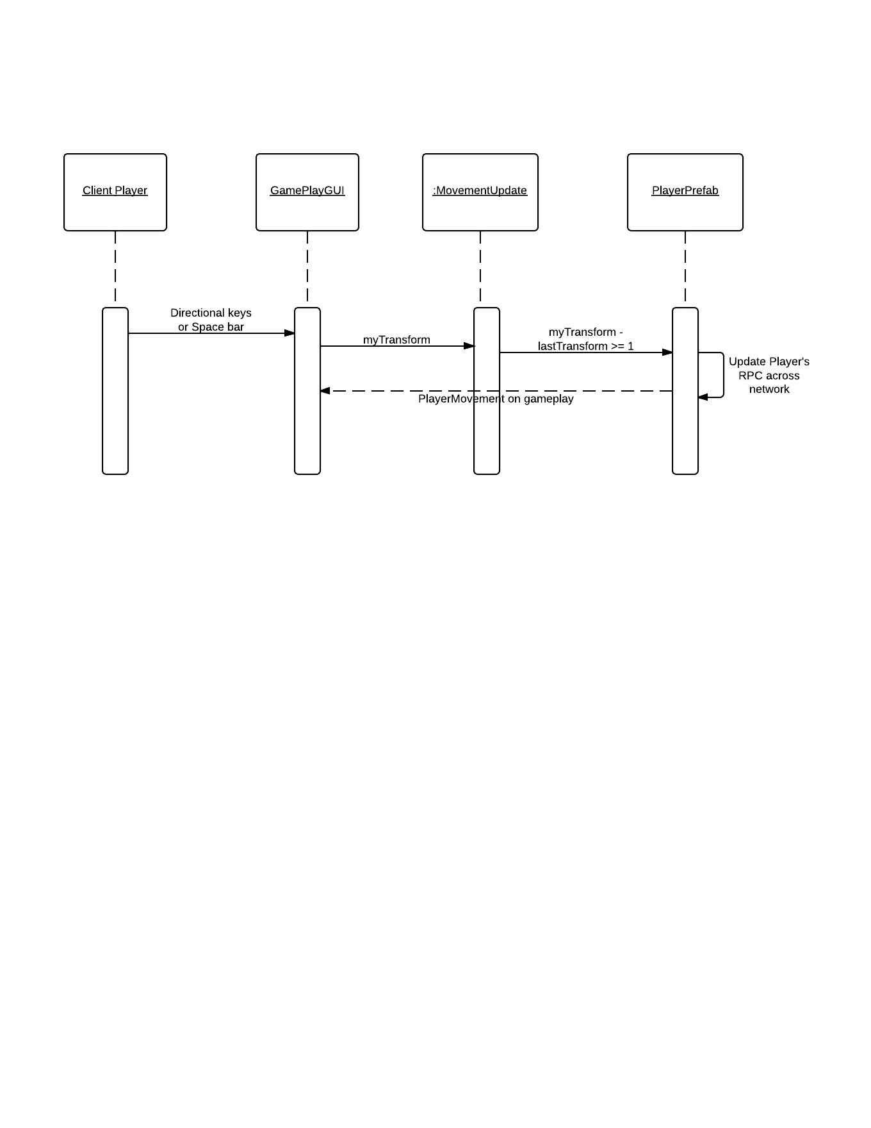

### 5.4.3 Module 3: Fire Bullet

While playing the game, if the player presses the mouse0 button then the FireBullet object instantiates a bullet from the bullet prefab. If the bullet hits some gameObject then the explosion effect is carried out and if the hit gameObject is of opponent team; then his health is reduced from the Health object.

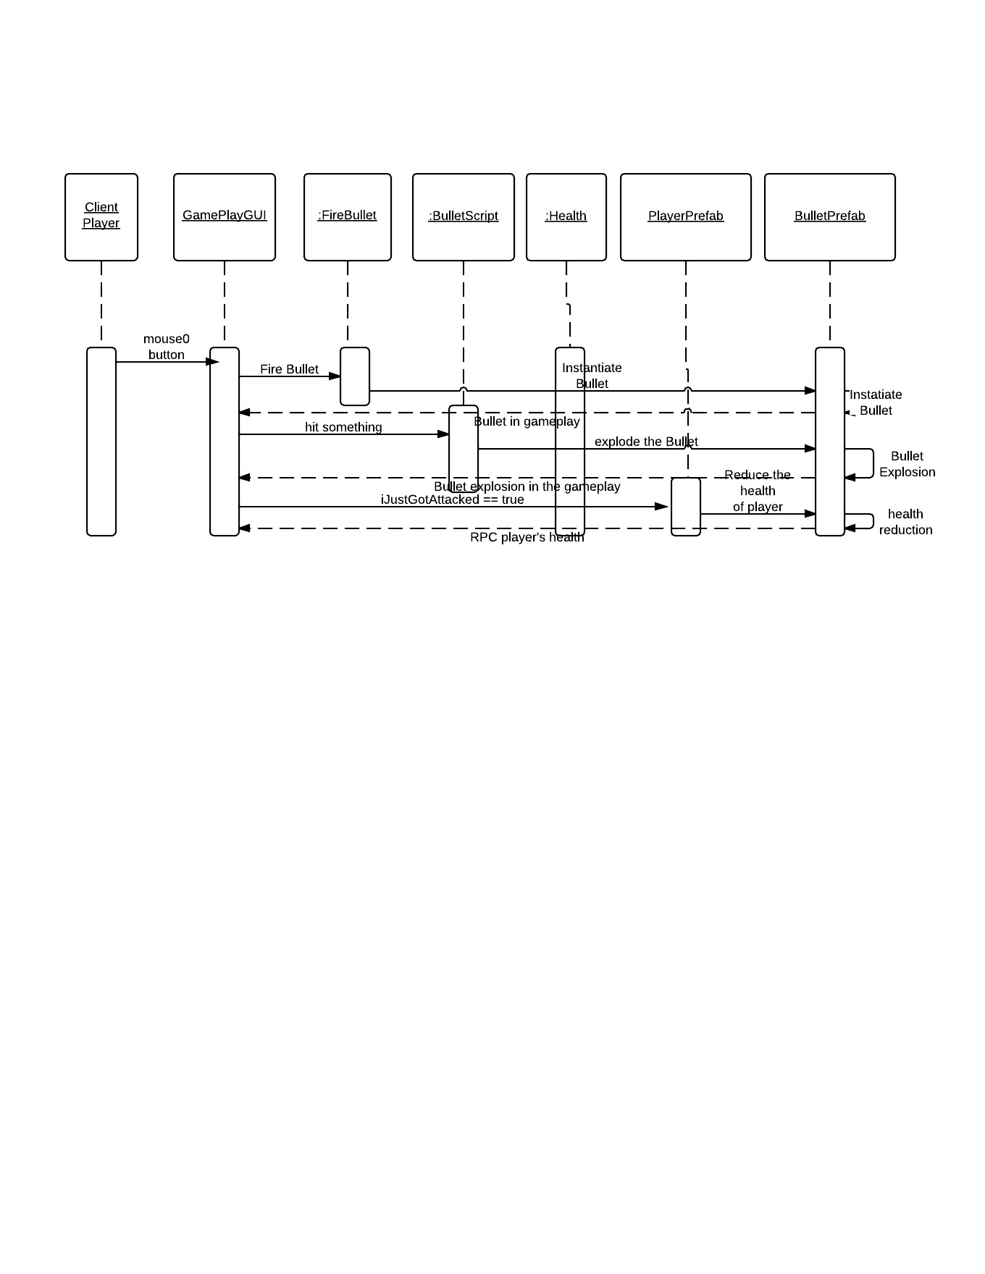

### 5.4.4 Module 4: View Score

When the player presses the view score button, the system shows the current score of the gameplay. When the button is released, the score table disappears.

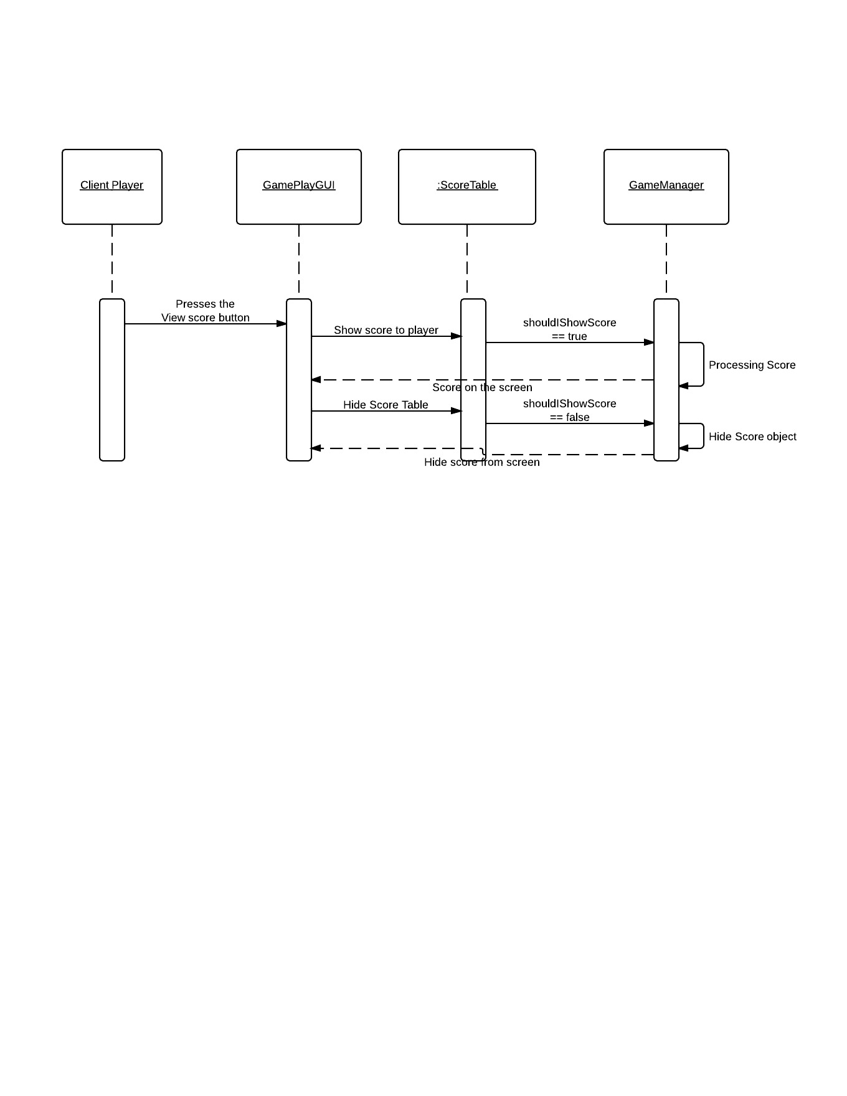

### 5.4.5 Module 5: Spawn into Game again

When the player is destroyed, the game window will show a “Respawn” button. When the player presses the button he is respawned into the game again.

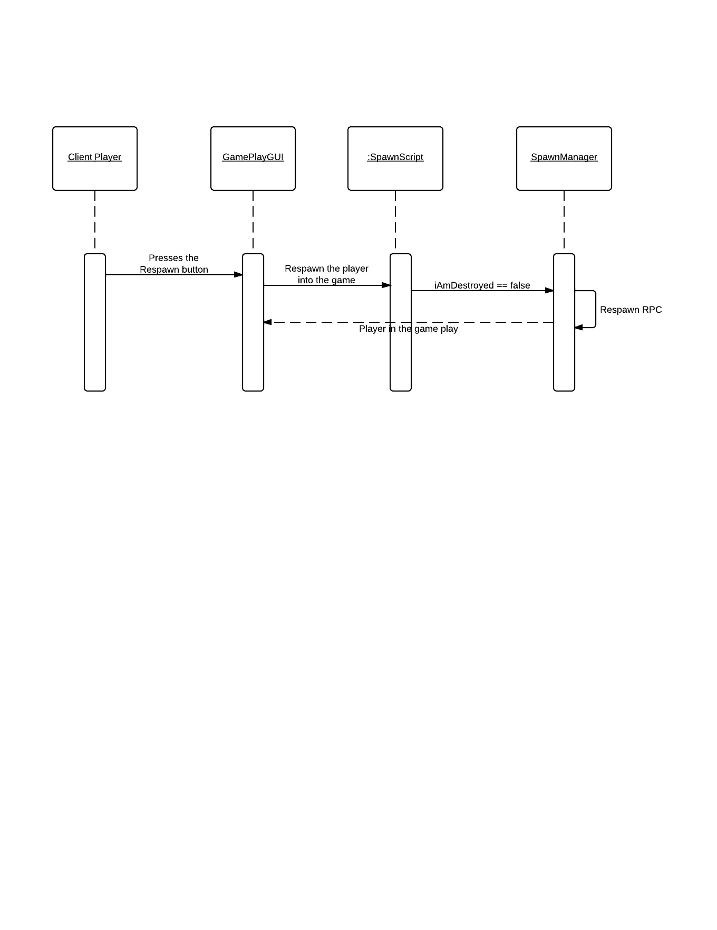

### 5.4.6 Module 6: Start or Stop the server

If the server operator wants to start up the server then he presses the start a server button, and enters the server name and Port number to use. Then the server is started.

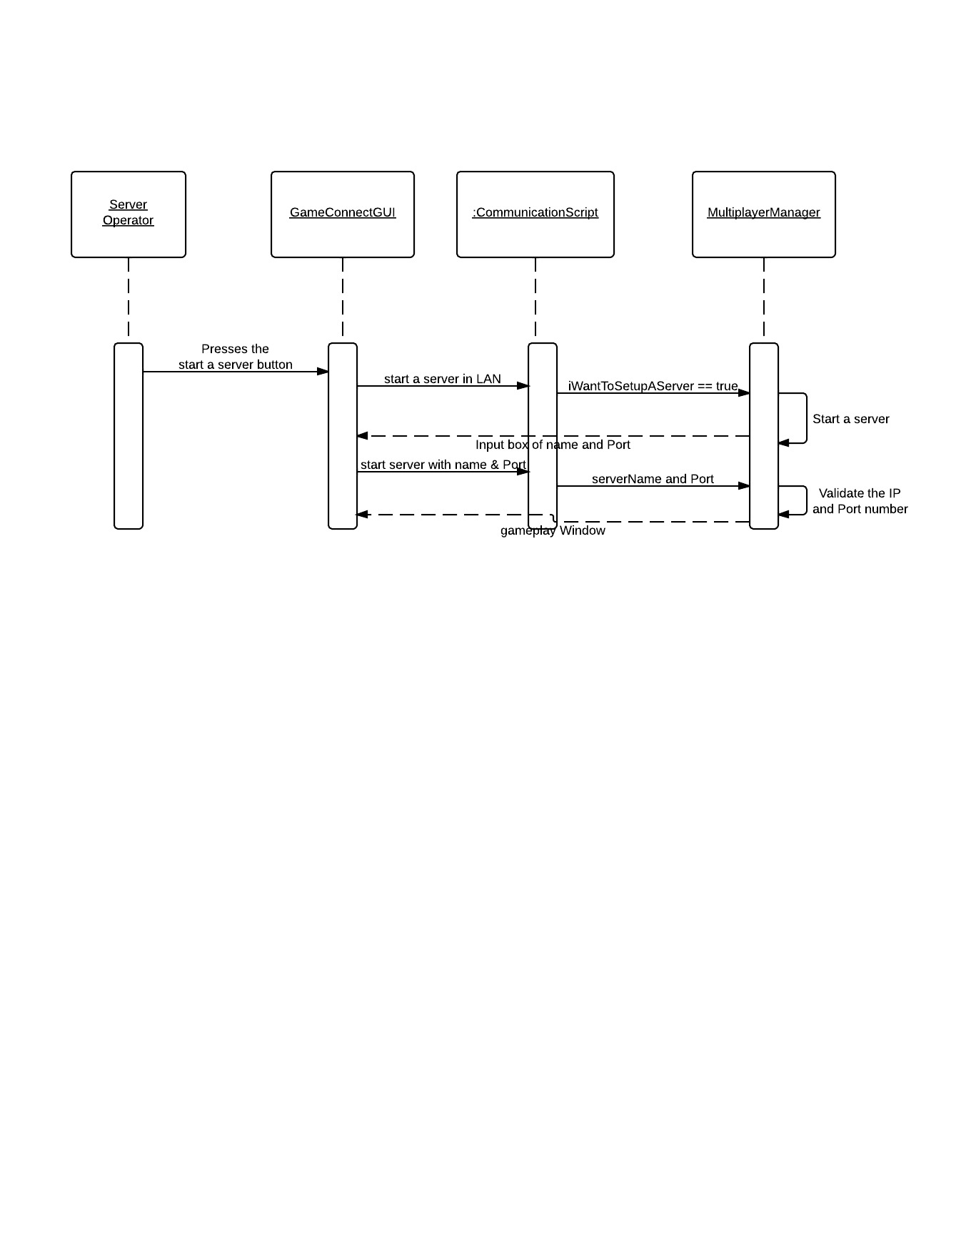

If the server operator wants to disconnect the running server, then he presses the “Disconnect” button. Then server is shutdown from his computer.

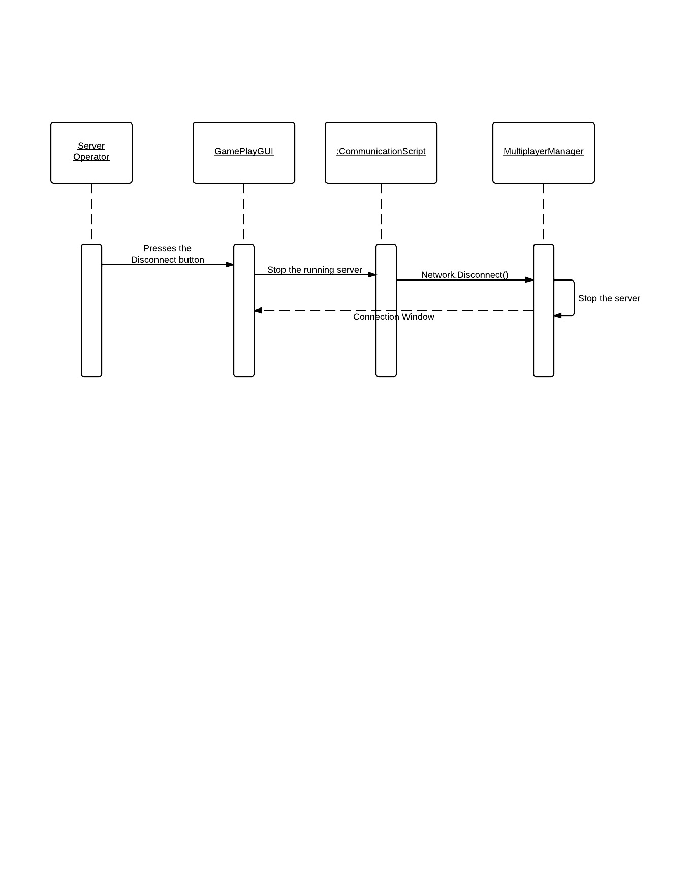

## 5.5 Statechart Diagram

### 5.5.1 BulletScript.cs

The BulletScript get active in the Bullet gameObject as soon as the Bullet is instantiated. When the Bullet his some gameObject it gives the Bullet Effect but if the hit object is of opposite team then the health of the player is reduced.

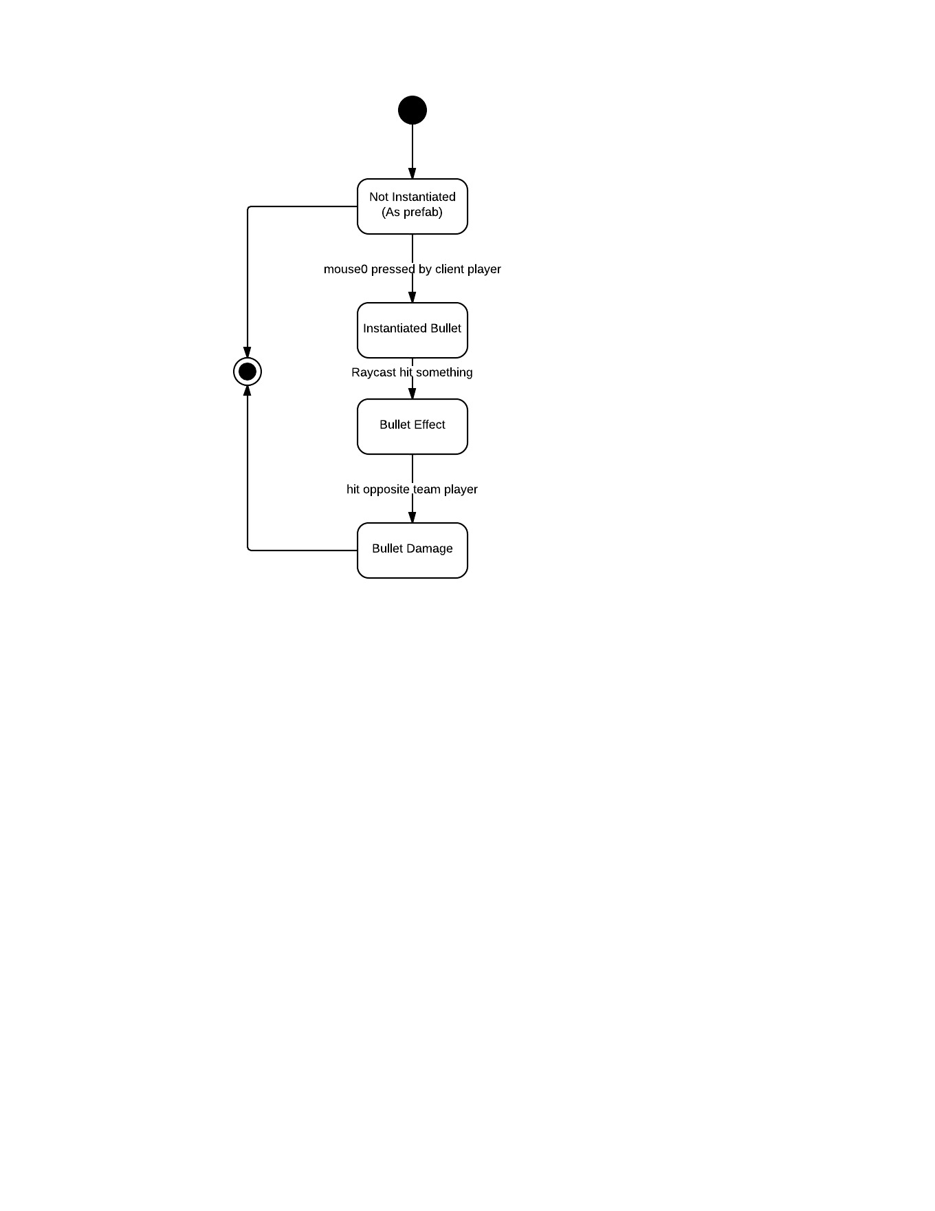

### 5.5.2 CameraMovement.cs

When the game is started in a player’s computer the CameraMovement finds the CameraHead gameObject and places the mainCamera there.

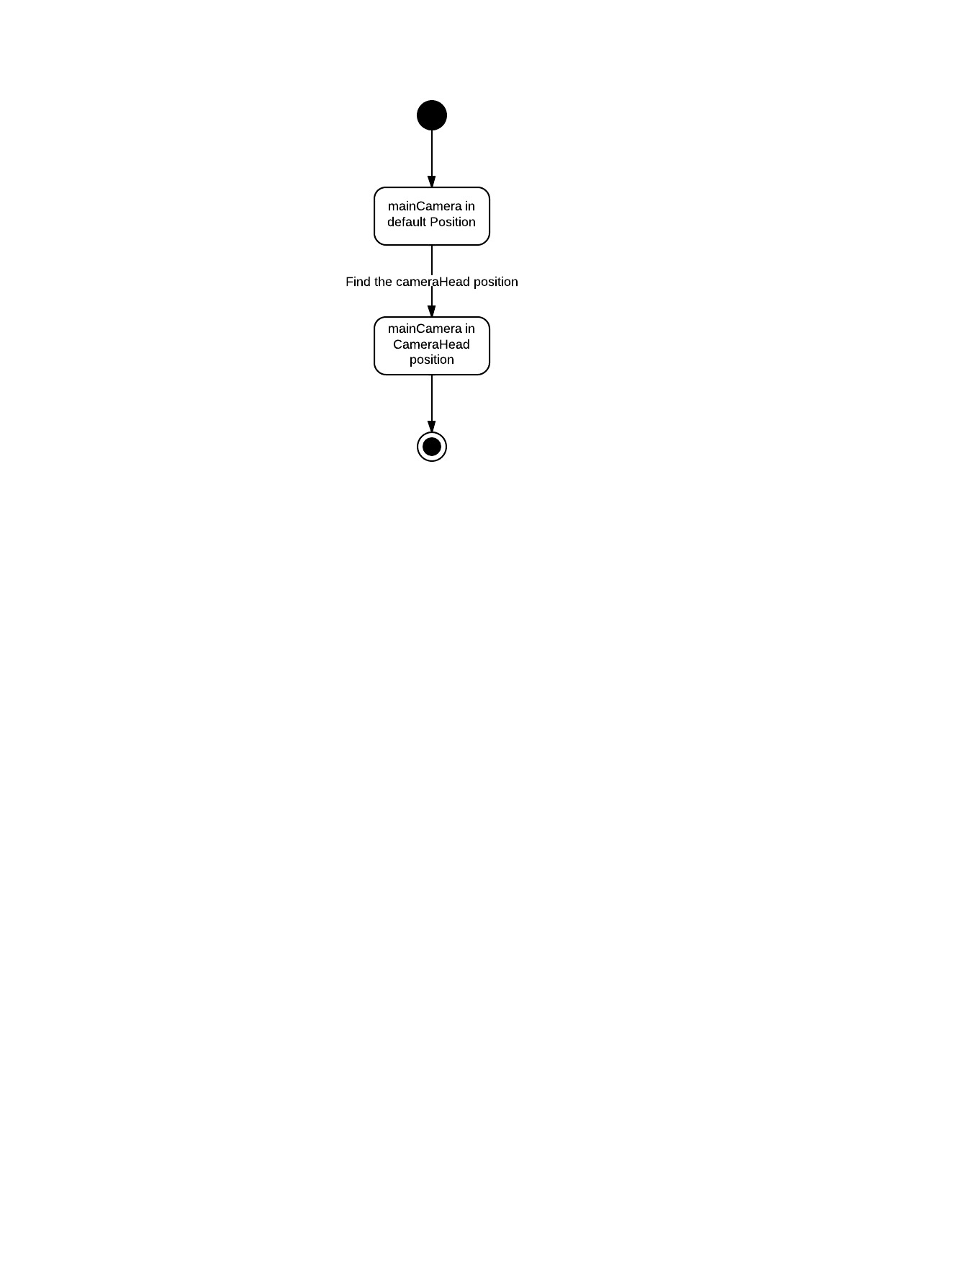

### 5.5.3 CommunicationScript.cs

The COmmunicationScript starts the game with the connection window, where the players can connect to a running server or create their own server.

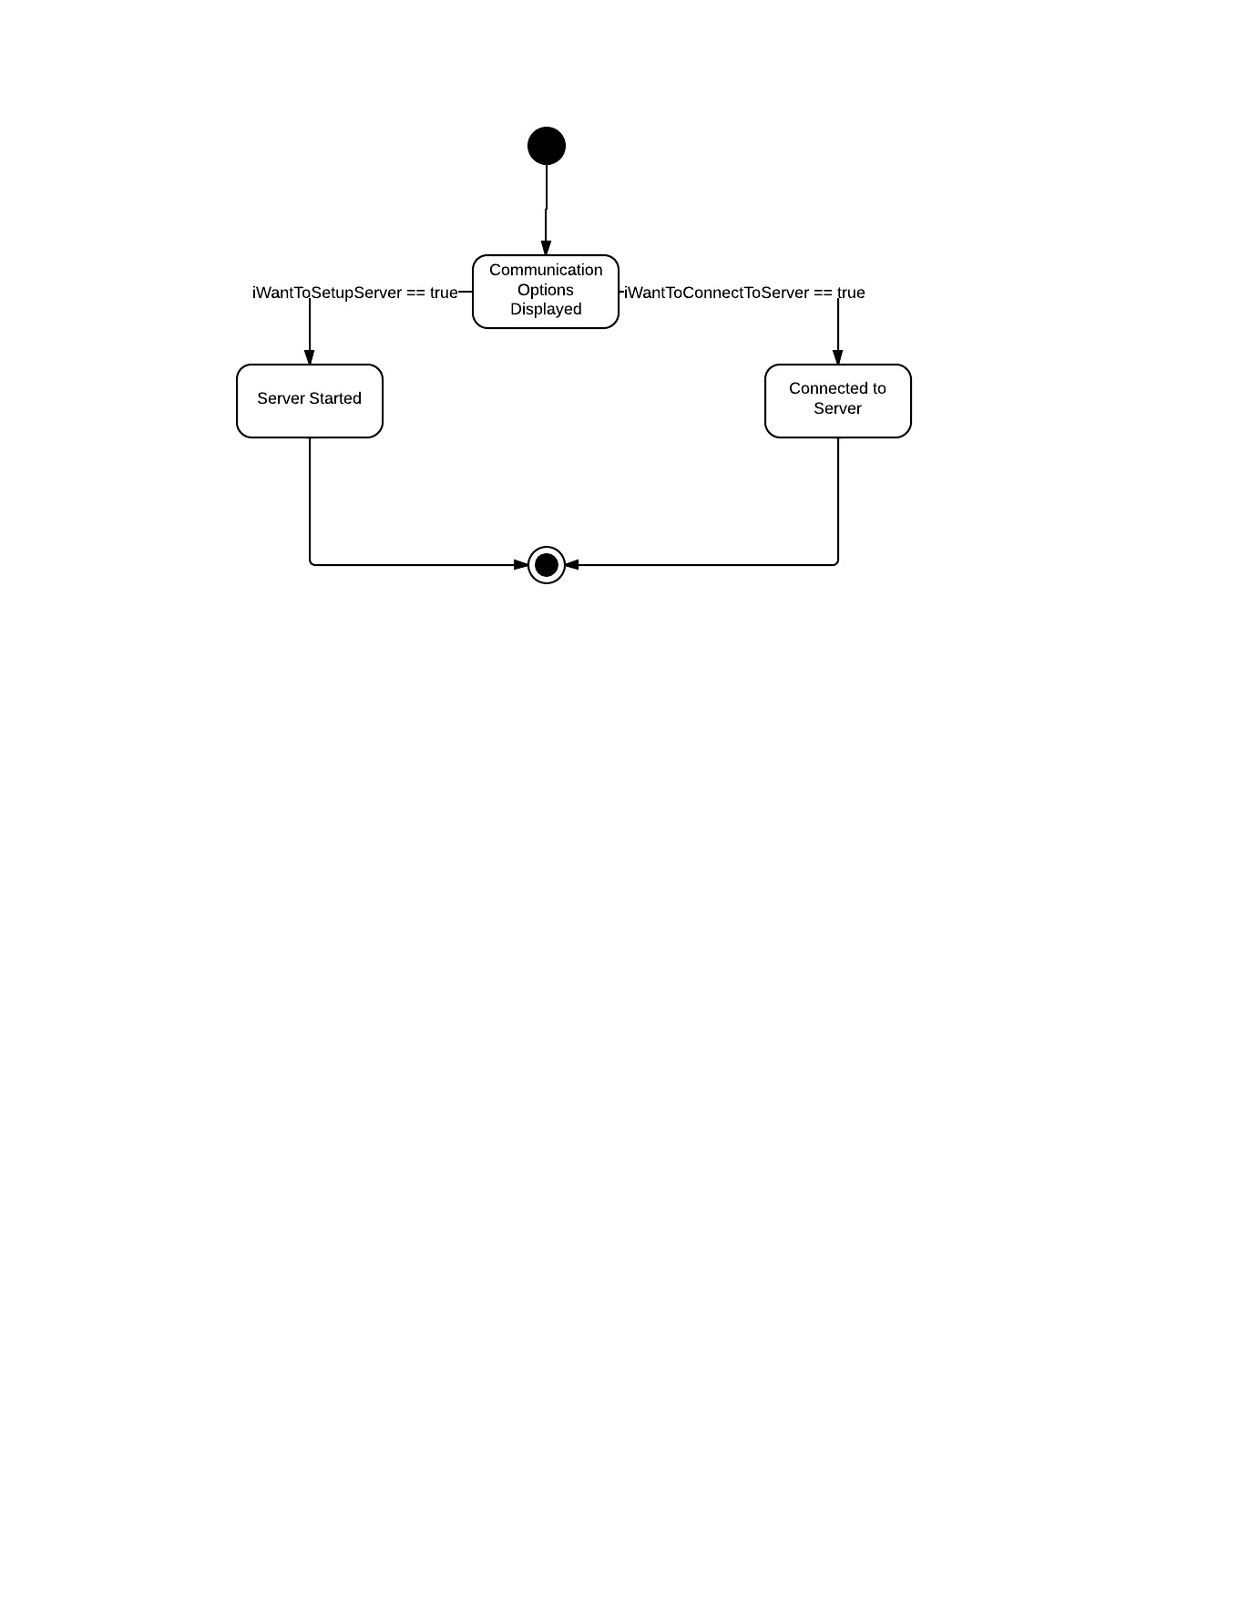

### 5.5.4 CursorControl.cs

This script helps the screen to be locked or not, when the game is started the script becomes disabled until the networkView == true.

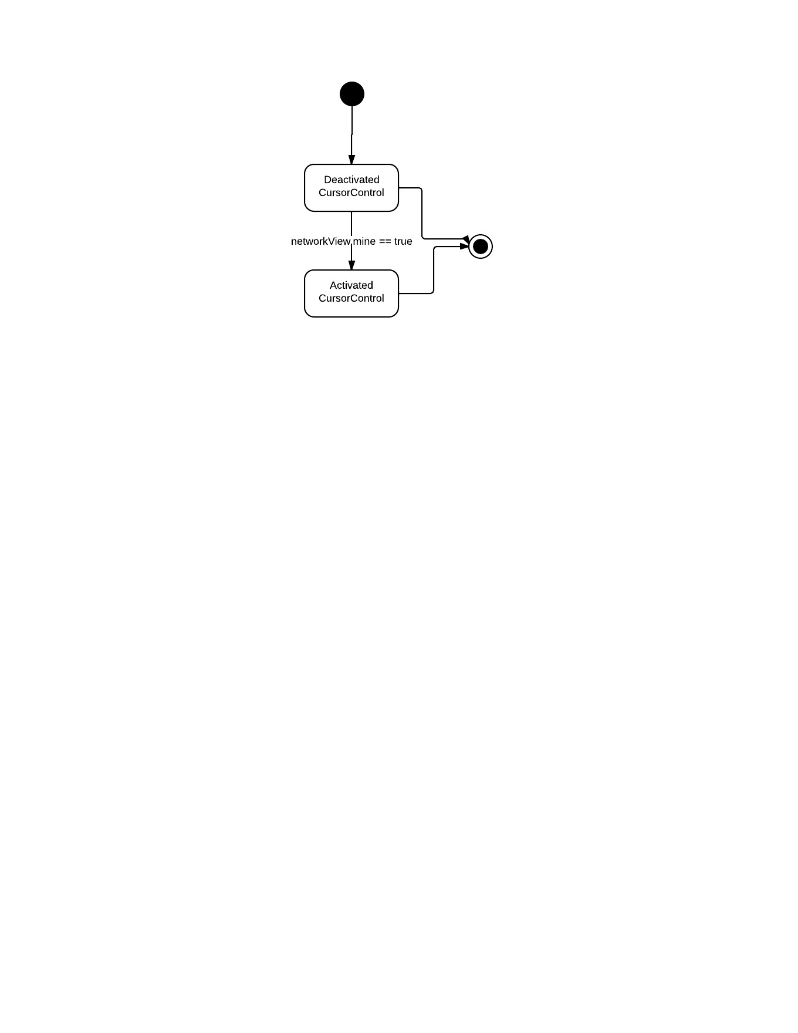

### 5.5.5 ExplosionDestruct.cs

When the Bullet hit a gameObject the Explosion effect script is activated for 1 secs and then it get destroyed.

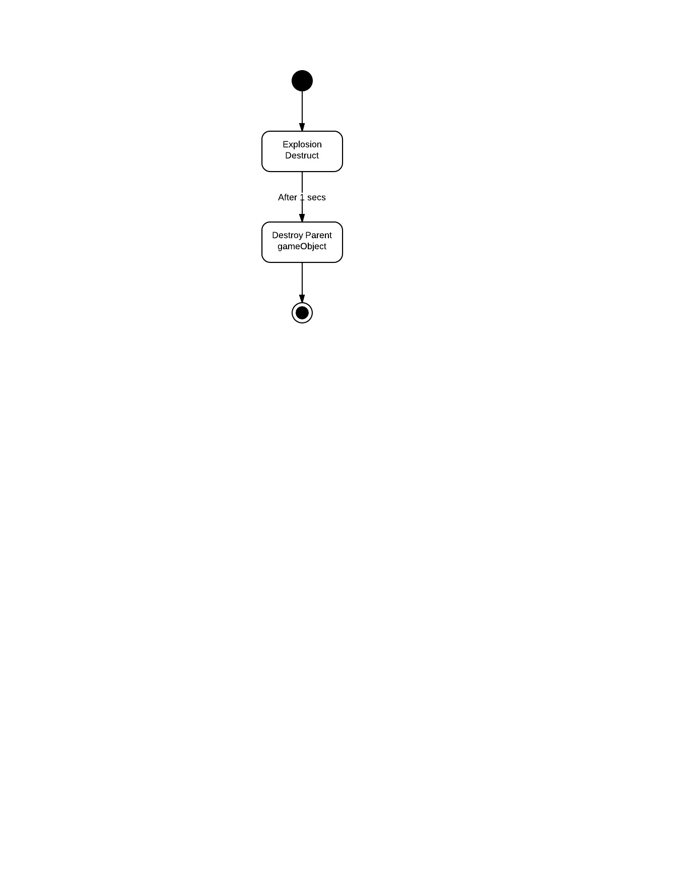

### 5.5.6 FireBullet.cs

The object is not activated until the game view is mine, when the player presses the mouse0 button the Bullet gets instantiated and the RPC is send to the network.

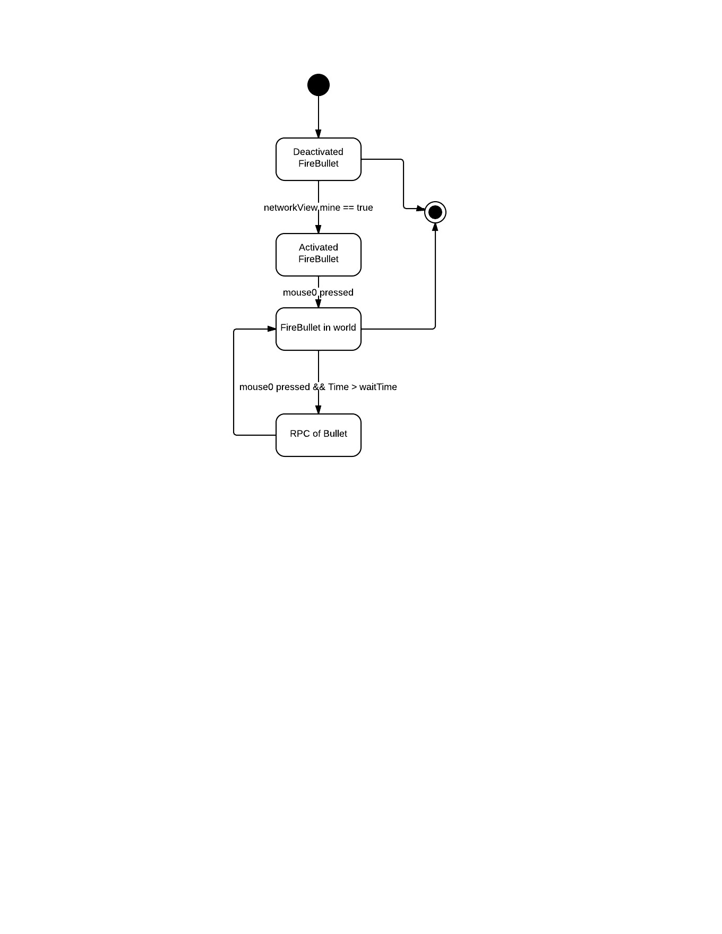

### 5.5.7 Health.cs

When the health object is instantiated the health parameter is set to 100, when it gets attacked by another opponent team player it reduces its health. And the health is also regenerated over time, whicle the health parameter is RPC to the network.

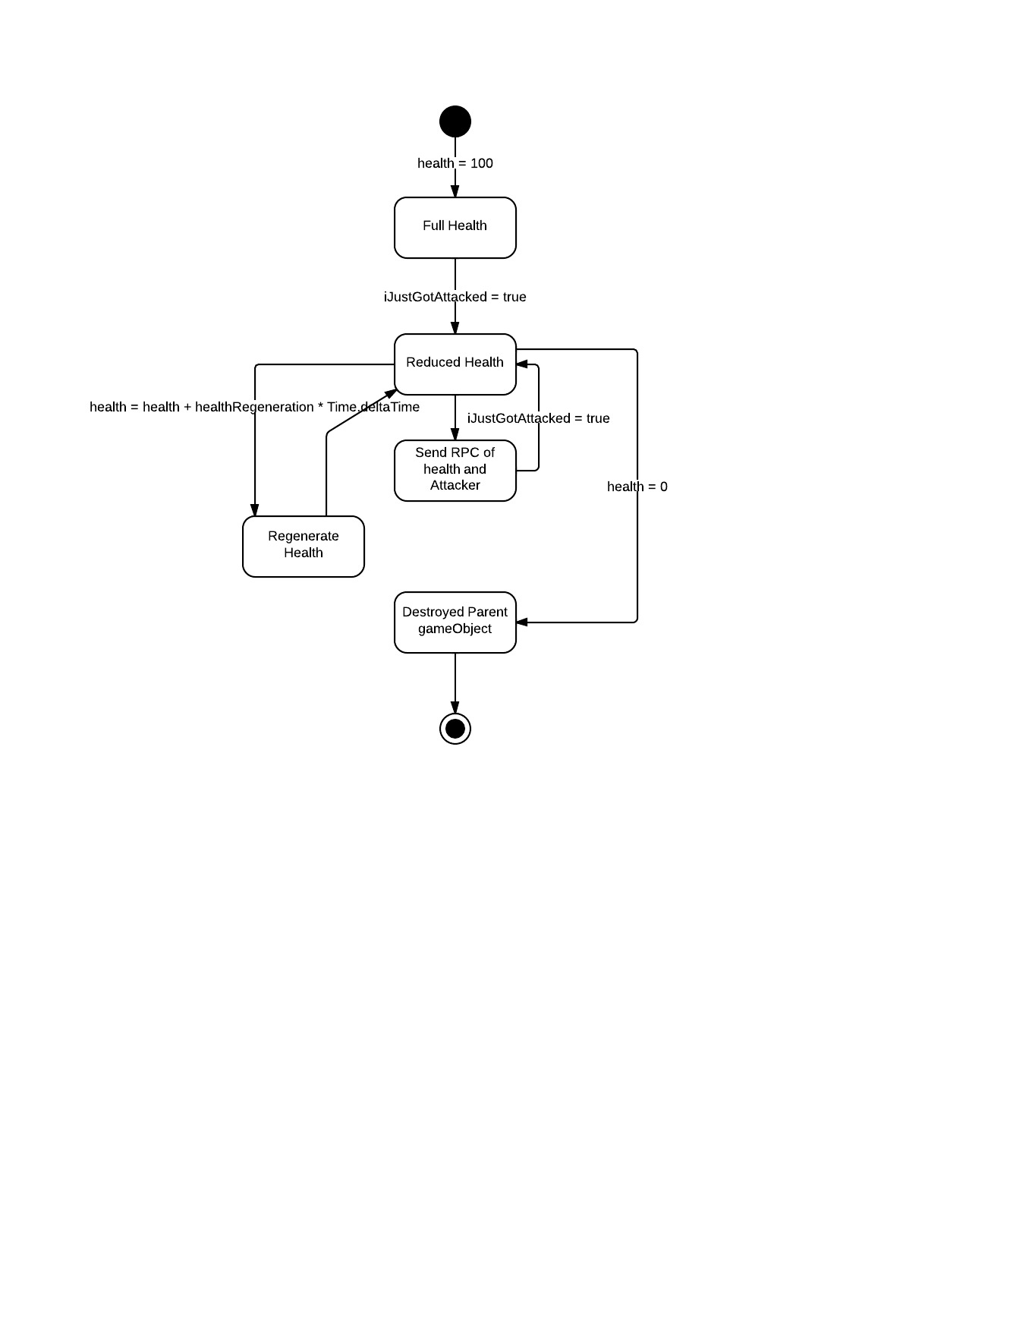

### 5.5.8 MovementUpdate.cs

This object gets active only if the network view is of the playing client.

If the player makes the noticeable movement then the RPC of the movement os made across the network. 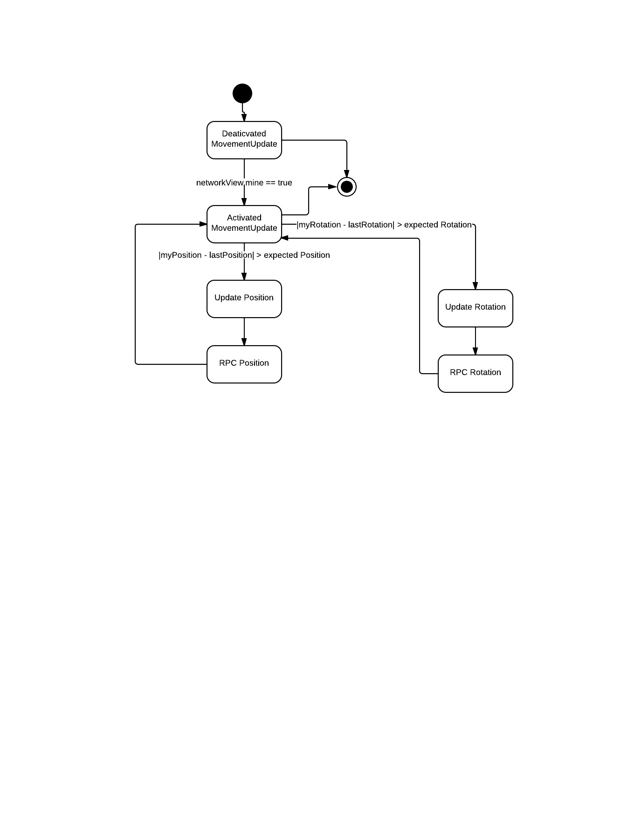

### 5.5.9 PlayerDatabase.cs

This object is responsible for updating the name, score and team of each player from their game instance. If the name, score or team parameter is changed then the RPC is made by this object to the network.

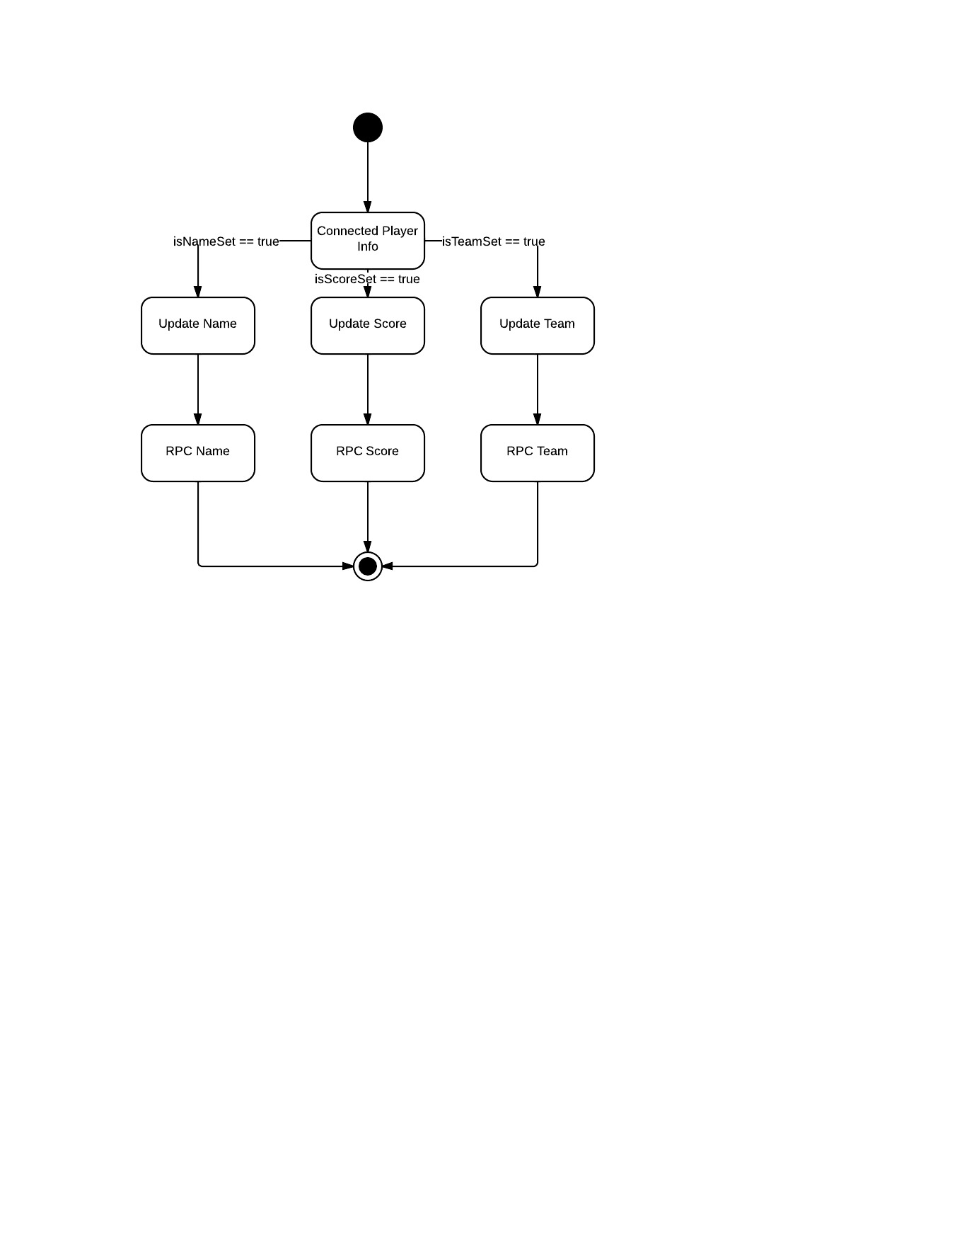

### 5.5.10 PlayerScore.cs

This script is activated if only the networkView is of the respective player. This object will update the score of itself in its own instance of game.

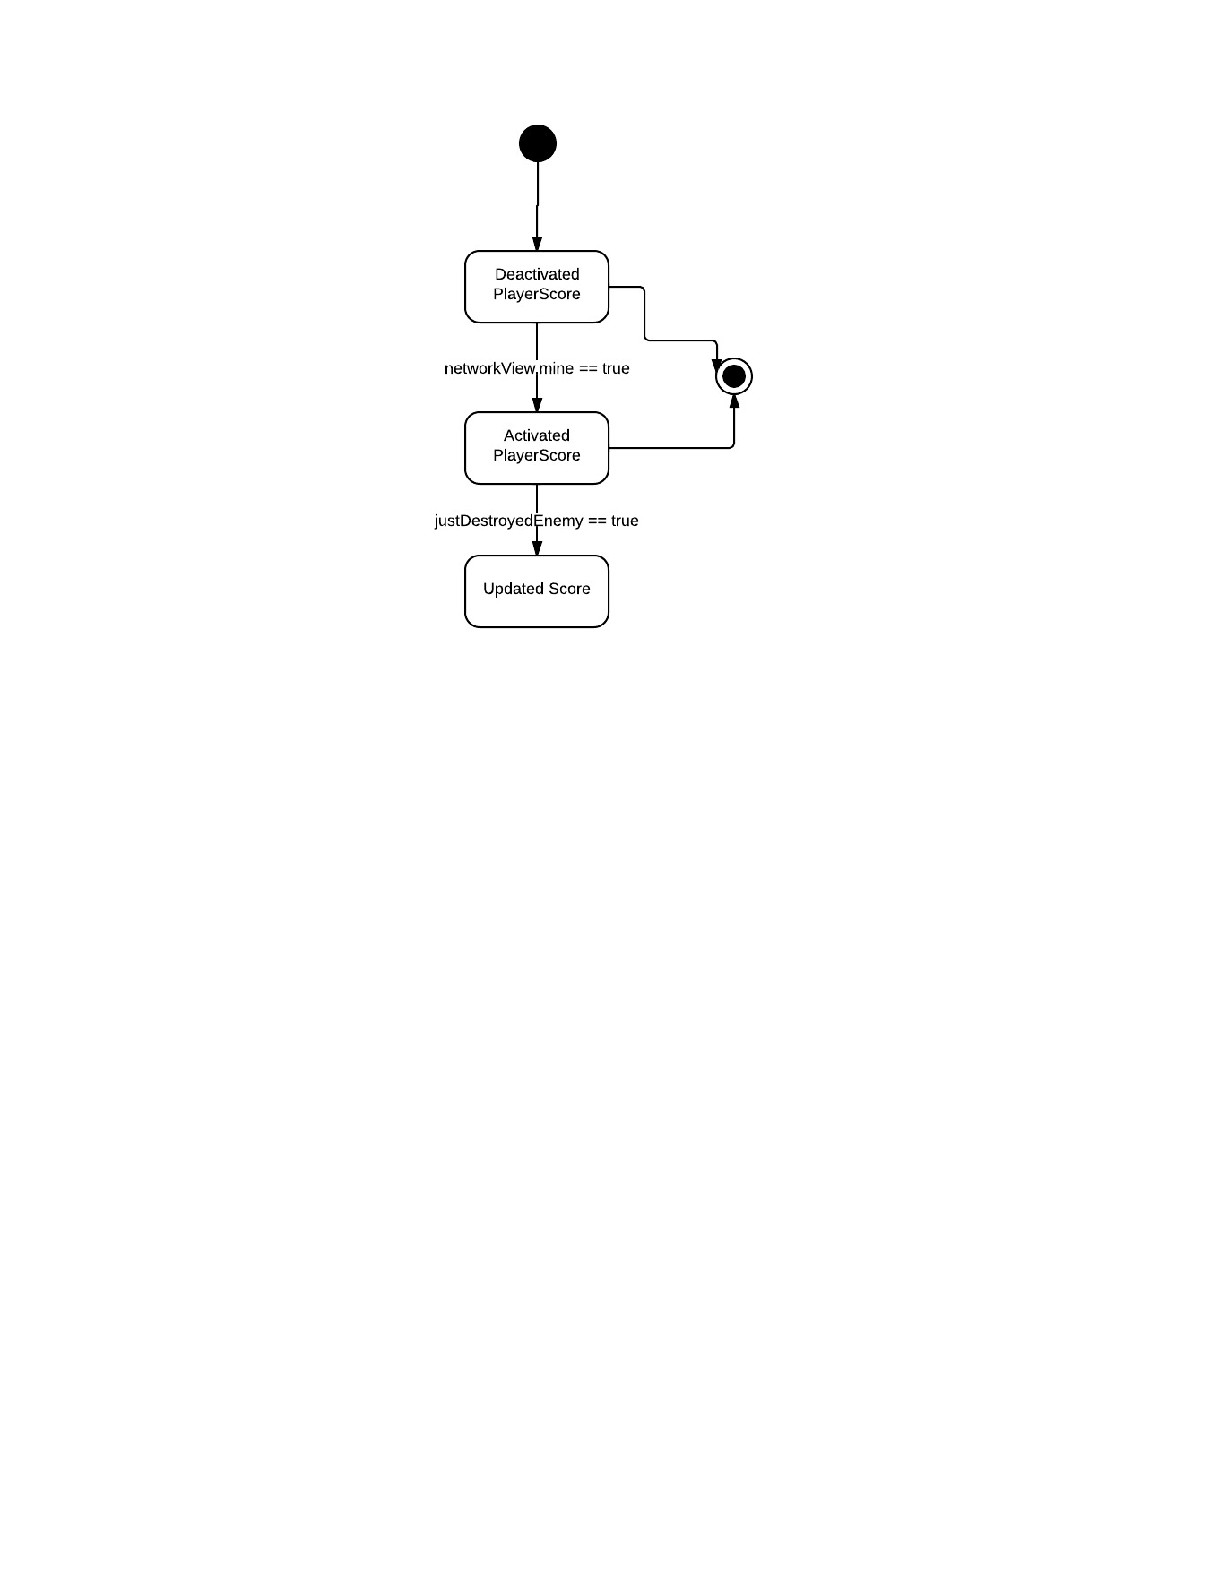

### 5.5.11 PlayerLabel.cs

This object will get activated only if the networkView is of the respective player. This object is responsible for showing the player label on the script every frame.

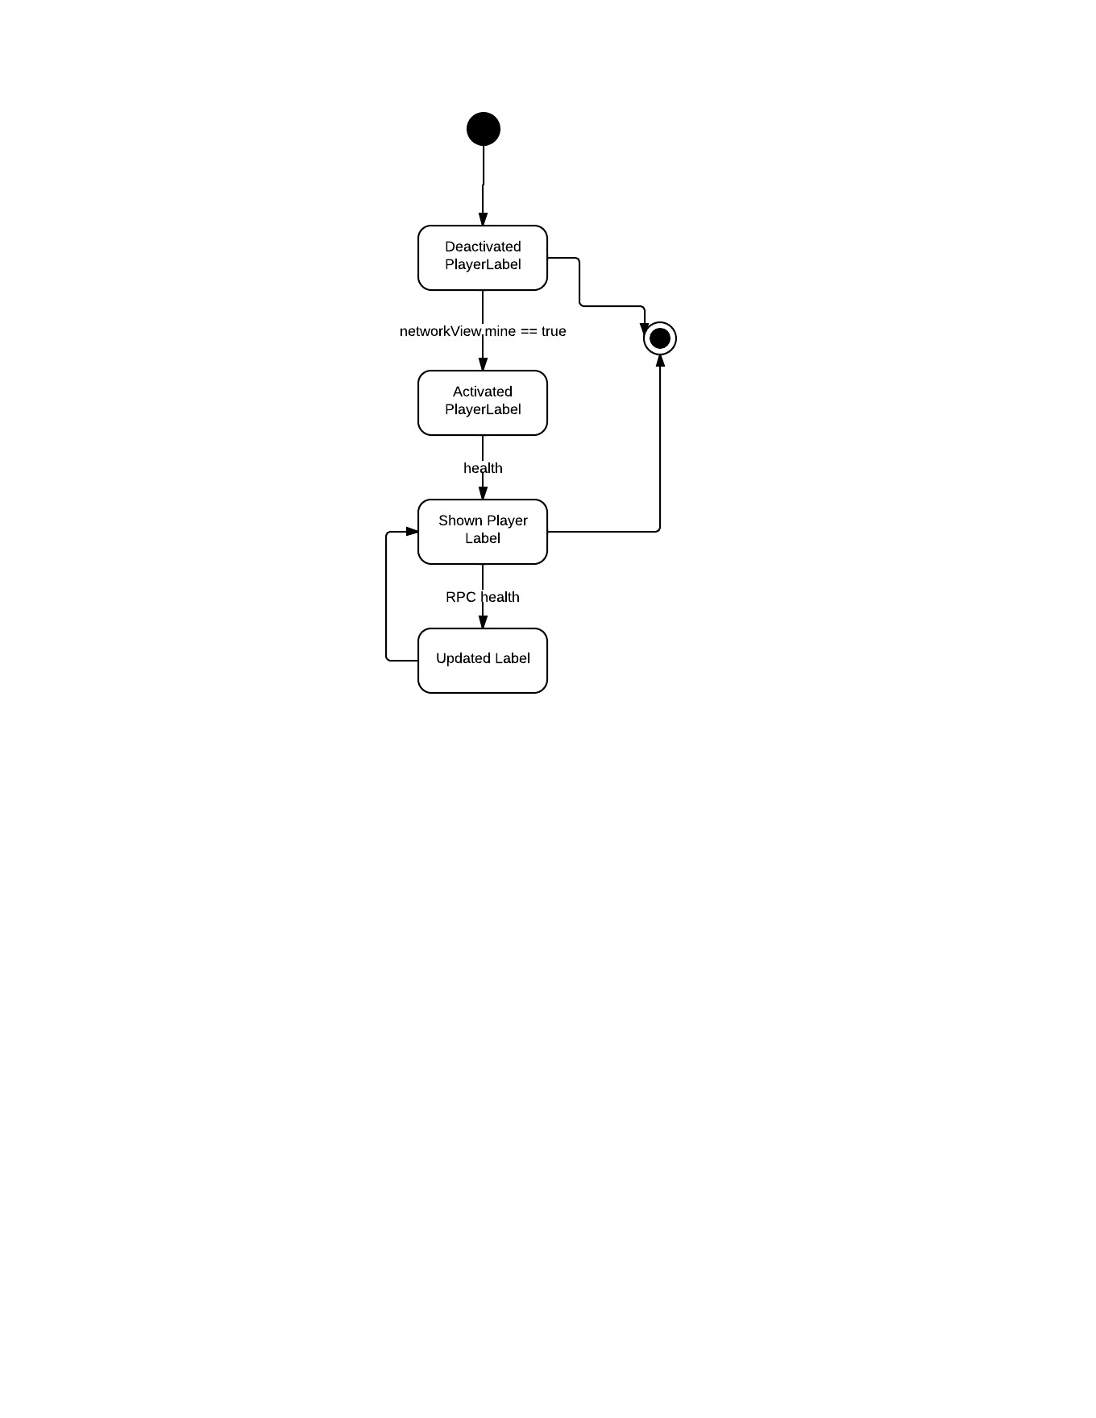

### 5.5.12 PlayerName.cs

This object is activated only if the networkView is of the respective player. If the player name is set then the player name is updated across the network via RPC.

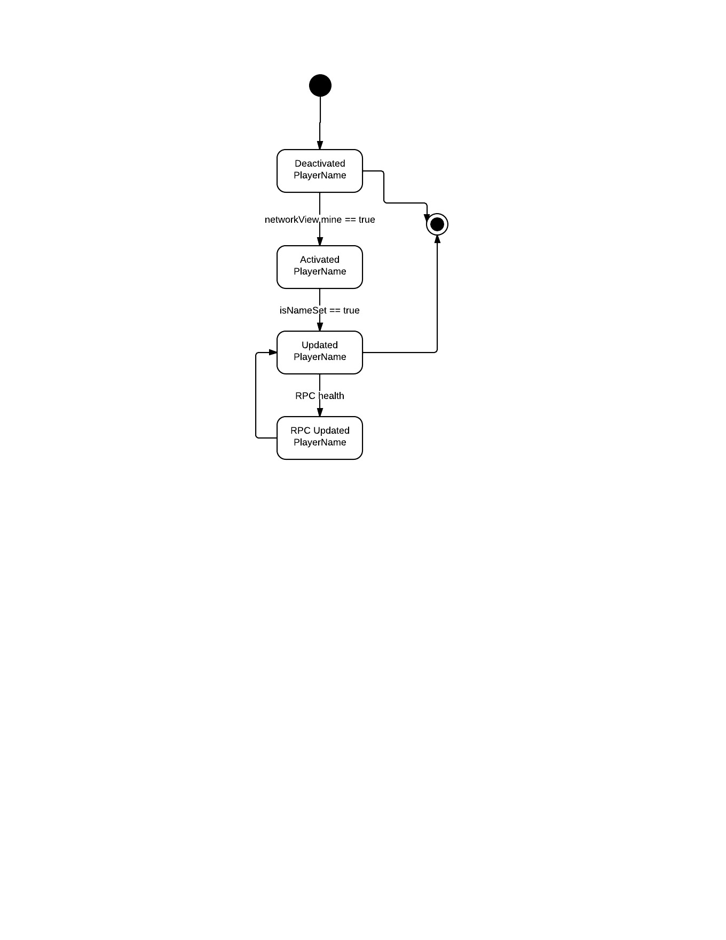

### 5.5.13 StatDisplay.cs

This object is activated only if the networkView is of the respective player. This script updates the health of the player and shows it on the screen each frame.

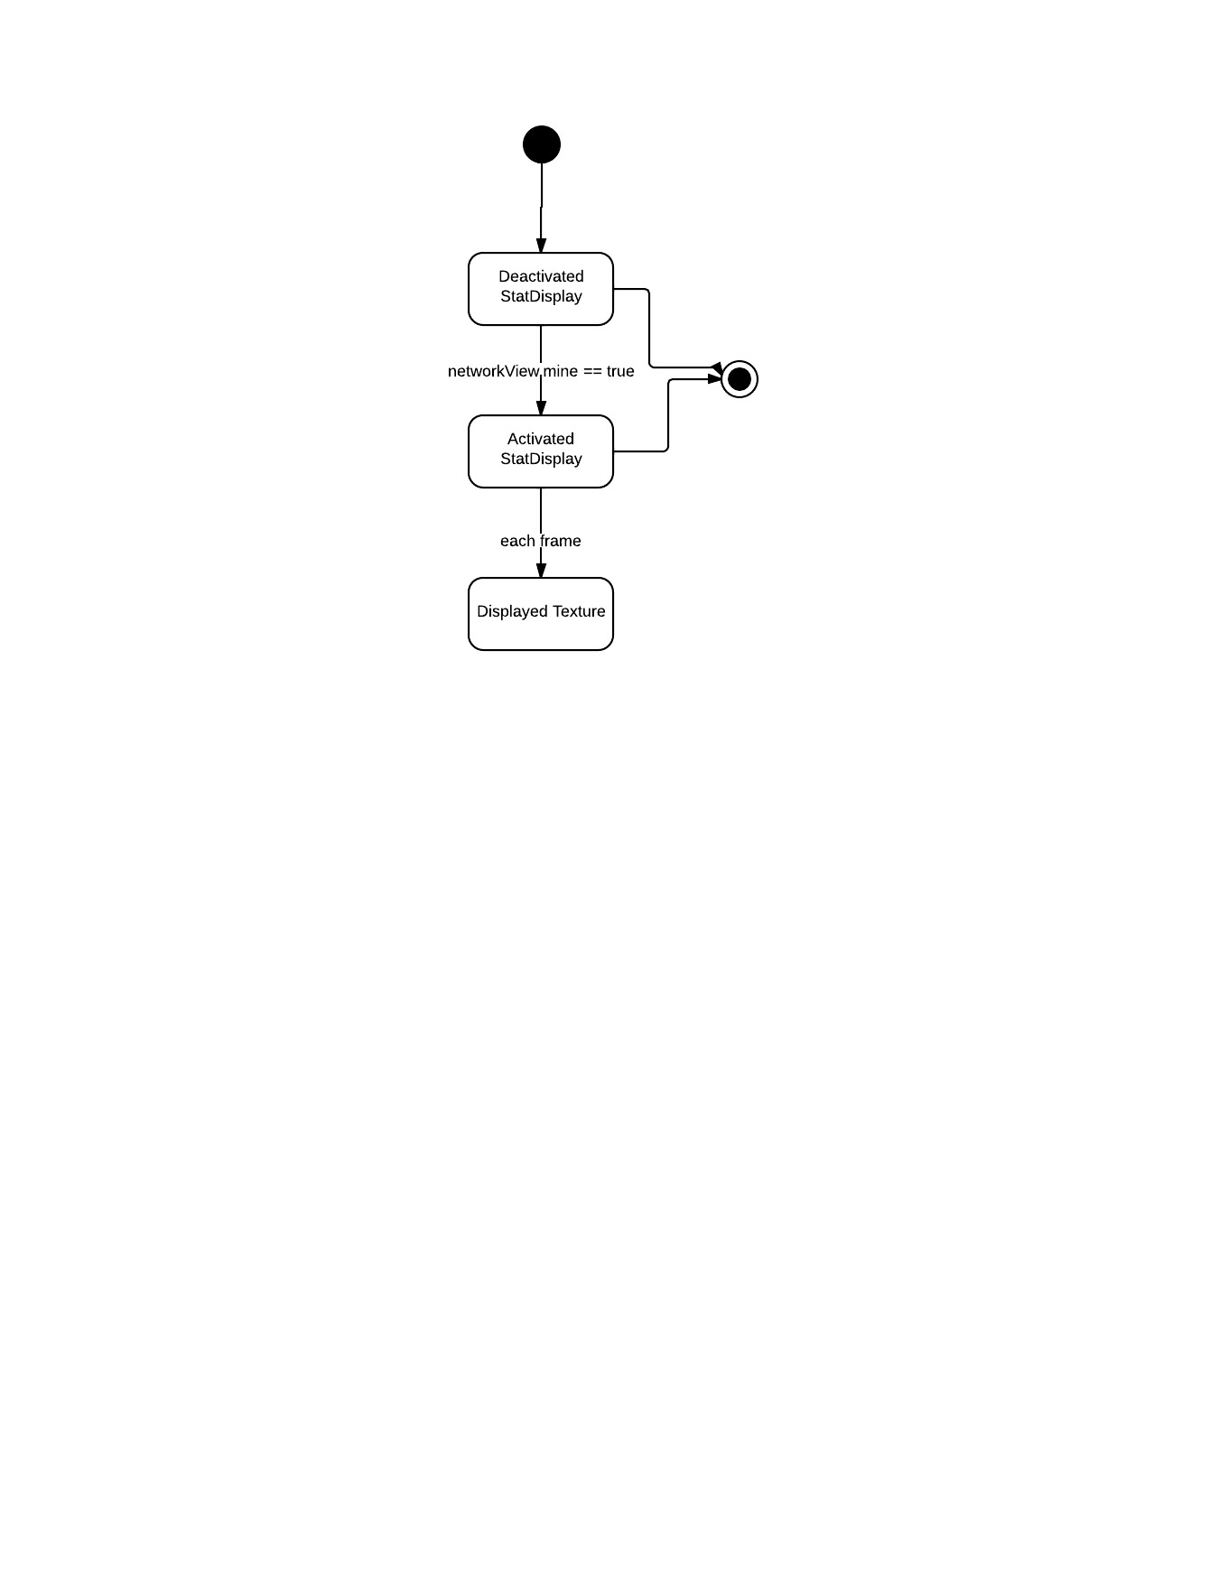

### 5.5.14 Target.cs

This script makes the target for the bullet to hit is shown on the screen. It is activated on the networkView of the respective player.

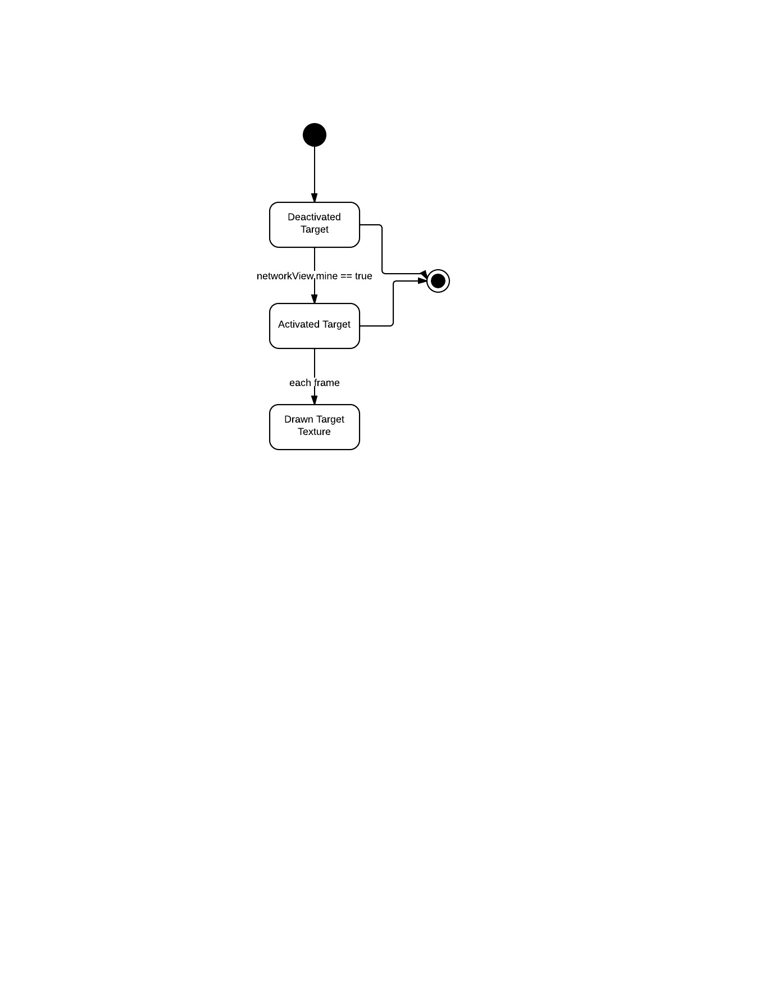

### 5.5.15 ScoreTable.cs

This object will show the score of the game as long as the show score button is pressed.

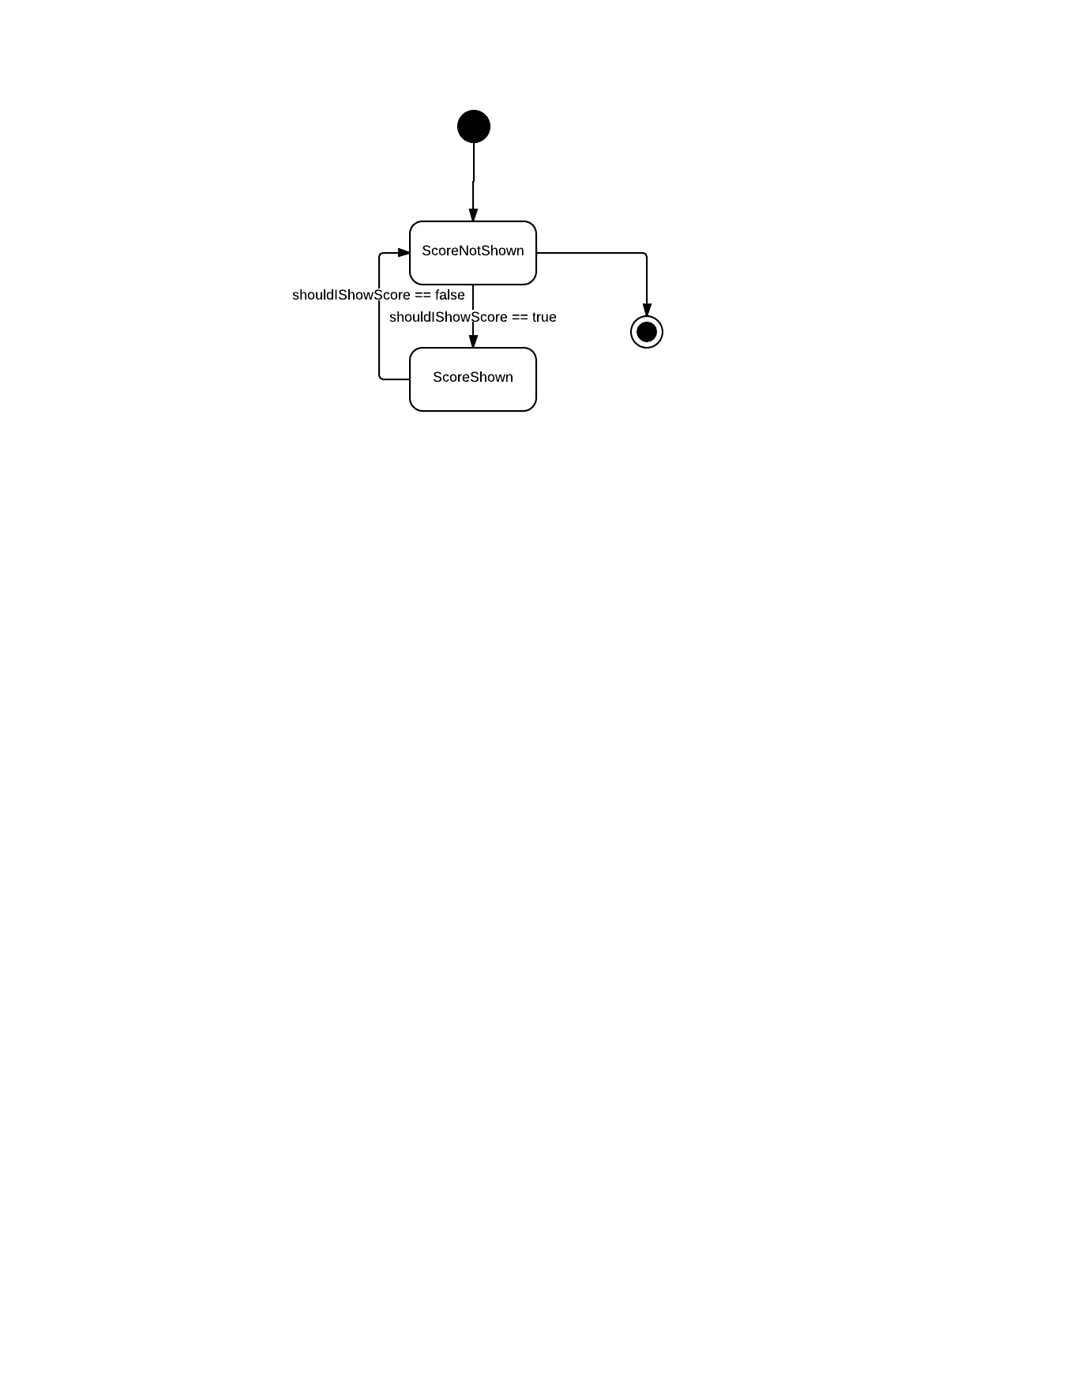

### 5.5.16 SpawnScript.cs

This object will spawn the player into the game again when the player is destroyed.

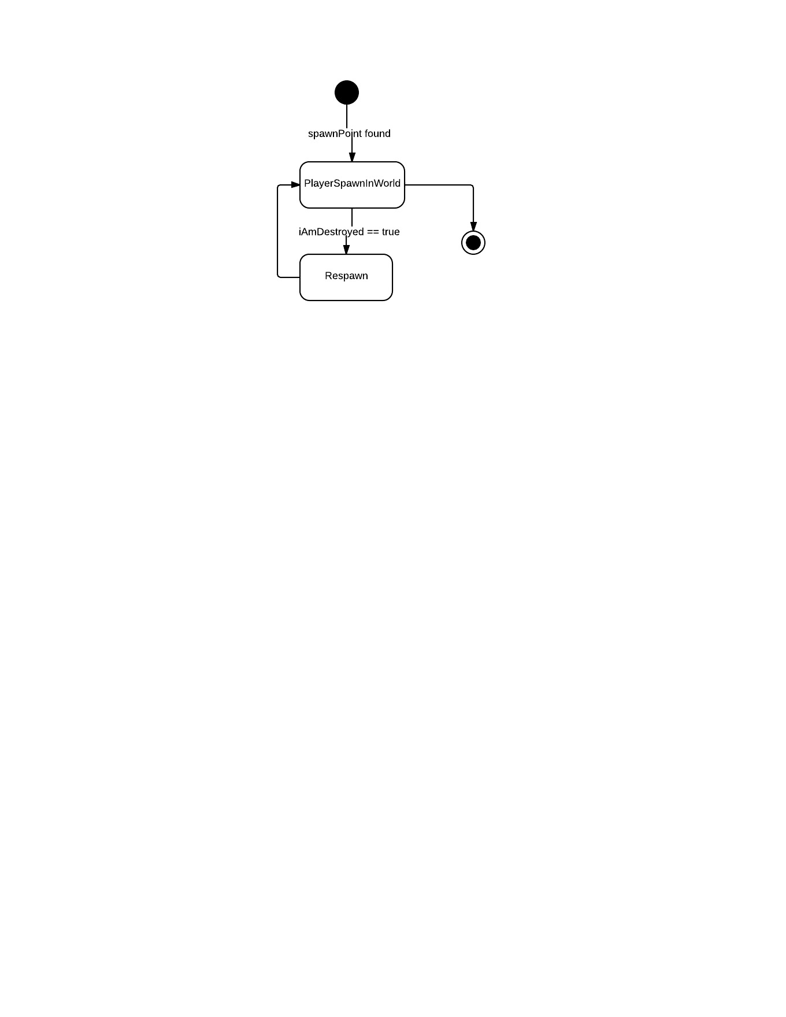

## 5.6 Activity Diagram

### 5.6.1 Server Connect and Disconnect

### 5.4.1 Module 1: Server Connect and Disconnect

When the client wants to connect to the server, he presses the connect button. The player inputs the name, IP and Port number of the server to connect, if it is valid the connect is established.

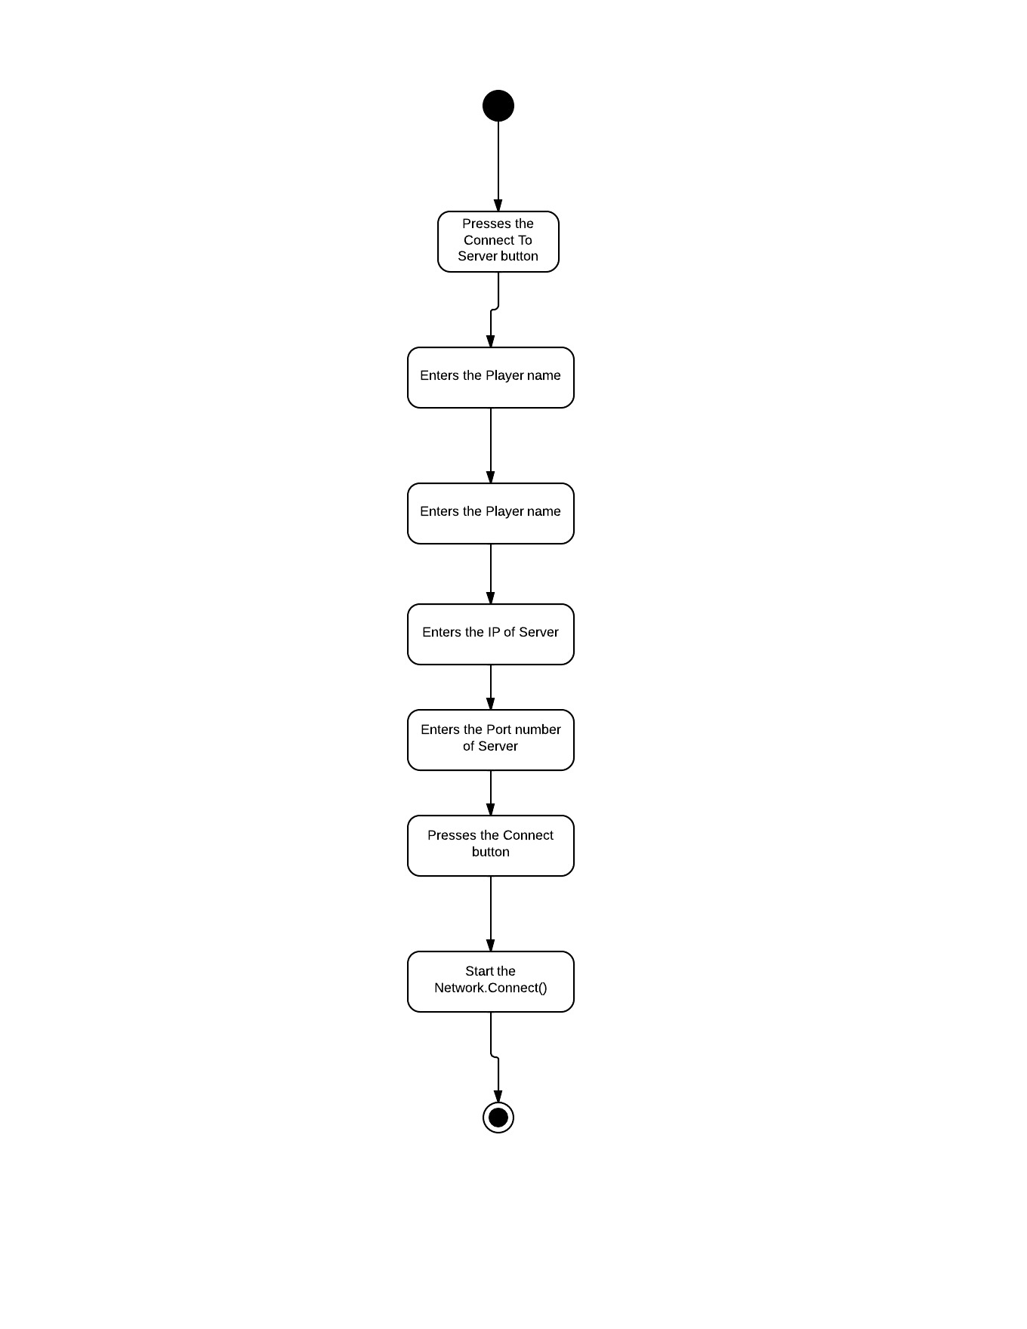

When the player presses the pause button, the game is paused with a disconnect window. If the player presses the Disconnect button, then he gets disconnected from the server.

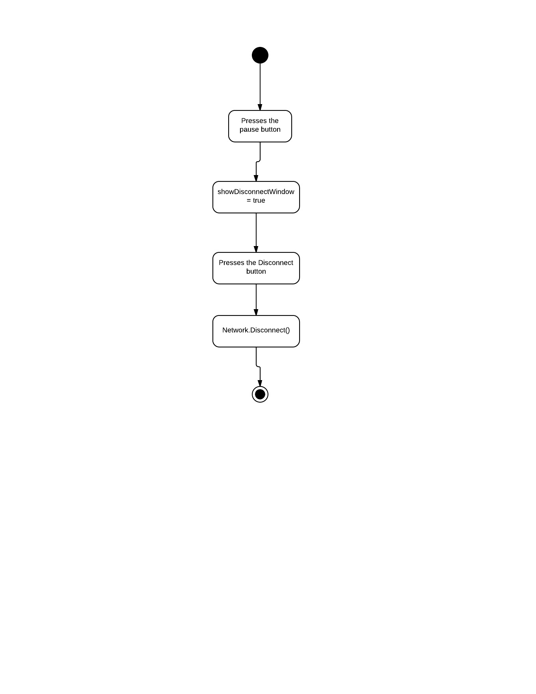

### 5.4.2 Module 2: Player Movement

If the client player presses the direction keys for movement or space bar for jumping, his transform gets altered. If the transform value is noticeable the object of MovementUpdate sends out a RPC to all the client player to update the new location of the current player.

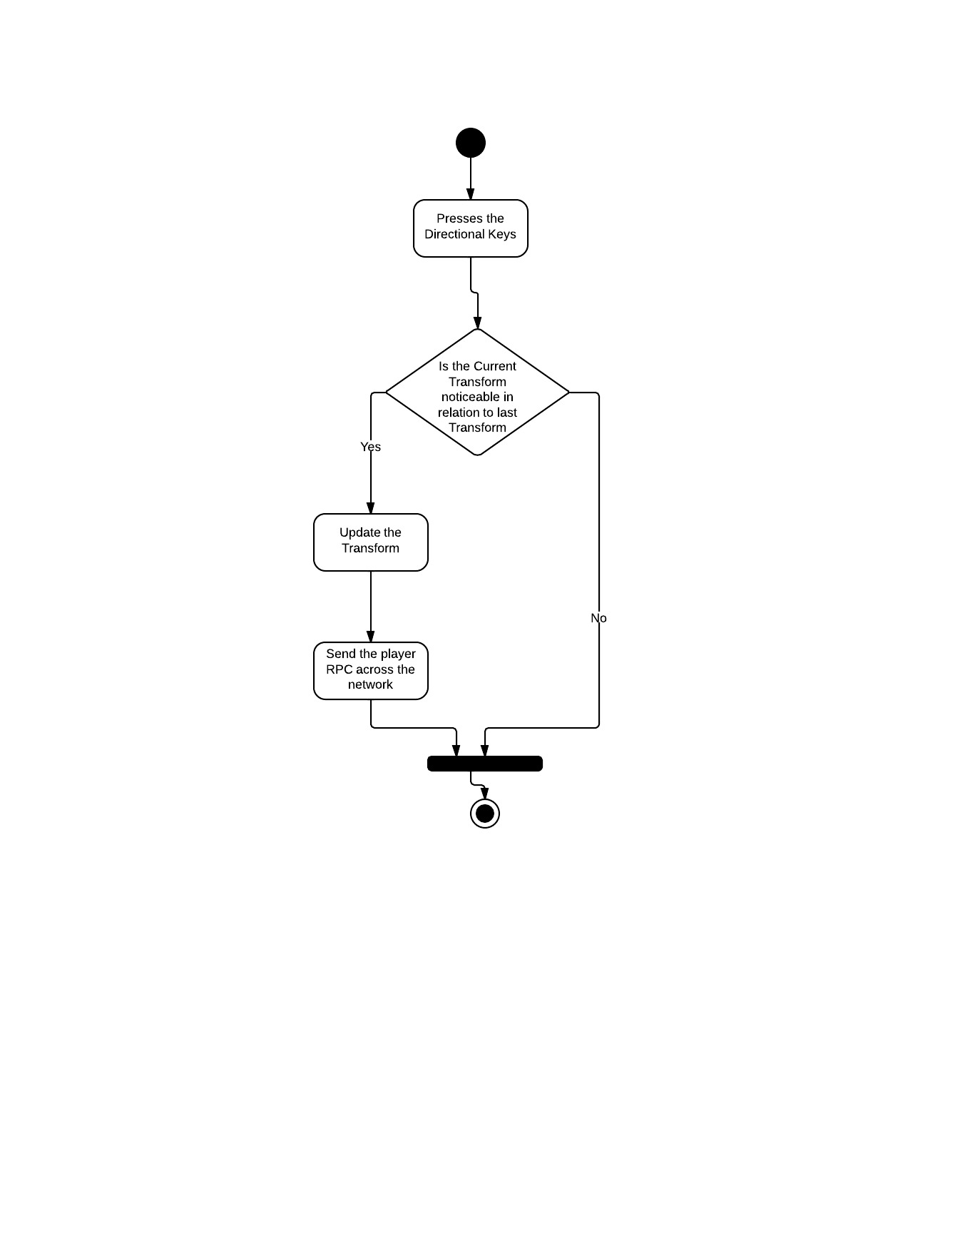

### 5.4.3 Module 3: Fire Bullet

While playing the game, if the player presses the mouse0 button and if the waiting time is over, then the FireBullet object instantiates a bullet from the bullet prefab. If the bullet hits some gameObject then the explosion effect is carried out and if the hit gameObject is of opponent team; then his health is reduced from the Health object.

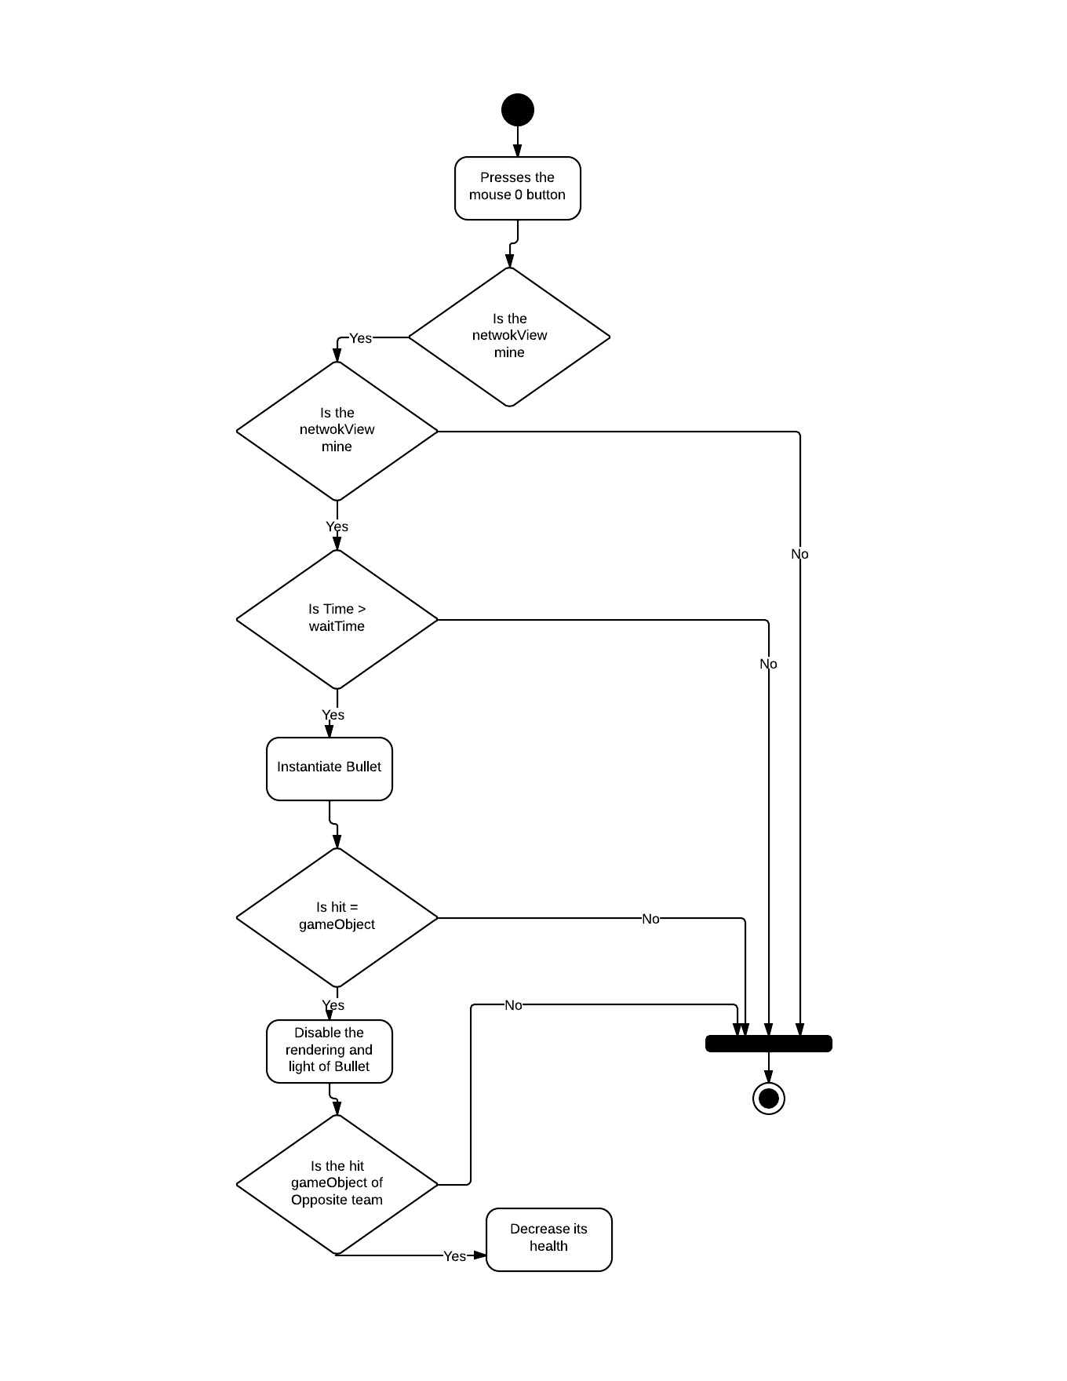

### 5.4.4 Module 4: View Score

When the player presses the view score button, the system shows the current score of the gameplay. When the button is released, the score table disappears.

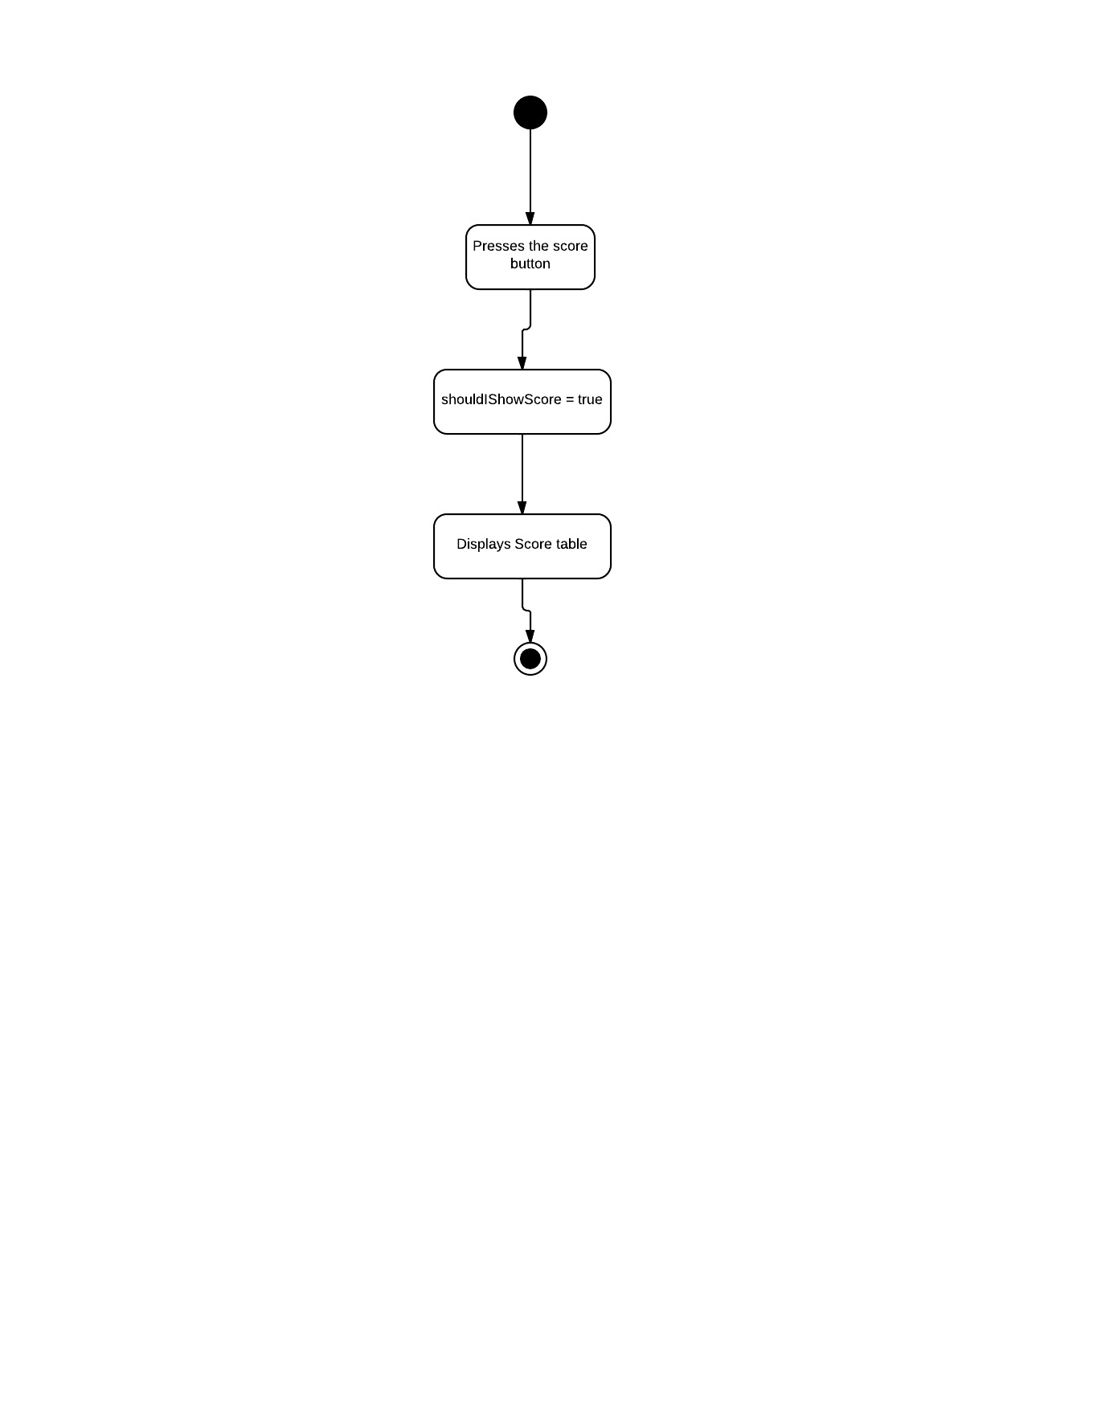

### 5.4.5 Module 5: Spawn into Game again

When the player is destroyed, the game window will show a “Respawn” button. When the player presses the button he is respawned into the game again.

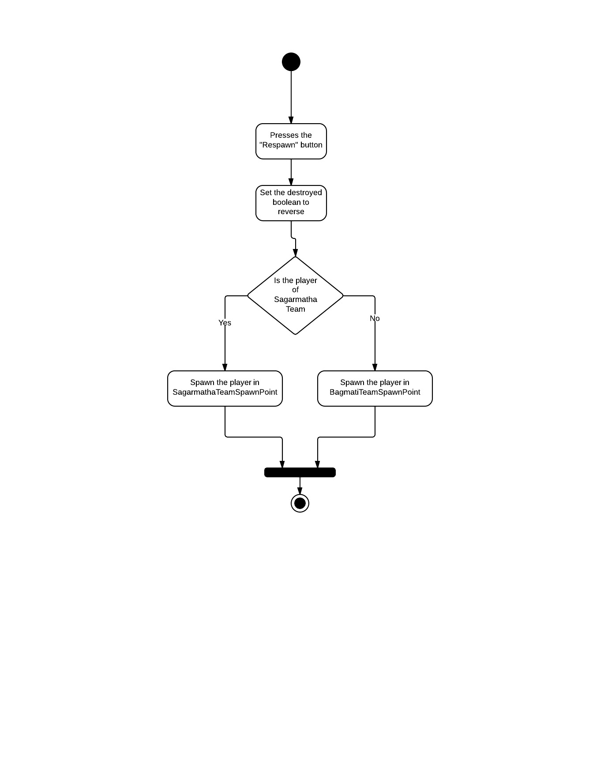

### 5.4.6 Module 6: Start or Stop the server

If the server operator wants to start up the server then he presses the start a server button, and enters the server name and Port number to use. Then the server is started.

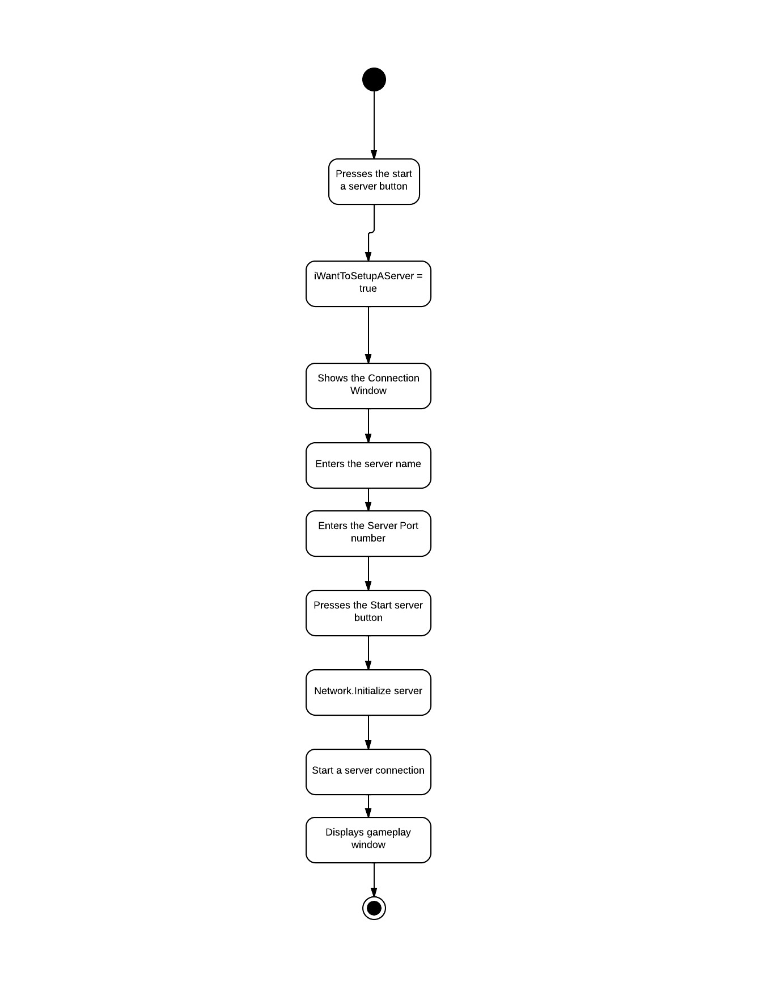

If the server operator wants to disconnect the running server, then he presses the “Disconnect” button. Then server is shutdown from his computer.

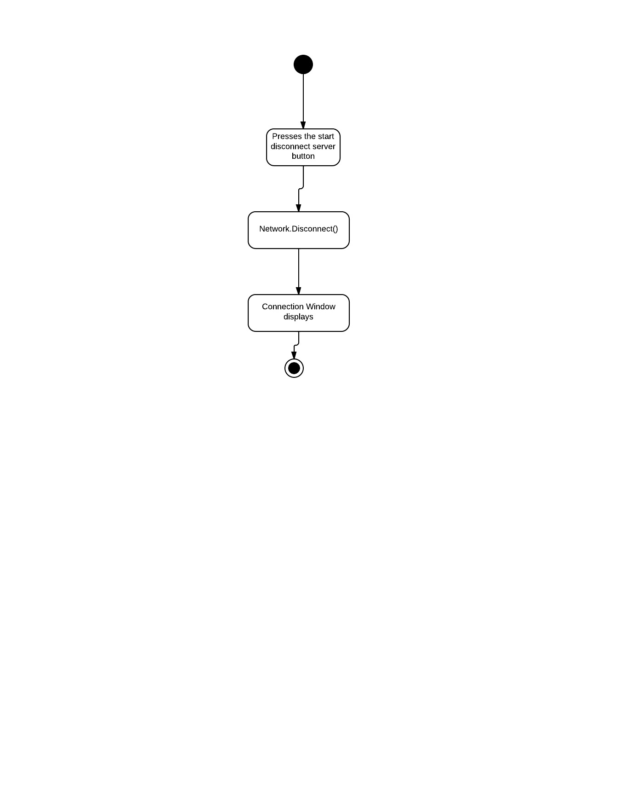

# Chapter 7. System Testing and Implementation

In this section we test if the system meets the user expectations and the internal system functions properly.

## 7.1 Testing Overview

The testing is done in three simple format:

a) User Acceptance Testing

b) Unit/Component Testing

c) System Integration Testing

## 7.2 User Acceptance Testing

|  |  |  |  |  |
| --- | --- | --- | --- | --- |
| ***Actor*** | ***Test Case*** | ***Objective*** | ***Requirement Traceability*** | ***Date*** |
| Server Operator | 1 | To test if the server operator can start a server |  |  |
| Server Operator | 2 | To test if the server operator can stop the server |  |  |
| Client Player | 3 | To test if the player can connect to the server |  |  |
| Client Player | 4 | To test if the player can disconnect from server |  |  |
| Client Player | 5 | To test if the player can make movement can other players can trace the movement |  |  |
| Client Player | 6 | To test if the player can fire bullet and reduce the health of opponent player |  |  |
| Client Player | 7 | To test if the players can see the score board |  |  |
| Client Player | 8 | To test if the player can spawn into the game after being destroyed |  |  |

### 7.2.1 User Acceptance Test Logs

|  |  |
| --- | --- |
| ***Test Case*** | ***1*** |
| Objective | To test if the server operator can start a server |
| Test Data | All the server staring data (Server name, Port number) |
| Expected Result | Server is to be started in the localhost |
| Actual Result | The server was started in the localhost IP |
| Conclusion | Actual result is as expected |

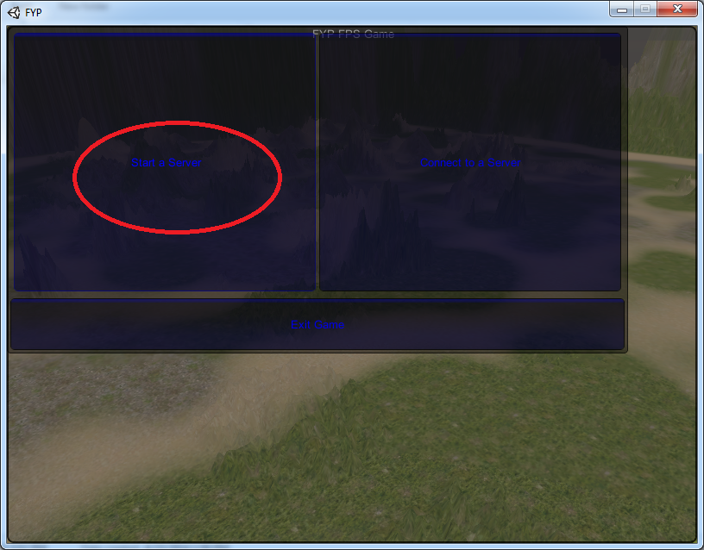

Figure The server operator clicks on the "Start a Server" button

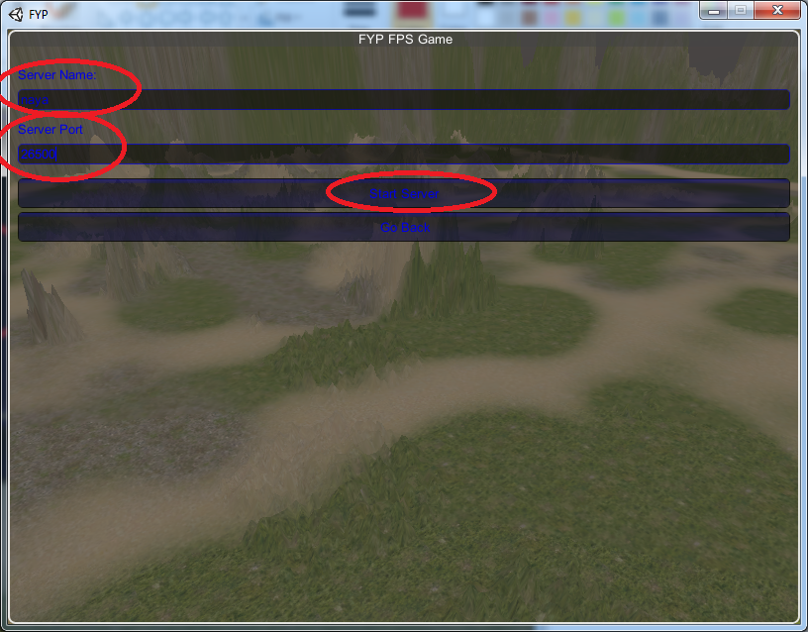

Figure The Server name, Port number is filled and "Start Server" button is pressed

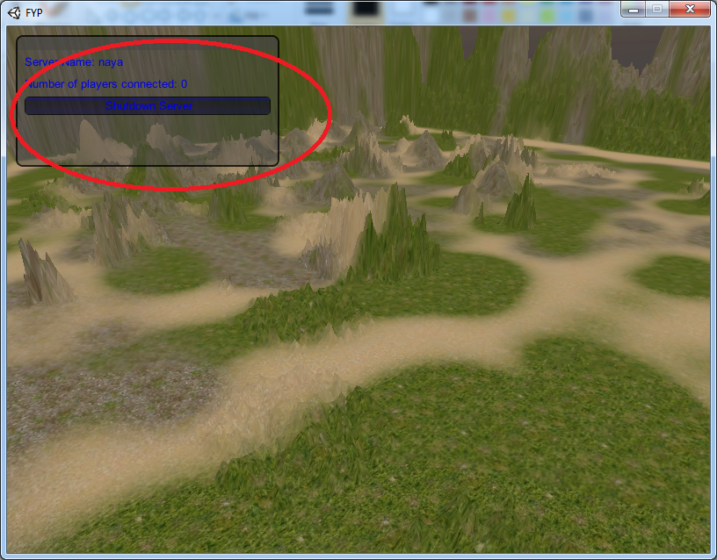

Figure The server is started, showing the total number of players connected

|  |  |
| --- | --- |
| ***Test Case*** | ***2*** |
| Objective | To test if the server operator can stop the server |
| Test Data | The “Shutdown Server” button is presses |
| Expected Result | Server is to be Stopped and connection window should appear |
| Actual Result | The server was shutdown |
| Conclusion | Actual result is as expected |

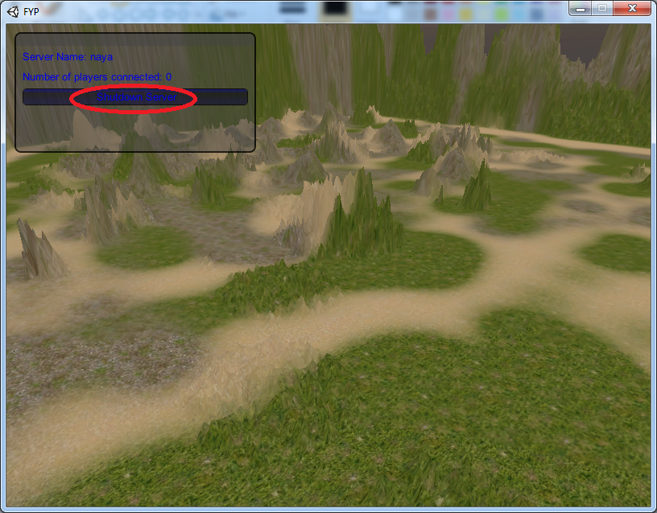

Figure The "Shutdown Server" button is pressed

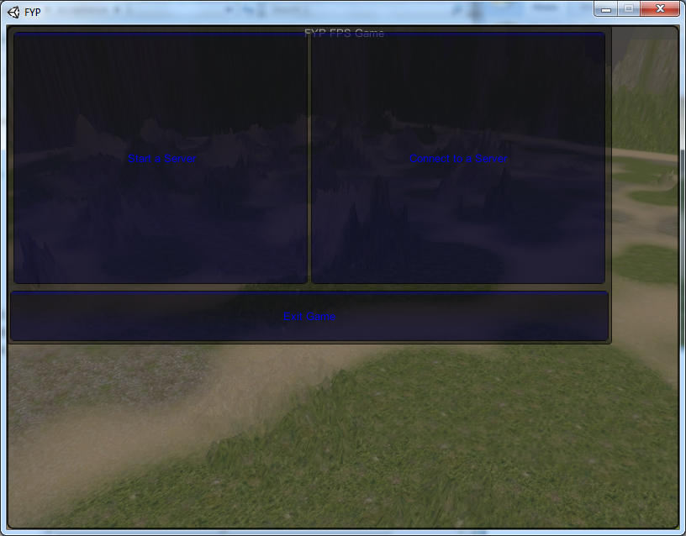

Figure The starting Connection Window appears

|  |  |
| --- | --- |
| ***Test Case*** | ***3*** |
| Objective | To test if the player can connect to the server |
| Test Data | The server is run on the background, and a new instance of game is open and is tried to connect in “127.0.0.1” IP in the same Port number as of server |
| Expected Result | The client player is to be connected to the server. |
| Actual Result | The client is connected |
| Conclusion | Actual result is as expected |

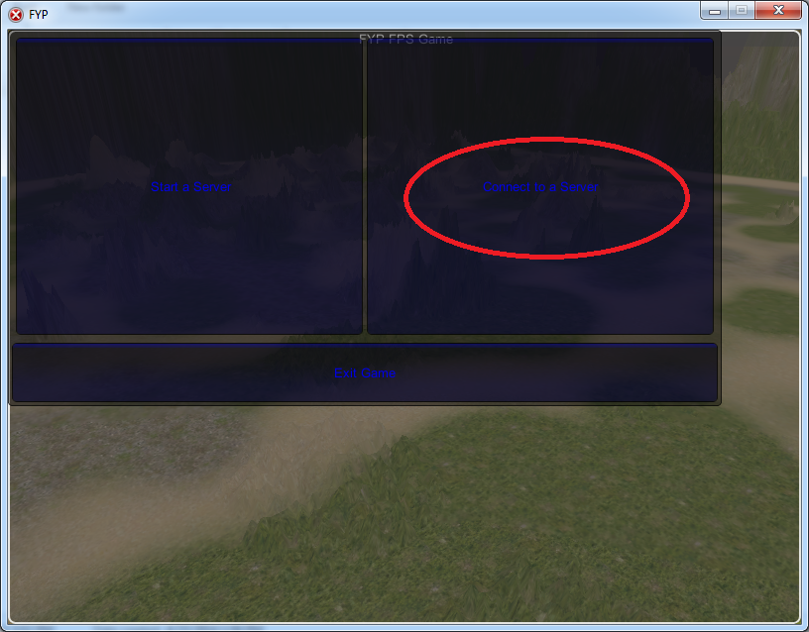

Figure The client player presses the "Connect to a Server button"

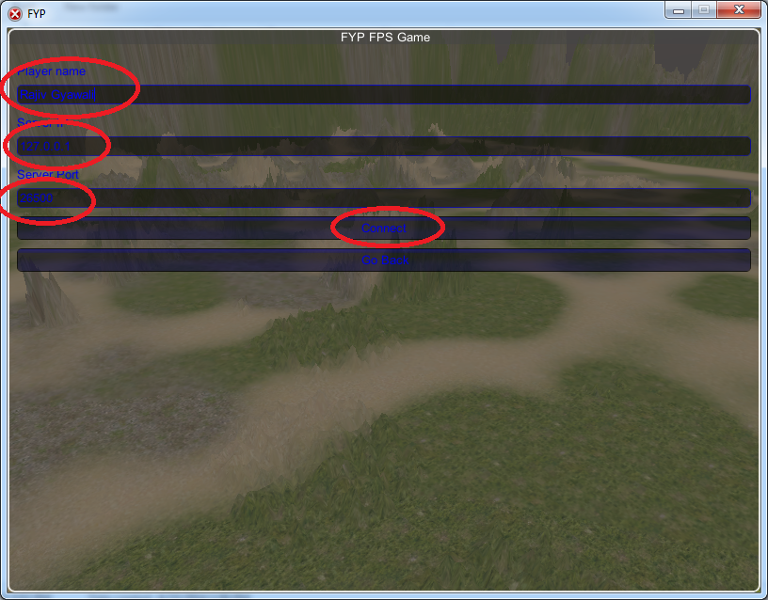

Figure The Player name, Server port and Server IP is etered and "Connect" button is pressed

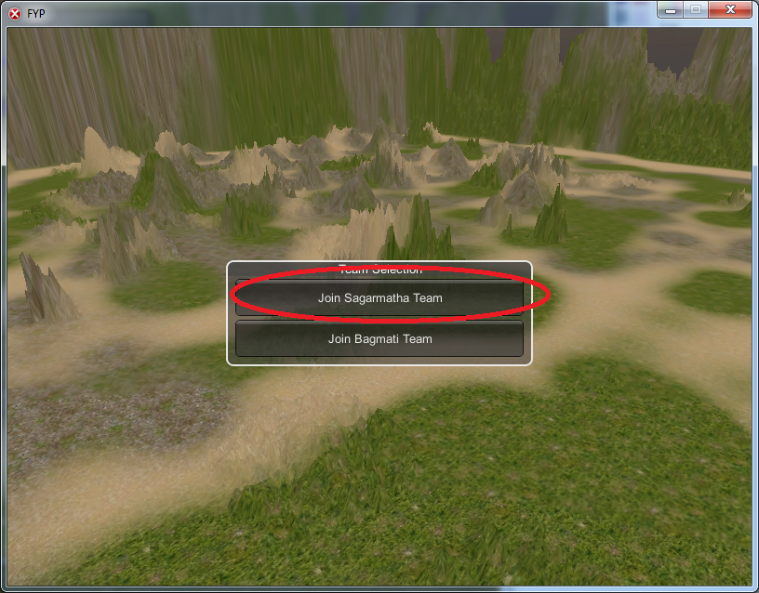

Figure The player enters as "Sagarmatha Team" player

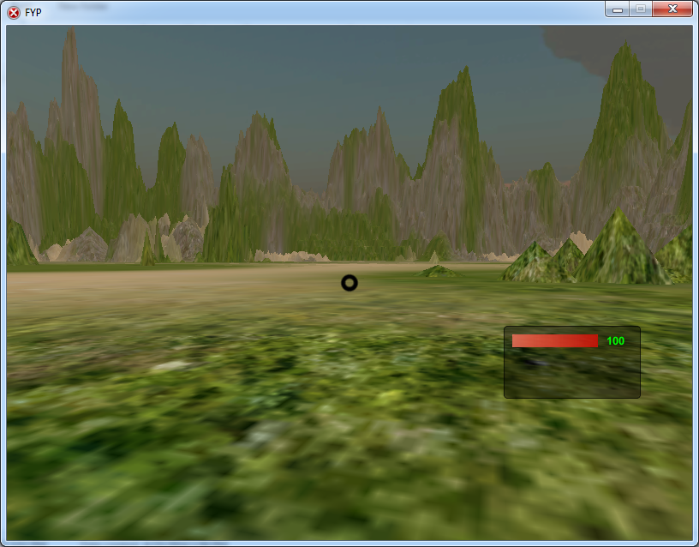

Figure The client is shown with the gameplay window

|  |  |
| --- | --- |
| ***Test Case*** | ***4*** |
| Objective | To test if the player can disconnect from server |
| Test Data | The client presses the “Disconnect” button |
| Expected Result | The client player should disconnect from the server and show the connection window |
| Actual Result | The client is disconnected from the server |
| Conclusion | Actual result is as expected |

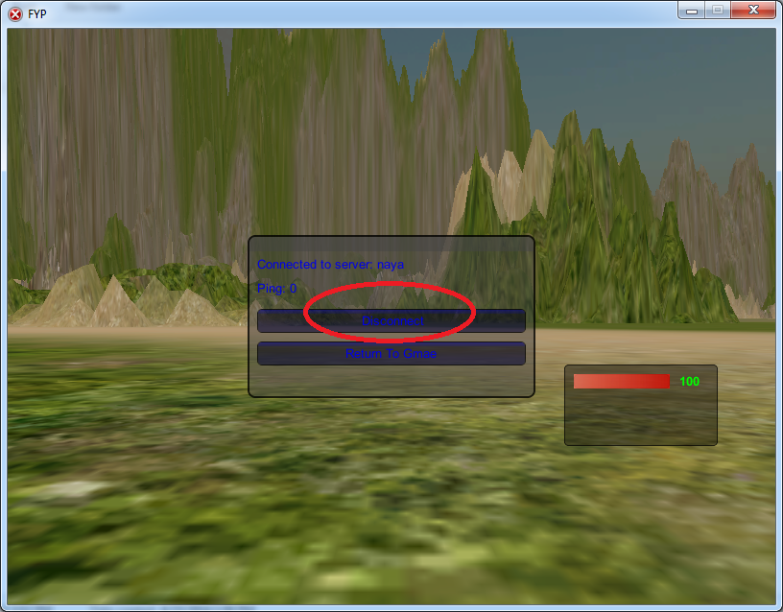

Figure The player pauses the game, and presses the "Disconnect" button

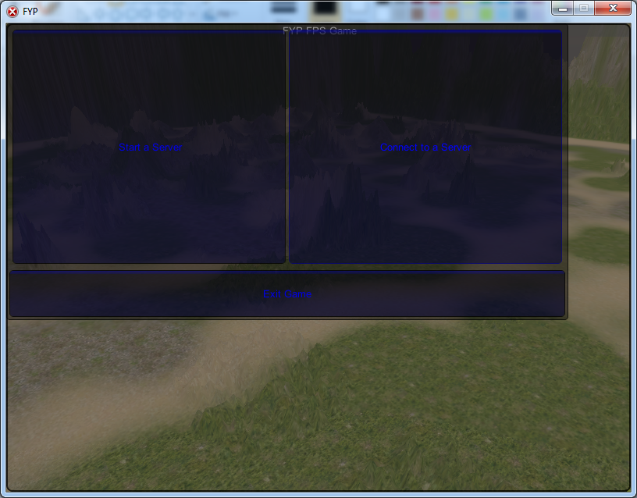

Figure The startup Connection Window appears

|  |  |
| --- | --- |
| ***Test Case*** | ***5*** |
| Objective | To test if the player can make movement can other players can trace the movement |
| Test Data | A client player makes movement, while 2 players are connected in the same game. |
| Expected Result | The other player should see the transform of position |
| Actual Result | The other player can see the transform |
| Conclusion | Actual result is as expected |

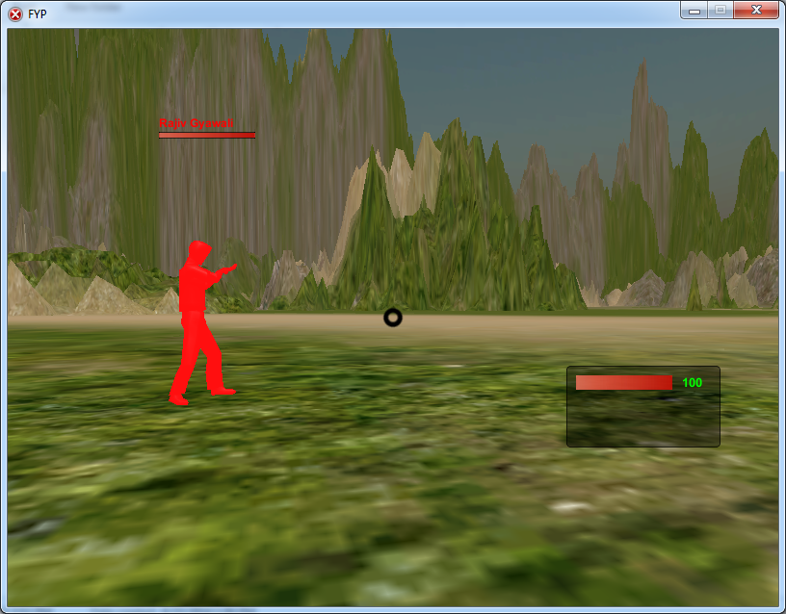

Figure The player named "Rajiv Gyawali" is in the right transform position

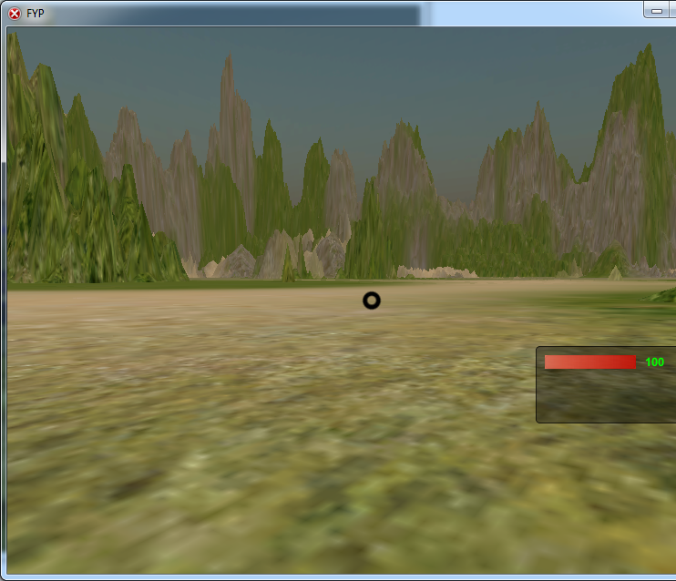

Figure The "Rajiv Gyawali" player moves forward

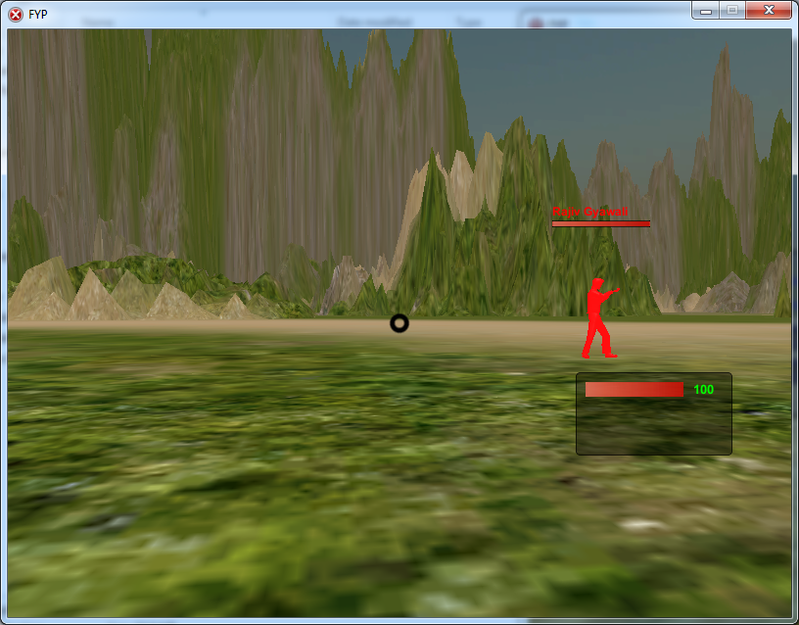

Figure The movement is updated

|  |  |
| --- | --- |
| ***Test Case*** | ***6*** |
| Objective | To test if the player can fire bullet and reduce the health of opponent player |
| Test Data | A client player aims at the opponent player and presses the mouse0 button. |
| Expected Result | The other player should have their health reduced. |
| Actual Result | The other player’s health is reduced |
| Conclusion | Actual result is as expected |

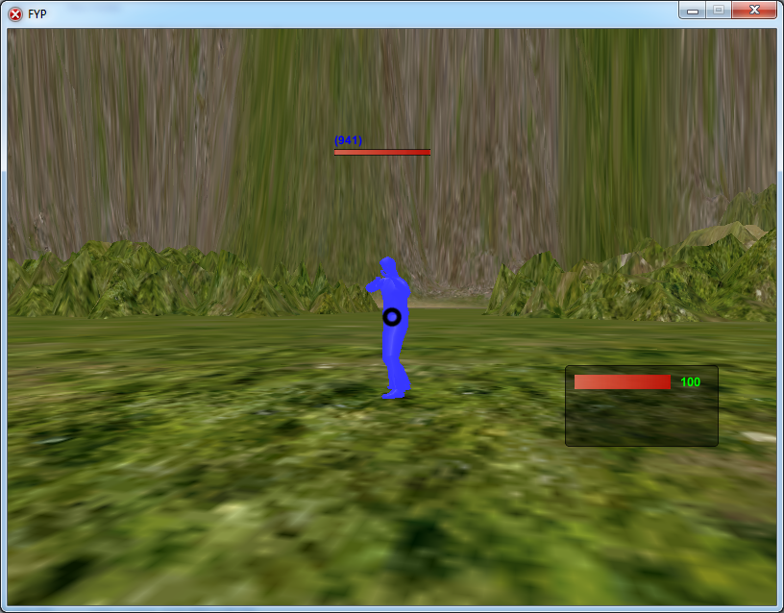

Figure The opposing team player is targeted and shooted with bullets

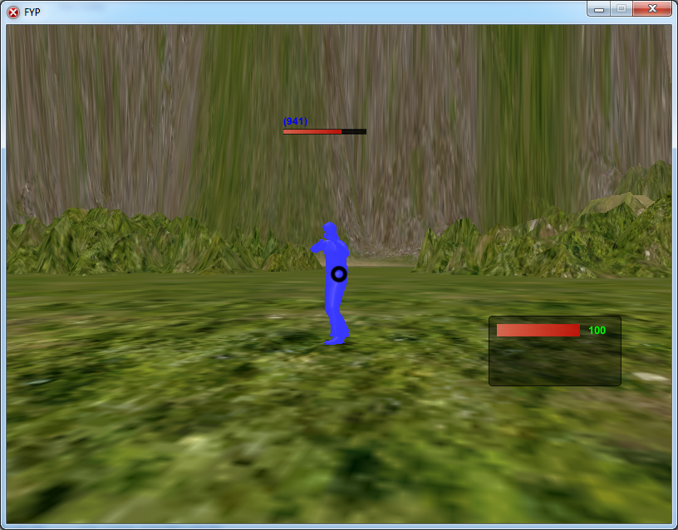

Figure The health of the player is decreased

|  |  |
| --- | --- |
| ***Test Case*** | ***7*** |
| Objective | To test if the players can see the score board |
| Test Data | A client player presses the view score button. |
| Expected Result | The player should be updated with the score table. |
| Actual Result | The player score was updated in the score table. |
| Conclusion | Actual result is as expected |

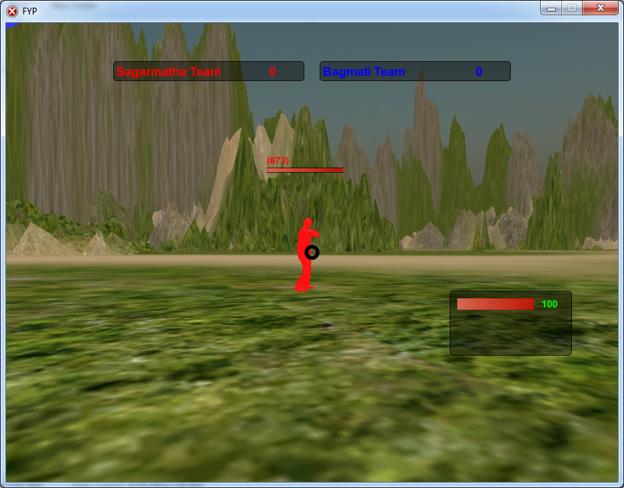

Figure At the initial stage the scoreboard shows the same points for both teams

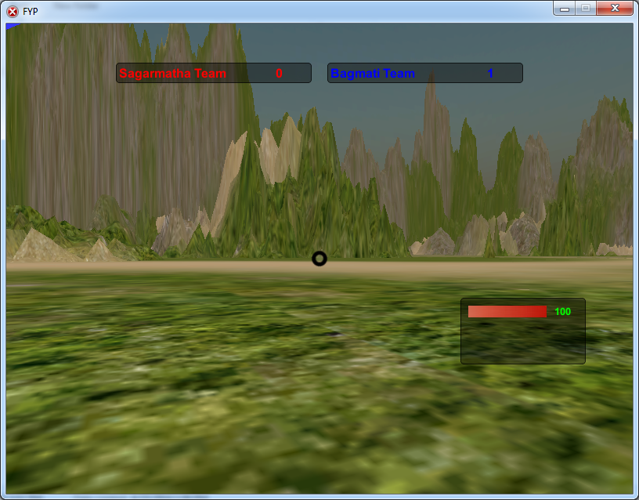

Figure When the Sagarmatha team player is destroyed the scoreboard is updated

|  |  |
| --- | --- |
| ***Test Case*** | ***8*** |
| Objective | To test if the player can spawn into the game after being destroyed |
| Test Data | A client player destroys another player. |
| Expected Result | The player should be able to respawn to the game. |
| Actual Result | The player was able to respawn to the game |
| Conclusion | Actual result is as expected |

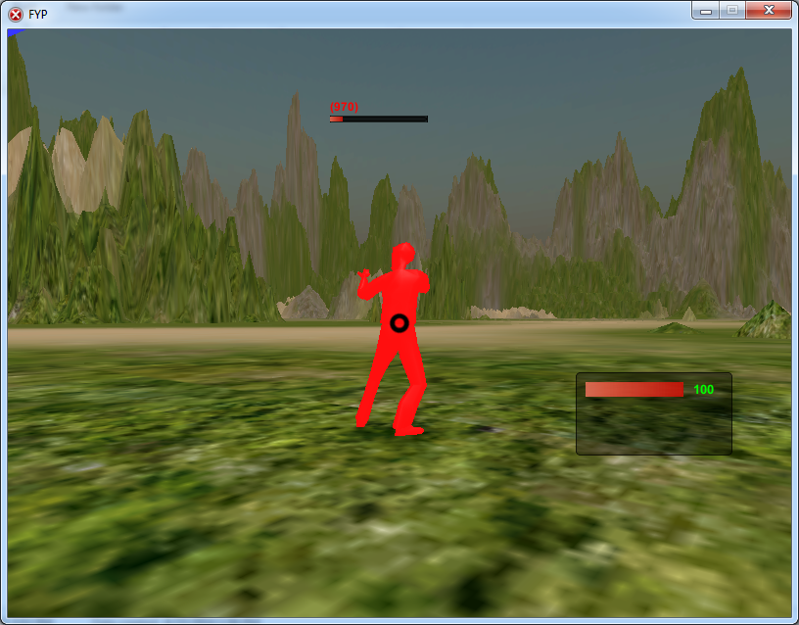

Figure The (970) player is to be destroyed with bullets

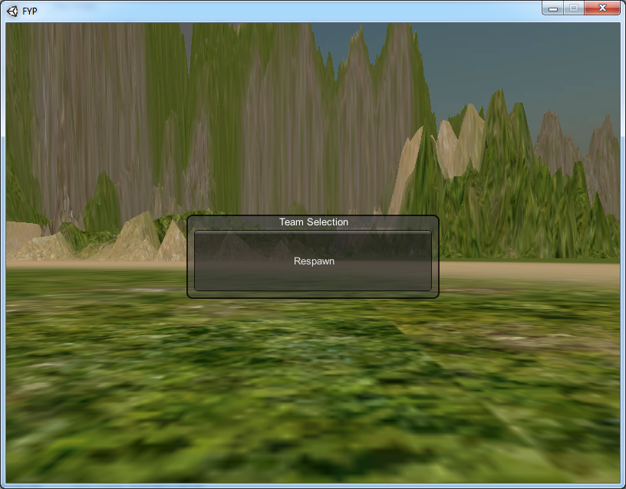

Figure The Respawn button appears after being destroyed

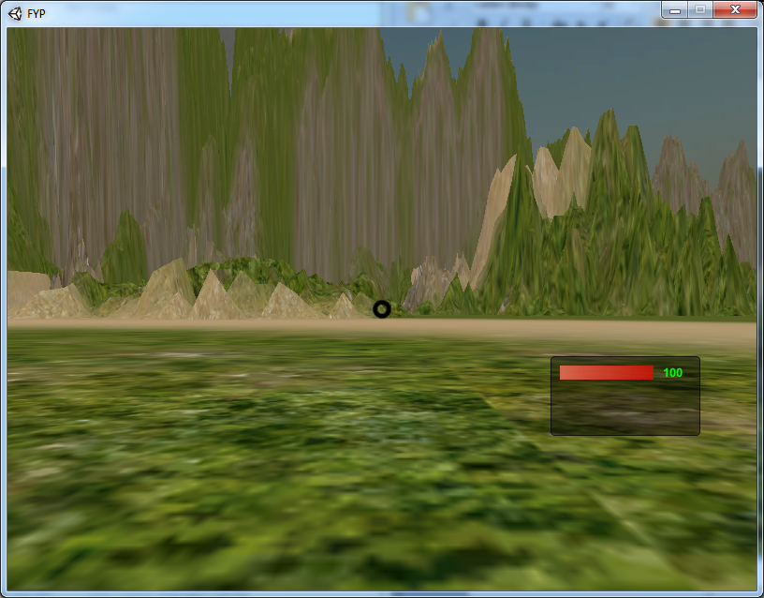

Figure After pressing the "Respawn" button the player is again brought into the gameplay

### 7.2.1 User Acceptance Test Result

|  |  |  |
| --- | --- | --- |
| ***Test Case*** | ***Objective*** | ***Status*** |
| 1 | To test if the server operator can start a server | Successful |
| 2 | To test if the server operator can stop the server | Successful |
| 3 | To test if the player can connect to the server | Successful |
| 4 | To test if the player can disconnect from server | Successful |
| 5 | To test if the player can make movement can other players can trace the movement | Successful |
| 6 | To test if the player can fire bullet and reduce the health of opponent player | Successful |
| 7 | To test if the players can see the score board | Successful |
| 8 | To test if the player can spawn into the game after being destroyed | Successful |

## 7.3 Unit/Component Testing

The unit testing is done on all the script s and components of the system. This is the testing that will make the system response and integrate well when the system is gradually built.

|  |  |  |
| --- | --- | --- |
| ***Test Case*** | ***Objective*** | ***Date*** |
| 1 | Test if all the variables are initialized at first. |  |
| 2 | Test if the condition on all conditional statements are valid |  |
| 3 | Test if loops will terminate |  |
| 4 | Test if the compound statements are properly bracketed |  |
| 5 | Test if the output variables are assigned before they are displayed |  |
| 6 | Test if the method calls have correct number of parameters |  |

### 7.3.1 Unit/Component Test Logs

|  |  |
| --- | --- |
| ***Test Case*** | 1 |
| ***Objective*** | Test if all the variables are initialized at first. |
| ***Test Data*** | Initialized variables in script |
| ***Expected Result*** | All variables need to be initialized first |
| ***Actual Result*** | All variables were initialized first |
| ***Conclusion*** | Actual result is expected |

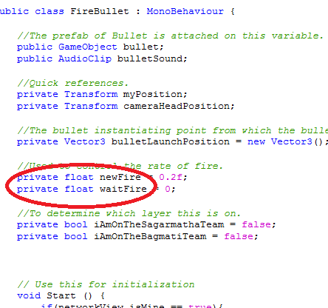

|  |  |
| --- | --- |
| ***Test Case*** | 2 |
| ***Objective*** | Test if the condition on all conditional statements are valid |
| ***Test Data*** | Condition in the script |
| ***Expected Result*** | All conditions on conditional statements are valid |
| ***Actual Result*** | All conditions on conditional statements were valid |
| ***Conclusion*** | Actual result is expected |

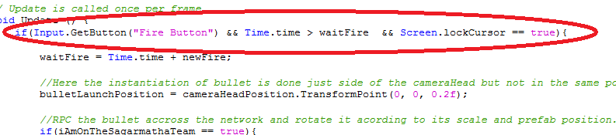

|  |  |
| --- | --- |
| ***Test Case*** | 3 |
| ***Objective*** | Test if loops will terminate |
| ***Test Data*** | Loops in the script |
| ***Expected Result*** | All loops in the script needs to terminate |
| ***Actual Result*** | All loops in the script were terminated |
| ***Conclusion*** | Actual result is expected |

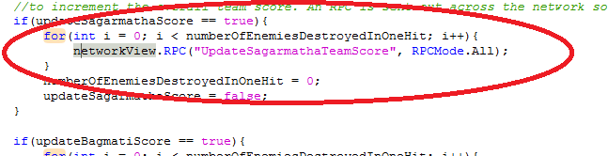

|  |  |
| --- | --- |
| ***Test Case*** | 4 |
| ***Objective*** | Test if the compound statements are properly bracketed |
| ***Test Data*** | Compound statements |
| ***Expected Result*** | All compound statements need to be properly bracketed |
| ***Actual Result*** | All compound statements were properly bracketed |
| ***Conclusion*** | Actual result is expected |

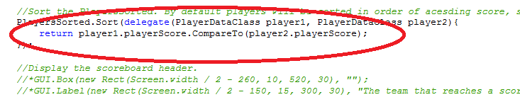

|  |  |
| --- | --- |
| ***Test Case*** | 5 |
| ***Objective*** | Test if the output variables are assigned before they are displayed |
| ***Test Data*** | Output variables |
| ***Expected Result*** | All the output variables need to be assigned before they are displayed |
| ***Actual Result*** | All the output variables were assigned before they were displayed |
| ***Conclusion*** | Actual result is expected |

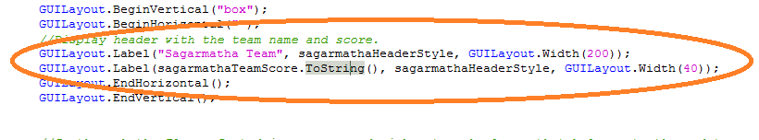

|  |  |
| --- | --- |
| ***Test Case*** | 6 |
| ***Objective*** | Test if the method calls have correct number of parameters |
| ***Test Data*** | Methods |
| ***Expected Result*** | All methods call should have correct number of parameters |
| ***Actual Result*** | All methods call had correct number of parameters |
| ***Conclusion*** | Actual result is expected |

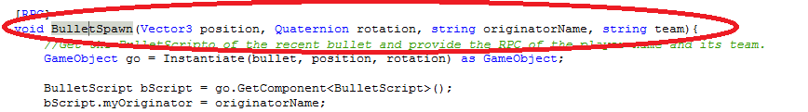

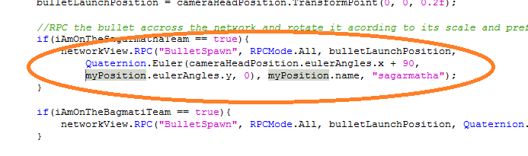

### 7.2.2 Unit/Component Test Result

|  |  |  |
| --- | --- | --- |
| ***Test Case*** | ***Objective*** | ***Result*** |
| 1 | Test if all the variables are initialized at first. | Successful |
| 2 | Test if the condition on all conditional statements are valid | Successful |
| 3 | Test if loops will terminate | Successful |
| 4 | Test if the compound statements are properly bracketed | Successful |
| 5 | Test if the output variables are assigned before they are displayed | Successful |
| 6 | Test if the method calls have correct number of parameters | Successful |

## 7.3 System Integration Testing

This testing is carried out in order to check the communication between the different modules of the system.

### 7.3.1 System Integration Test plan

|  |  |  |
| --- | --- | --- |
| ***Test case*** | ***Objective*** | ***Date*** |
| 1 | Does the BulletScript changes the state of Health component’s iJustGotAttacked, whoAttackedMe and iGotHitByBullet after hitting the player with the bullet |  |
| 2 | Does the FireBullet component change the state of BulletScript variables such as myOriginator and team |  |
| 3 | The CommunicationScript changes the ScoreTable winningScore value at the initial stage as 20 |  |
| 4 | PlayerName component changes the PlayerDatabase isNameSet to true and sets the playerName to corresponding player name |  |

### 7.3.2. System Integration Test Logs

|  |  |
| --- | --- |
| ***Test case*** | ***1*** |
| Objective | Does the BulletScript changes the state of Health component’s iJustGotAttacked, whoAttackedMe and iGotHitByBullet after hitting the player with the bullet |
| Test Data | iJustGotAttacked, whoAttackedMe and iGotHitByBullet |
| Expected Result | The variables needs to be changed in their value |
| Actual Result | The variables were changed in their value |
| Conclusion | Actual result is as expected |

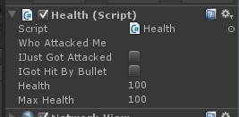

Figure iJustGotAttacked = false, iGotHitByBullet = false, whoAttackedMe = null, Health = 100

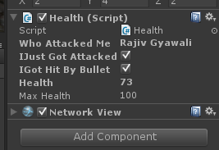

Figure After being Attacked by bullet; iJustGotAttacked = true, iGotHitByBullet = true, whoAttackedMe = "Rajiv Gyawali", Health = 73

|  |  |
| --- | --- |
| ***Test case*** | ***2*** |
| Objective | Does the FireBullet component change the state of BulletScript variables such as myOriginator and team |
| Test Data | myOriginator and team |
| Expected Result | The variables needs to be changed in their value |
| Actual Result | The variables were changed in their value |
| Conclusion | Actual result is as expected |

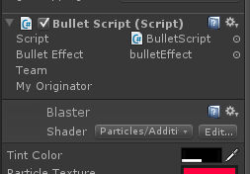

Figure myOriginator = null

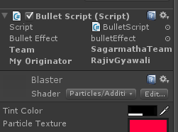

Figure Fater being instantiated; myOriginator = Rajiv Gyawali

|  |  |
| --- | --- |
| ***Test case*** | ***3*** |
| Objective | The CommunicationScript changes the ScoreTable winningScore value at the initial stage as 20 |
| Test Data | winningScore |
| Expected Result | The variables needs to be changed in their value |
| Actual Result | The variables were changed in their value |
| Conclusion | Actual result is as expected |

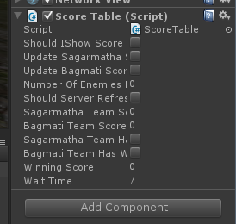

Figure winningScore = 0

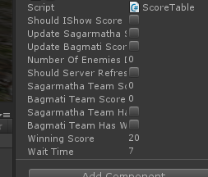

Figure After the game starts; winningScore = 20

|  |  |
| --- | --- |
| ***Test case*** | ***4*** |
| Objective | PlayerName component changes the PlayerDatabase isNameSet to true and sets the playerName to corresponding player name |
| Test Data | isNameSet, playerName |
| Expected Result | The variables needs to be changed in their value |
| Actual Result | The variables were changed in their value |
| Conclusion | Actual result is as expected |

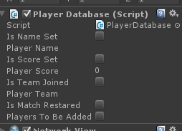

Figure isNameSet = false, playerName = null

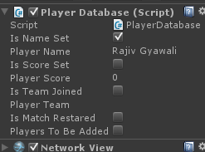

Figure After the player provides his name; isNameSet = true, playerName = "Rajiv Gyawali"

### 7.3.3. System Integration Test Results

|  |  |  |
| --- | --- | --- |
| ***Test case*** | ***Objective*** | ***Result*** |
| 1 | Does the BulletScript changes the state of Health component’s iJustGotAttacked, whoAttackedMe and iGotHitByBullet after hitting the player with the bullet | Successful |
| 2 | Does the FireBullet component change the state of BulletScript variables such as myOriginator and team | Successful |
| 3 | The CommunicationScript changes the ScoreTable winningScore value at the initial stage as 20 | Successful |
| 4 | PlayerName component changes the PlayerDatabase isNameSet to true and sets the playerName to corresponding player name | Successful |

## 7.4 Implementation Plan

For implementing the system, the following requirements need to be met.

### 7.4.1 Hardware Requirements

### 7.4.2 Software Requirements

### 7.4.3 System Deployment

The system will be deployed in the windows app store, which will require a windows license for app developer. Then the app can be deployed to any corner of the world.

### 7.4.4 User Manual

a) Running the game

- Locate the “PlayMe.exe” file under the “Build” folder and double click it.

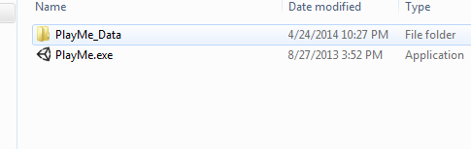

b) Setting up the game

- Adjust the Screen resolution that you want and the Graphics quality that you want. (more hardware resources will be used for higher quality and resolution settings).

- If you want the game to go full screen uncheck the “Windowed” check box.

- You can change the Input parameters if you want.

- Click on the “Play” button

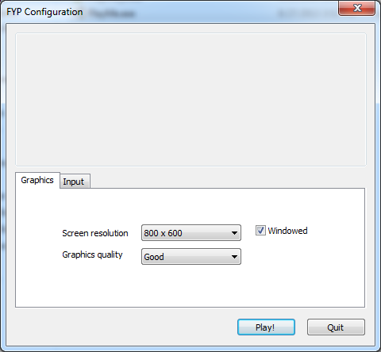

c) Setting up the server

- Click on the “Start a server” button.

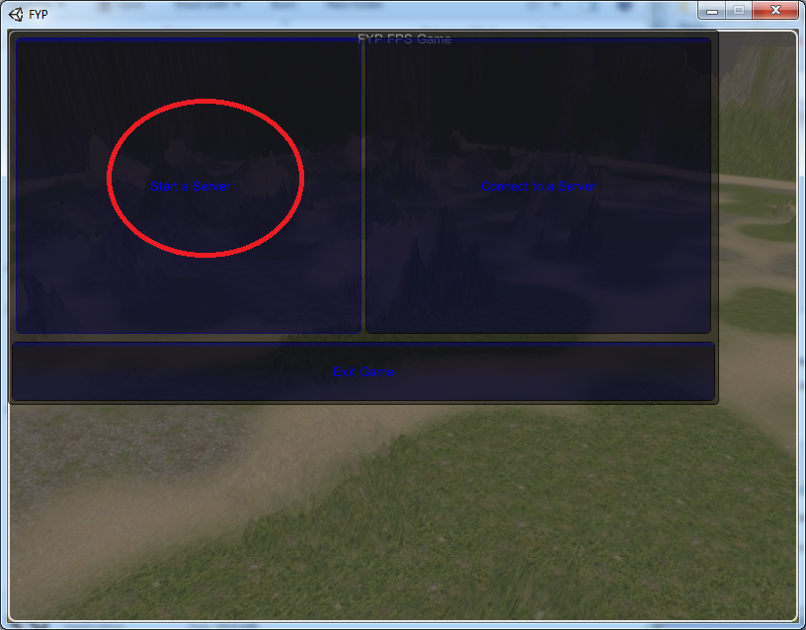

* Give you server name and the Port number that you want to use.
* Then click the “Start Server” button.

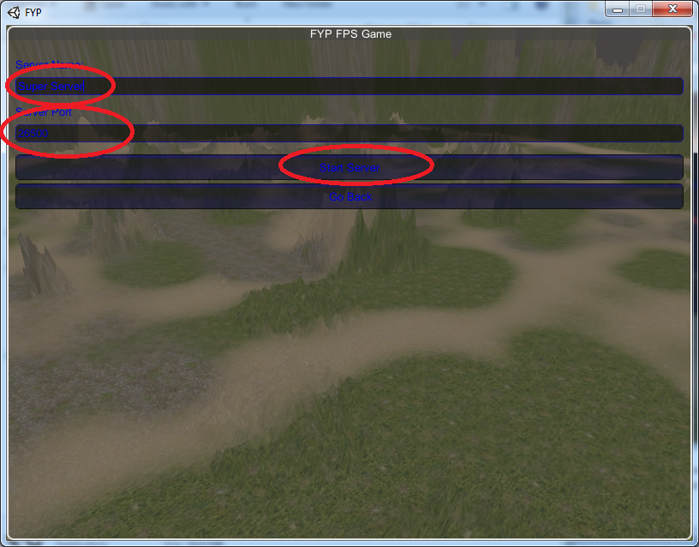

* Then the server is started, you can see the server name and number of players connected on the top left corner.

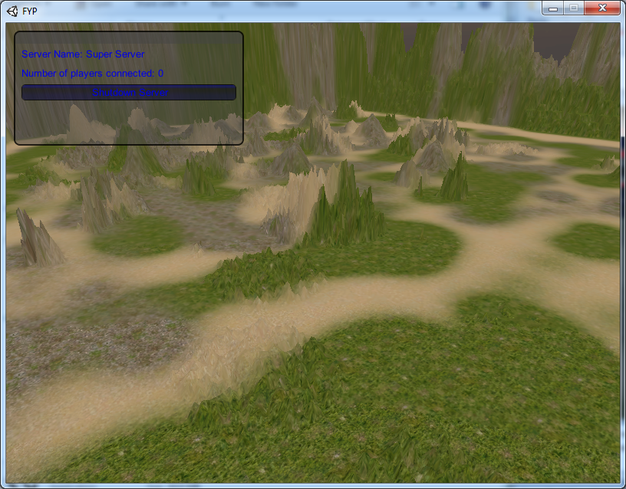

d) Stopping the Server

- Click the “Shutdown Server” button on the top left corner.

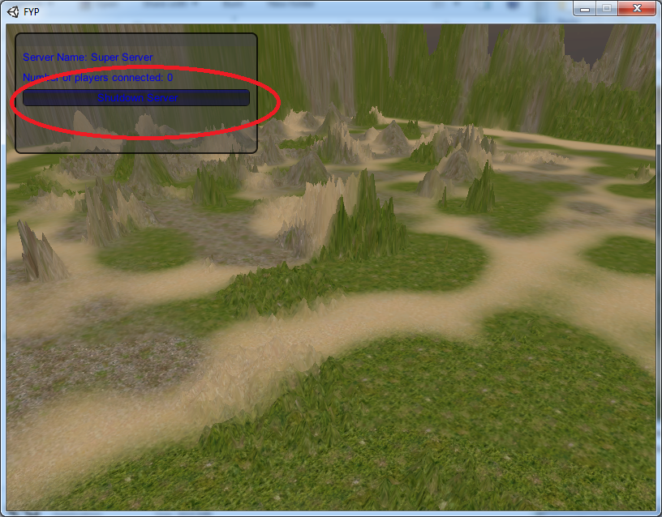

e) Connecting to a server

- While the server is running in some other IP or in localhost, click the “Connect to a Server” button.

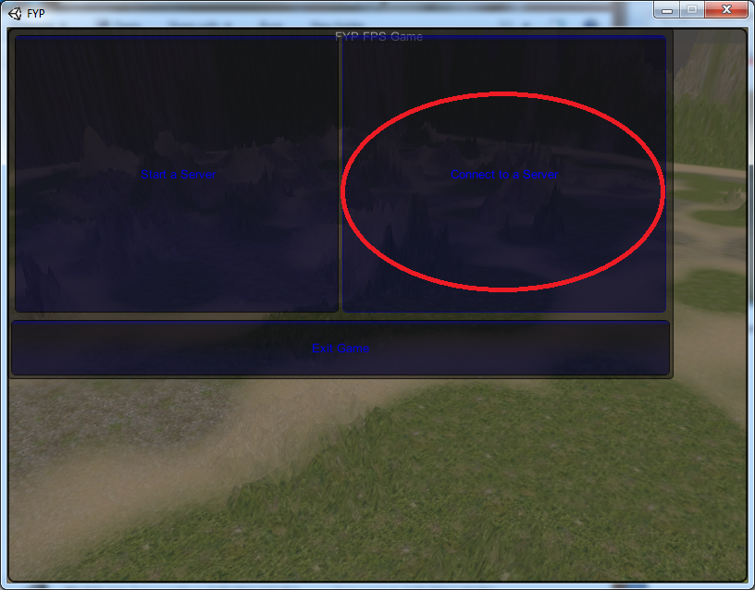

* Fill in the Player name, IP of the server and the server Port number and click “Connect”.

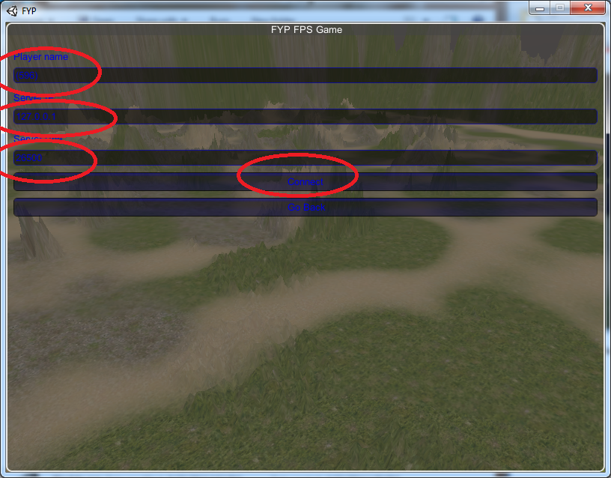

* Click on the team you want to select.

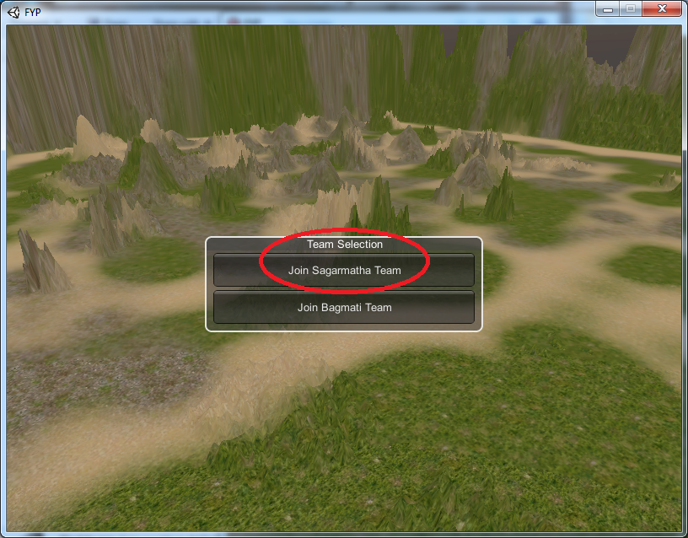

* Now you are connect as client player.

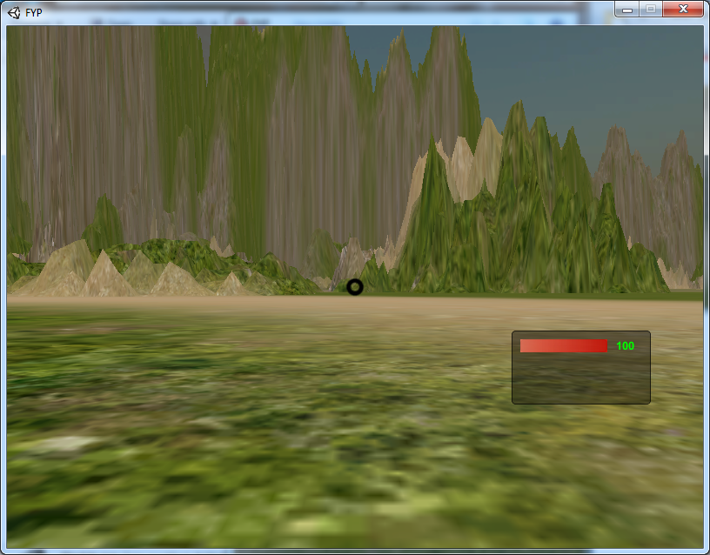

f) Player Movement

- Press the Direction keys on the keyboard (↑, ↓, ←, →) for Movement and Space Bar for Jumping.

g) Firing the Bullet

- Adjust the target to the opponent team player and presses the Left Mouse Button to fire the bullet.

h) Moving the camera angle

- Move the mouse cursor to make the main camera change its angle of view.

i) Disconnecting from Server (Client Player)

- While the game is running, press the “Escape” button.

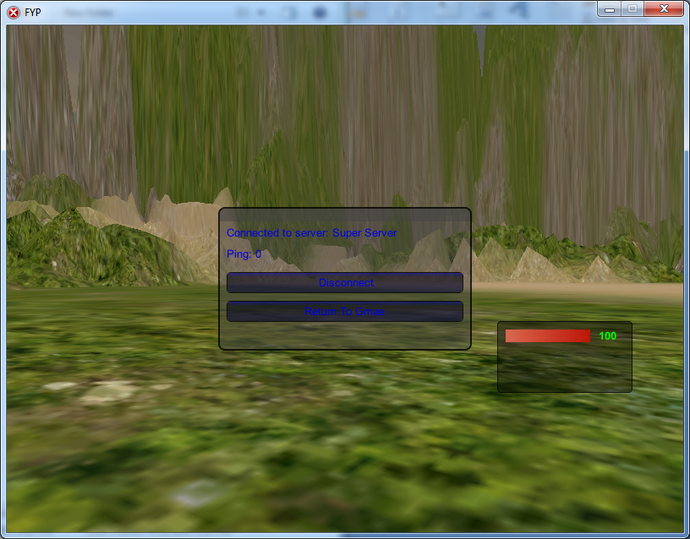

* Click on the “Disconnect button”.

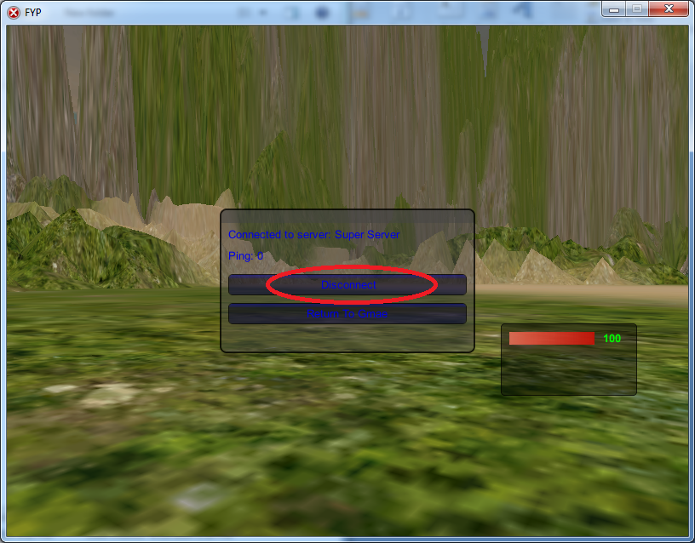

j) Disconnecting the server (Server operator)

- While the server is operating click on the “Shutdown Server” button on the top left corner.

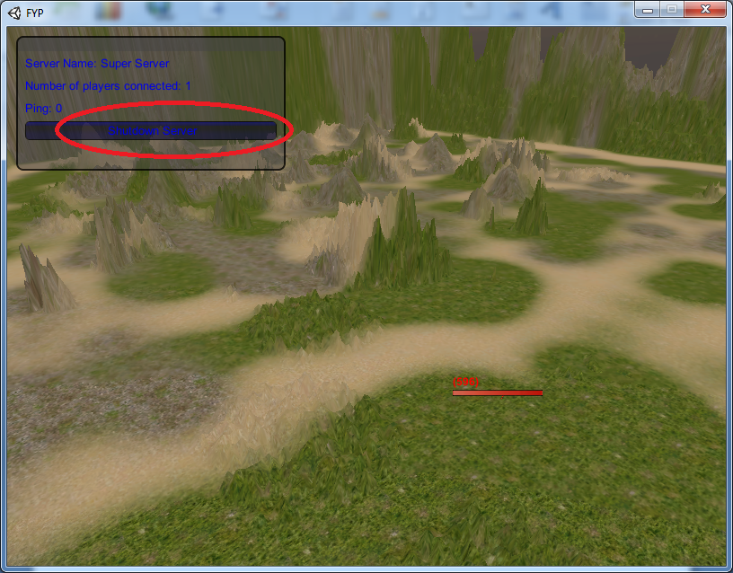

### 7.4.4 Installation Guide

The system build is very easy to setup, just by clicking the executable file the system starts to run. But for starting the server on computer with operating system such as Windows 7, we need to adjust the Firewall settings.

* Goto Windows Firewall
* Click on the “Advanced Settings” button

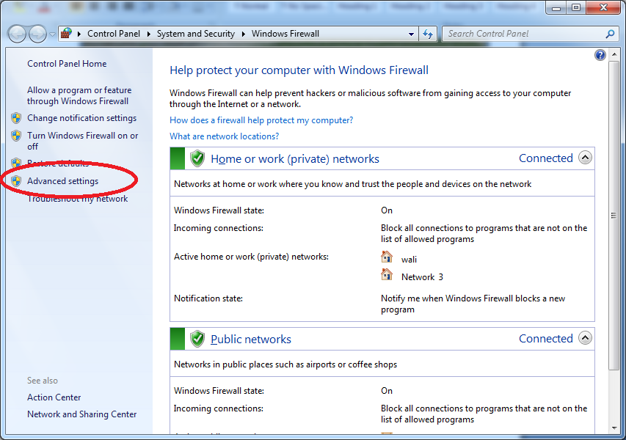

* Click on the “Inbound Rules” button.

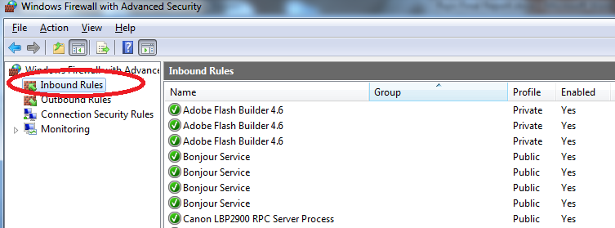

* Change all the “PlayMe” objects to allow the connection.

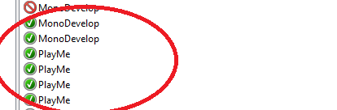

* Now you can setup a server in your computer.

### 7.4.5 System Testing and Implementation Summary

This chapter was the backbone in making sure that the system is fine and the system can be deployed via certain method. Here we tested the system in three different ways; Acceptance testing, Unit/Component Testing and System Integration Testing. All of the test cases were successful so the system was ready to be deployed. For implementation, we have a user manual and system installation guidelines.

# Chapter 8: Critical Evaluation

## 8.1 Introduction

## 8.2 Evaluation of the Project Objectives

The aim of this project was to build up a game in which many players could connect via a LAN; which would run in low hardware resource system. The main objectives were to:

* Research on other similar projects from which the positive aspects can be followed and negative aspects can be avoided.
* To carry the fact findings of the problem domain.
* Make the requirement engineering for this system
* To select the design, development, implementation methods.
* Design the system with UML components.
* Learn to operate Unity 3D and its components.
* Import and work with character controllers in Unity 3D.
* Build the terrains in Unity 3D.
* Embed the scripts to the components.
* Make multiplayer components.
* Port the system in Windows platform.
* To test the system for its functionalities.
* Implement and Install the system.

### 8.2.1 Objective Review

***Chapter 1: Introduction***

Here the aims and objective of this project is comprehended and then a detailed scenario of the game development trend in the whole world is illustrated.

Status: Achieved

***Chapter 2: Literature Review***

In this section, the similar game developed which can be referenced to my current project is described then are compared with each other with different technical aspects.

Status: Achieved

***Chapter 3: Methodology***

In this section of the document, the approach and model of the system development cycle for this project is illustrated.

Status: Achieved

***Chapter 4: Requirement Analysis***

This chapter talks about the ways in which the requirement for this project was compiled.

Status: Achieved

***Chapter 5: System Design Specification***

In this chapter, the design of the system is illustrated with class diagram, state transition diagram and many more.

Status: Achieved

***Chapter 6: Development***

This chapter shows the main codes which were written to make the system functioning.

Status: Achieved

***Chapter 7: System Testing and Implementation***

Here the build system is tested with test cases and the deployment of the system is discussed.

Status: Achieved

***Chapter 8: Critical Evaluation***

Here the evaluation of the system and the methods are made, along with the challenges that were faced are briefed.

Status: Achieved

***Chapter 9: Issues***

The social, legal, ethical economical and technological issue that should be considered by this project is stated here.

Status: Ongoing

***Chapter 10: Conclusion***

The entire project is concluded here.

Status: On going

## 8.3 Project Deliverables

|  |  |
| --- | --- |
| ***Project Intention*** | ***Deliverables*** |
| To start and stop a server in LAN | * Server Start Component * Server Stop Component |
| To connect and disconnect a player from the server | * Server Connect Component * Server Disconnect Component |
| To make the player movement | * Player Movement component |
| To allow players to fire bullets | * Fire Bullet Component |
| To allow players to view the score table | * View Score Component |
| To allow the players to spawn into game again | * Respawn Component |

## 8.4 System Implication on Stakeholders

|  |  |
| --- | --- |
| ***Stakeholders*** | ***Implication of the System*** |
| Server Operator | They can start or stop a server when they want. |
| Client Player | They can join into a game or disconnect from the game |
| Client Player | They can make their players move. |
| Client Player | They can fire bullets in game play |
| Client Player | They can view the current score of the system. |
| Client Player | They can respawn into the game after being destroyed. |

## 8.5 Evaluation of Project Practice

### 8.5.1 Fact-finding techniques

While collecting the requirements for this system, I was searching for a game development team. The well know multimedia institution of 3D animation was “Maya Animatio Academy” of Jamal, Kathmandu, Nepal. There I found Mr. Binod Guragain, who had been working on a outsourcing company for game design. I interviewed him, and he inspired me on developing this system for multiplayer platform. I took his interview and shocked to find that no 3D games have been yet developed commercially for Nepal market.

### 8.5.2 System Design

As this system was not yet implemented the database functionality, the design document illustration method was directed towards the gameObjects concept. The gameObject were responsible for storing the data, this made me learn a different approach on making the documentation of the system

### 8.5.3 System Development

Working with Unity 3D was a different yet exciting journey for me. The game development engine made me realize that any individual can make a game on their own if they are considering to do so. To develop the code in the system I had to look thorough various documentation of Unity 3D. I watched many tutorials online; this made my interest on game development more vivid.

### 8.5.4 Challenges faced

The college was very helpful to make my concept of Object Oriented Programming via Java, I learned a lot from the exams and assignments but the system that I wanted to develop was a step forward from what we were taught in college. The system required not only the knowledge of programming but networking and multimedia as well. I did research on the game development trend and I found Unity 3D to be the best platform in which I can develop my system. In the initial stage of learning the terms of game development was very difficult to understand but gradually I developed the skill to understand the Unity 3D game development skill.

I also faced some problem in time management as I had been working on a company as an employee in this last semester, this made me work only on the night time and on holidays for R&D of this project. Even though I managed the time by taking extra leaves for office for this last month.

## 8.6 Evaluation Summary

In this chapter the evaluation of this system was made in respect to the system build and the proposed system. All the aims and objectives of this system were analyzed and the evaluation on the system development life cycle was made. Here the problems that I encountered were discussed along with the explanation on how I tackled them were briefed.

# Chapter 9: Issues

## 9.1 Introduction

The systems are made to be deployed in the market so that it can make impact on the environment. Some impacts are positive while the other are negative; the game developed from this project also has some issues that needs to be considered, so that only positive aspects are exposed to the environment.

## 9.2 Types of Issues

### 9.2.1 Social Issues

The system developed will impact on the society as the society consists of people and people like to play games. The society of Nepal may consider this a remarkable achievement by an individual and from this system some well commercialized system can emerge. The society should be made aware of how a game can be made simply via game engines and need to choose the traditional approaches to develop games.

### 9.2.2 Legal Issue

The system should abide by the windows legal rules before it is deployed to the windows app store. The windows app store has some algorithm to check the validity of the system and the technical approaches that were taken while developing the system. Therefore, all the legal issues such as license and development tools need to be legal for deploying this system to windows app store.

### 9.2.3 Ethical Issue

The system should have all the ethics covered, when the system includes the team player group names such as “Sagarmatha” and “Bagmati”; we need to consider the impact of those name on the ethics of the country. As the pride of our nation are included in the system, we can expect this system to be well adjusted with the gaming policies.

### 9.2.4 Economic Issues

For uploading this system onto the windows app store, a developer license needs to be purchased. And for making changes on the system after a year again a unity 3D pro license needs to be purchased. The implementation of the system is cost effective is can run on any windows platform system and can be operated as server or client in just click of a mouse button.

### 9.2.5 Technological Issues

The community of Unity 3D is ever changing, there are rumors that Unity 3D 5 is on the way, on the upcoming version of unity the code implementation and shading languages are expected to be changed. This might mean that for changing the system or updating the system to the new requirement of stakeholders the new system might need to be installed.

## 9.3 Conclusion

This chapter stated the issues that might come on future that needs to be considered now. Here we discussed not only on the system development but the environmental aspects as well.

# Chapter 10: Conclusion

## 10.1 Introduction

## 10.2 Project Achievement

The system was build and along with the system many other components were also accomplished.

a) FPS Multiplayer Game for Windows

The game that was intended to be developed was build at last, the game as expected delivers all the requirements. The game can be operated on two categories client player or server operator. The server operator can start or shutdown the server, while the client player can start the game and play the FPS game. The game implements the bullet and health system, which was a mandatory to be on the system.

b) User manual

The people who are familiar with game playing will adjust with the game play in instance but for those inexperienced users there is a user manual, which will instruct them on how to play the game. The user manual consists of all the vital information about the game play and also addresses the Firewall blocking issue.

## 10.3 Advantage of the system

Some of the positive aspects of the system are:

* Requires relatively lesser hardware resources to operate
* Requires relatively lesser network bandwidth to operate
* It is a fully playable FPS multiplayer game
* This system can be implemented for both server operating and gameplay purpose.

## 10.4 Drawbacks of the system

Some of the negative aspects of this system are:

* The terrain created is not attractive.
* The lights and effects of the system are not of industry standards.
* The game cannot store the high score in the cloud.
* The game cannot be played with game controller.

## 10.5 Future Enhancements

The system that is build is not mature enough to be commercialized. The system needs to be improved in the exterior aspects to make it a magnet in attracting the gamers. Some of the aspects that needs to be enhanced for future are:

* Terrain enhancement
* Level Reload when a team wins
* Player control with Game controller
* Porting to other devices such as iOS and Mac OS X.

## 10.6 Lesson Learnt (Reflection)

The lessons that I learnt from the project are:

* Research and Development
* Fact-Finding techniques
* Design the system via UML
* Development of game in Unity 3D (C#)
* Testing and Implementation
* Game development industry
* Game development techniques and tricks
* Manipulating 3D objects
* Evaluating and Analysis the system

## 10.7 Final Summary

There were many obstacles on the system development cycle, but by overcoming all those obstacles this system is made complete. A well adjusted system is build at last and this system is expected to do well in enhancing by technical as well as social skills. Hence, the documentation of the FPS Multiplayer System for Windows is concluded.